**DEAF ACCESSIBILITY IN THE FINANCIAL SECTOR**

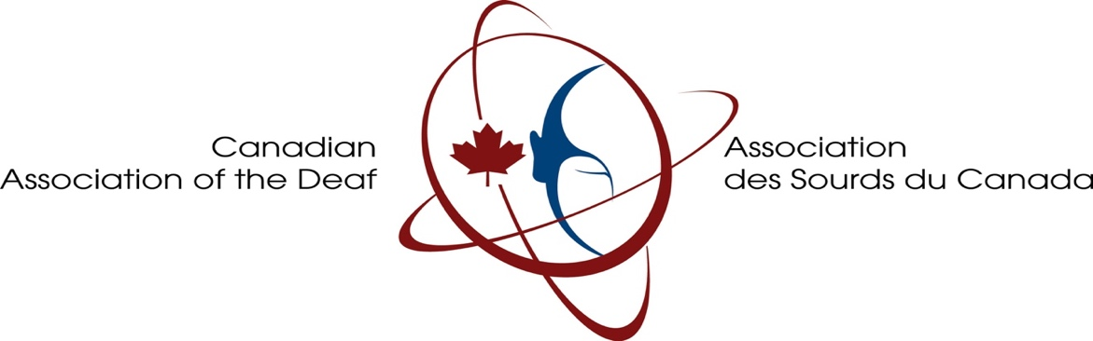

March 2023

Table of Contents

EXECUTIVE SUMMARY 6

INTRODUCTION 8

Recommendations 10

Websites 10

In-Branch Accessibility 11

Bank Staff Intranets 12

Client Access To Videoconferencing 14

Live Chat 14

Incoming Phone Calls 15

Activation Process for New or Replacement Debit or Credit Cards 16

Methodology 17

Deaf Community 17

Deaf Survey Respondents and Deaf Financial Professionals 17

Deaf Service Agencies 18

Banks and Credit Unions 18

Outreach Through Media and Conferences 19

Overview of the *Accessible Canada Act* As Applied to Canada’s Financial Sector 20

The Personal Banking Experience 21

The “Big Six” Bank Written Survey 23

Accessibility of Bank Websites 25

The Credit Union Written Survey 27

Interviews with Deaf or Deaf-friendly (Signing) Professionals 28

Real Estate Agents 28

Financial Planners 30

Deaf Employees in Banks 32

Deaf Community Survey Responses 34

Interviews with Deaf Community 35

Deaf Service Agencies 39

New Outside Developments in Accessibility 41

Service Canada 41

New Bank Initiative 44

First Bank to Offer a Dedicated VRS Number 45

Unique U.S. Bank Focused on the Deaf 46

APPENDICES 49

APPENDIX 1 – FIRST DEAF COMMUNITY (ASL) SURVEY 49

APPENDIX 2 – FIRST DEAF COMMUNITY (LSQ) SURVEY 61

APPENDIX 3 – SECOND DEAF COMMUNITY (ASL) SURVEY 74

APPENDIX 4 – SECOND DEAF COMMUNITY (LSQ) SURVEY 98

APPENDIX 5 – DEAF SERVICE AGENCY SURVEY 119

APPENDIX 6 – BANK WRITTEN SURVEY 121

APPENDIX 7 – CREDIT UNION SURVEY 127

APPENDIX 8 – TRANSCRIPT OF CALL WITH A DEAF CLIENT AND BANK 132

APPENDIX 9 – DETAILED BANK VISITS 134

Bank #1 134

Bank #2 136

Bank #3 138

Bank #4 140

Bank #5 142

Bank #6 143

APPENDIX 10 – GRAPHICAL RESPONSES FROM DEAF COMMUNITY SURVEYS 146

Graphical Highlights from Surveys 146

APPENDIX 11 – Government Deaf-Centric Alerts and Educational Materials 154

# EXECUTIVE SUMMARY

*The Canadian Association of the Deaf has received funding from Innovation, Science and Economic Development Canada’s Contributions Program for Non-profit Consumer and Voluntary Organizations. The views expressed in this report are not necessarily those of Innovation, Science and Economic Development Canada or of the Government of Canada. / L’Association des Sourds du Canada a reçu du financement en vertu du Programme de contributions pour les organisations sans but lucratif de consommateurs et de bénévoles d’Innovation, Sciences et Développement économique Canada. Les opinions exprimées dans ce rapport ne sont pas nécessairement celles d’Innovation, Sciences et Développement économique Canada ou du gouvernement du Canada.*

* This report seeks to establish the current baseline before the *Accessible Canada Act, 2019* fully impacts the banks regulated by the *Bank Act*. Remember that a lot of other large financial sector institutions, such as credit unions, real estate agencies, investment firms, and many mortgage brokerage companies are provincially regulated and insurance companies, by and large, are federally regulated. While mortgage lenders typically follow the jurisdiction of the banks (federal) or credit unions (provincial).
* Compared to the period prior to the passage of the *Accessible Canada Act*, Canada’s “Big Six” banks, namely TD Bank, Royal Bank of Canada, Bank of Montreal, National Bank of Canada, CIBC, and Bank of Nova Scotia have, generally, made significant improvements to their accessibility for Deaf customers, both in-person and on-line. This could be in part that five of the Big Six have head offices in Toronto – and many of their subsidiaries are subject to the *Accessibility for Ontarians with Disabilities Act, 2005* (AODA) and its regulations which includes customer service.
* The most significant improvements appear to be in the form of on-line, queued sign language interpreter services at the click of a command[1], once a Deaf customer walks in. However, not all the “Big Six” banks have this feature, and in some banks, Langue des signes Québécoise (LSQ) is missing as an option in this feature. Some banks have cited the *Accessible Canada Act* as a primary reason, as well as customer satisfaction, as a primary motivator to offer better accessibility to Deaf clients.
* Canada’s provincial governments, by and large, do not adequately fund Deaf service agencies, or mandate interpreter services for financial sector institutions (i.e. credit unions, insurance companies, real estate law firms, mortgage companies, and real estate agencies) if the businesses refuse to pay, or do not respond to such requests. The Government of Ontario is one exception, by allocating enough funds to cover meetings of a financial nature for Deaf Ontarians. In the rest of Canada, Deaf customers are frustrated with access to such small or regional financial institutions.
* It was also noted that there are few resources on the Internet developed to financial literacy and anti-fraud education in American Sign Language (ASL) or Langue des signes Québécoise (LSQ) in a Canadian context. Whatever Internet resources that are best available to the Deaf community are only in ASL produced within the United States, which has a very different financial, governmental, and tax regime from Canada’s.
* It is hoped that the gains made by the most progressive of the “Big Six” banks be copied or codified, and applied to all banks and to ensure consistency of the best practices available with the technology that exists now. An important step is to promote these best practices among the remainder of Canada’s financial sector large institutions, such as the credit unions, national insurance companies, and national mortgage companies and encourage all financial sector institutions to adopt the best practices from this report.
* Another key takeaway is to urge governments to enhance annual sign language interpreting community funds to Deaf service agencies to cover all financial services, for those smaller agencies and firms, such as real estate law, real estate agencies, independent “teams” of financial professionals such as insurance brokers, financial advisors, and mortgage brokers. Such enhanced funds to Deaf service agencies should also cover Deaf financial professionals who accept hearing clients or need to meet other hearing professionals in order to ensure their employment status and career success.
* Further funded research projects are recommended, in those following areas:
  + Financial literacy, net worth, employment income, and investment portfolios of Deaf Canadians.
  + Cost recovery methods and contractual language for on-line on-demand, queued sign language interpreter services, for financial institutions in both official languages.
  + Expansion of the VRS (Video Relay Service) telephone interpreting model to cover meetings, either in-person or on-line, between Deaf clients, businesses, government and service agencies for financial purposes
  + Establishing an on-line, on-demand sign language interpreting services agency, like the existing Canadian Administrator for VRS, to provide VRI services (Video Remote Interpreting) as a queued call centre, for Deaf clients. While larger and mid-size financial institutions can obtain their own instantaneous, on-call service and absorb the cost, such a study should review how small to medium financial institutions or independent agents, or deaf employees could have this option quickly and effectively.
  + Developing proposals to provincial governments to increase public funding to sign language interpreting budgets of Deaf service agencies that will include financial services as a community need.
  + Developing, in the context of today’s technology, a checklist of “best practices,” for serving the Deaf community, publicly available to all financial institutions in Canada.
  + Identify barriers that prevents Deaf people from succeeding in the accounting, banking, and financial career fields.

# INTRODUCTION

The Canadian Association of the Deaf undertook this project in order to promote accessibility for, and to remove barriers, on behalf of Deaf Canadians when they access services in Canada’s financial sector, including banks, trust companies, insurance companies, real estate agents, investment firms, and independent financial planners. A secondary concern identified by the Canadian Association of the Deaf was the widespread prevalence of on-line and in-person financial scams that affect the Deaf community, targeting a vulnerable group.

Conclusions show that the “Big Six” banks in Canada, namely the Bank of Nova Scotia, Bank of Montreal, TD Bank, CIBC, National Bank, and Royal Bank of Canada, all have made tremendous strides toward accommodating Deaf clients, including any unscheduled walk-ins, especially with regard to availability of on-line, on-demand sign language interpreting, and more widespread use of videoconferencing once Deaf clients have set up accounts at a bank.

However, other than the “Big Six” banks, the remaining institutions in Canada’s financial sector, such as insurance companies, mortgage companies, and credit unions have yet to provide substantive accessibility to Deaf customers, as well as independent financial professionals such as mortgage brokers, real estate agents, and financial advisors.

Also, the “Big Six” banks in Canada have to continually remain vigilant to ensure that their ever-changing technology does not create new barriers. For example, verification methods can inadvertently exclude Deaf customers when a system requiring voice identification to a central call centre is the only means of verification.

On the issue of personal finance, Deaf Canadians, for the most part, self-educate as to personal finances, as described in this report. This matter could be best explored in more depth in a new, specifically directed project worthy of being funded by the Government of Canada.

# Recommendations

After this comprehensive review of the accessibility of Canada’s financial sector to the Deaf community, we at the Canadian Association of the Deaf have some recommendations, by category: (and all recommendations apply equally in English (ASL) and French (LSQ))

## Websites

1. All websites[2] of banks, credit unions, insurance companies, and mortgage companies (including any French versions) should have the following;
   1. A dedicated webpage to the Deaf, hard of hearing, and Deafened community, welcoming them with an active offer to accommodate, and explaining what accessibility they might expect at this bank, including;
      1. A dedicated Video Relay Service (VRS) number where they may call without being asked confidential information any more complex than that for their hearing customers;
      2. The regular phone numbers for the bank, elsewhere widely distributed also to the hearing public, with explanations that no relay calls will be turned away as long as the standard confidentiality questions[3] are satisfied, but also advising of the dedicated VRS number in case a Deaf client prefers that option.
      3. A dedicated phone number that the Deaf (or anyone else interested in the bank’s accessibility policy or service) may use, relying on relay services, that goes directly to a team in the diversity and inclusion department in headquarters. Ideally, this phone number would be a team-managed number, and not an employee’s assigned phone number, so staff turnover won’t affect its usefulness.
      4. A dedicated email address, such as accessibility@[institution].com, that goes directly to a team in the diversity and inclusion department in headquarters. Ideally, this email would be a team-managed email address, so staff turnover won’t affect its usefulness.
      5. A link to where Deaf persons can find videos produced by the bank as to the bank’s services or how to log on, such videos using narrators who sign. These videos should also have either open captioning, or easy-to-use pre-recorded captioning options.
      6. Ideally, a live chat option that provides deaf clients the opportunity to connect visually with Deaf employees who can service customers in ASL and/or LSQ.

## In-Branch Accessibility

1. All branches of banks, credit unions, insurance companies, and mortgage companies that offer walk-in service should have the following:
   1. On-demand, queued virtual remote interpreting services that is available on the click on a screen (waiting time for first available interpreter within reasonable parameters) on any monitors mounted on top of frontline service counters, and such monitors should be designed to easily swivel to face the Deaf customer. There is also the option of using tablets instead for the same purpose, provided that they can easily be propped up to face the Deaf customer right away, by means of a foldable flip cover, or some other durable apparatus, such as a stand. Moreover, this service should be readily offered, even if it’s apparent that the request by the client will take only three to seven minutes, such as depositing a small amount of cash. Keep in mind that the bank staff usually needs their own screens for making inquiries on client accounts and performing transactions for the clients. Thus, either bank staff should have access to two screens each at the work station, or use a stand-up tablet with the sign language interpreting portal to complement a screen that is used only for serving the client.
   2. Same as above, but also in offices of the banks used for meeting clients for sit-down meetings to discuss financial matters that take up more time, such as opening an account, applying for a mortgage, or taking out an insurance policy.
   3. If a Deaf client still wishes to have an in-person interpreter, booked with advance notice, that option should always be available. The Deaf client should not be persuaded to choose the remote interpreter option (being simply informed of the option is fine, however) unless it is apparent the discussion required would take up only a short time. The banks and other institutions should clarify if there is a minimum expected meeting duration (in minutes) in order to request an interpreter in-person as opposed to the in-branch remote on-line interpreting, and display that minimum time consistently on a national basis so every Deaf client has clear expectation of service no matter the province or city of residence.
   4. The Deaf client should be allowed to bring in his or her favourite interpreter, as long as that interpreter is certified or is in the business of providing interpreter services, and that selected interpreter should be paid the same as the bank’s own standard rate per hour (and incidental expenses such as commuting mileage and parking) for its own interpreter list. The bank or other institution should also ensure it never takes more than one week from the time of the Deaf customer’s request, to the date the interpreter is scheduled to arrive, unless the Deaf customer wishes to schedule the meeting to take place at a later date.
   5. Moreover, for the in-person interpreting option, for a Deaf client at home or work thinking ahead as to a bank visit, there should be a clear link to the accessibility department (as discussed under “Websites”) so the Deaf customer is not left bewildered as to whom to contact to request a sign language interpreter in person. As for bank staff, contact information for sign language interpreter agencies, with clear guidelines as to how and where to book an interpreter, should be easily found on the bank intranet, so bank staff can advise a Deaf customer easily.
   6. All the above should also be in the near future, adapted to the real-time captioning option, for oral Deaf or Deafened customers who prefer to speak, but rely on captioning. Banks and other institutions should continue to develop contracts for on-demand, queued captioning services, in the same manner that sign language interpreting services and voice interpreting services (i.e. different languages) are readily available. If at the current moment such on-demand captioning services are difficult to find, banks and other institutions should still drive demand, by speaking with Canada’s largest Deaf service agencies or interpreter service agencies to see if they have developed the infrastructure[4].
   7. Ideally, banks should consider the option of establishing a video customer service channel that would be staffed by Deaf employees ready to answer basic financial questions in ASL and LSQ. These employees could connect customers with their local branches and ensure that the branch is ready with to deal with the nature of the customer’s query and accommodations to serve them.

## Bank Staff Intranets

1. Each bank or other institution should ensure that its intranet, available to all staff, contains depth of Deaf-related information, such as:
   1. How to use on-demand, queued remote interpreting services, such as downloading the app, finding the app, how to set it up to comfortably face the Deaf customer, whether sitting down or standing up, and how to do quick fixes to the set-up in case of simple mistakes.
   2. How to book and pay for in-person sign language interpreters, including lists of bank-approved sign language interpreter agencies, contact information, including standard prompt scheduling times, how to bill by cost centre, and how to include the Deaf client’s needs.
   3. How to use automatic captioning on bank’s videoconference platforms, such as Zoom, Skype, Microsoft Teams, and so on, and how to enable captions, if not automatically available, for the Deaf clients. In the same manner, how to automatically link sign language interpreters (optimally the bank’s own contracted remote interpreting service in a seamless connection to the videoconferencing platform). Also, how to ensure the Deaf client can comfortably view the sign language interpreter’s window on the screen, including options to magnify the interpreter’s allotted window, yet still see the bank staff participating in the videoconference meeting.
   4. General, brief information on the Deaf community and its methods of communication and etiquette, such as waiting longer for response times during interpreted meetings, facing the Deaf client directly, using pen and notes if requested, and understanding that there are many different subsets of the Deaf community, with different preferred communication methods, such as signing, speaking, texting, writing notes, and lipreading. Maybe several simple sign language illustrations, such as hello, please, thank you, you’re welcome, money, insurance, mortgage, payment, how much, and account.
   5. As discussed, bank staff should also be easily directed by the bank intranet as to how to access (nationally applicable, team-oriented phone numbers, emails, or texting) the diversity and inclusion department, optimally to the accessibility team, and be able to explain to Deaf clients how to access the accessibility staff in the case of further accessibility questions. Bank staff could also be reminded on the bank intranet that live chat (texting) is available, ideally a form of live chat with a live bank person that allows seamless transition from unverified client to verified client, instead of relying on a chat bot.
   6. Bank staff should also be informed by the intranet as to not request any additional security measures (other than required from all clients, hearing or not) when receiving phone calls from Deaf clients through relay services. If bank has its own Video Relay Service dedicated number, that number should be prominently featured in the information, so it is easy to find.[5]

## Client Access To Videoconferencing

1. If the bank offers videoconferencing to all its regular clients, such videoconferencing platforms should be accessible to Deaf clients. Optimally, such a platform (Zoom, Microsoft Teams) should be linked to a Deaf client’s account so that the Deaf client doesn’t have to phone or walk in to schedule a meeting. There should be a publicly available electronic calendar (for clients only) for anyone to easily book a time. Such scheduling software should also add an option for the Deaf client to request on-line interpreting during the videoconference. Of course, the Deaf client must ensure that he or she has a computer or other video camera available, linked to the videoconference, and ensure that his or her Internet speed can handle the capacity. Bank staff should be ready to notice such a request, and to be ready at the beginning of the meeting to ensure that the bank’s own remote interpreter service can be connected nearly immediately.
2. As soon as practicable, banks and other institutions should add real-time captioning[6] to its options to all clients to request captioning (instead of sign language) easily when booking the videoconference meeting. The considerations for sign language interpreting during videoconferences apply equally to real-time captioning, except that the captionist’s face does not need to be visible, however there should be plenty of lower bottom space available on the screen for the oral Deaf or Deafened client to easily read the captions, and the placement of the captions should not overlay any important visual information, such as the faces of the people speaking. The captions should be large enough to be read easily, and have its own contrasting background, such as black for white captions, or the reverse. A bonus for banks or other institutions to consider is to empower the Deaf client to adjust the captions, i.e. font size, colour, type of font, and background colour. However, such programming necessarily needs to be simple for the average client to figure out easily, and perhaps offer limited, but dramatically different options, so that the choices are not too overwhelming.

## Live Chat

1. Live Chat is very handy for Deaf persons because of its reliance on texting. However, chat bots, or no opportunity to ask confidential information about financial matters, render Live Chat much less useful. Therefore, as applicable to all clients, the bank should design, or re-design, its Live Chat so that there is always an opportunity to text and video (on the client’s screen at his or her home or place of work) to a live bank person, if requested. Similar to how the bank administers phone calls and verifies identity of the caller, the bank should also enable Live Chat to transition seamlessly into any confidential discussion once the client is able to prove his or her identity. It should be kept in mind that there should be no additional security questions or elevated security clearance simply because a client identifies as Deaf, on Live Chat, nor rely upon voice authentication. Recorded video chats could confirm the identity or agreement of the use of third parties such as interpreters or VRS.

## Incoming Phone Calls

1. One of the most significant controversies between large financial institutions and the Deaf community is the financial institution’s rejection of relay calls[7] from the Deaf community. Some banks require confidentiality forms in order to proceed with confidential information, and others simply refuse to serve any further. This report strongly submits that Deaf clients should be able to use relay calls to discuss anything they want, even confidential information, as the financial institution is free to apply the same security clearance (i.e. asking identity-verifying information) that it applies to all its regular customers. In fact, several bank websites do state they accept relay calls, but the practice of refusing calls still happens. Requiring an additional security clearance, such as demanding that the Deaf clients sign waivers and acknowledgement forms, is very cumbersome and can be humiliating to the Deaf community, because they are being treated differently simply because they cannot, or refuse to, volunteer their voices. This practice consumes significant time on behalf of both the Deaf customer and the responding bank staff person, wasting resources. Electronic signature (or having to sign on printed paper and scanning and returning) is still very awkward to administer. Also, such waivers and acknowledgment forms must be stored on a client’s account, and quite often these forms can be missing or hard to find, or simply not envisioned by unknowing bank staff. As well, a Deaf client could have several accounts in one bank, which are not always consolidated together under one client’s name, or different categories of products such as an insurance policy, a brokerage account, or a mortgage. Therefore, as seems to be the standard stated policy, banks, credit unions, insurance companies, and mortgage companies should always a) ask the same questions as to identity verification they apply to everyone, and b) accept the relay call.
2. In addition to the above, Video Relay Service (VRS) dedicated numbers are another feature that every bank, credit union, mortgage company, and insurance company should enable for Deaf customers, as there only needs to be two national VRS number for each institution (English – ASL and French – LSQ). Plus, not every Deaf person is fluent in sign language. However, having dedicated VRS numbers should not become an excuse not to serve Deaf clients through relay calls, or to require Deaf clients to sign waivers. Each financial institution should contact the Canadian Administrator for VRS (CAV) to request the two English and French institutional VRS numbers, and to work to publicize these numbers within the Deaf community.
3. Banks should consider, the inclusion of a VRS number as part of their contact channels that would be staffed by Deaf employees. Unfortunately, the Canadian Administrator of VRS (CAV) does not allow businesses to contract for this service. Hopefully, future modifications to the CRTC regulations or ACA rules will allow for this service. This will improve access to customers who use ASL and LSQ and provide employment opportunities for Deaf bank employees.

## Activation Process for New or Replacement Debit or Credit Cards

1. At no point in any bank service to all clients (Deaf or hearing) should anything **solely** rest on voice activation, as voice activation both greatly inconveniences the Deaf community, and discriminates against their disability. While voice activation is fine for hearing clients as an option, such instructions to all clients must also include other options for Deaf clients, such as website activation (logging in as a client). Financial institutions even do not allow in-branch staff any authority to activate debit or credit cards, thus also rendering a personal visit by the Deaf client (present in person; one of the strongest identity-verifying measures along with identity documents such as driver’s licences) as useless. Optimally, voice activation should be removed as fundamentally incongruent with universal design. For several years, financial institutions were accepting of activation through a client logging in through the usual procedure; there is little reason that voice activation enhances the security clearance, since practically no one listens to, or checks upon, the recorded voice file. Bank staff also do not remember, generally, the voices of its thousands of clients. Even if a voice profile is kept as back-up and evidence, usually by the time it is sought, any fraud that happens has already taken place, too late for the voice profile to be of much use. This report strongly suggests that whatever security precautions one institution has in place, voice activation should never be the **only** option to activate debit or credit cards, and better yet, replaced by a universal option such as logging in.

# Methodology

There was a variety of methods reaching out to the Deaf community and their supporters among general society, including Deaf service agencies, and to the major institutions in Canada’s financial sector, such as banks and credit unions.

## Deaf Community

The Deaf community itself received two surveys, one in August 2022 and continuing until sometime before the writing of this final report in February 2023. The other survey was distributed in November 2022 and ended at the same time as the first survey, i.e. February 2023. The first survey covered the banking experience; the second survey asked about financial fraud, payday loan companies, and personal finances self-education.

Both Deaf community surveys included French and English written as well as embedded American Sign Language (ASL) and Langue des signes Québécoise (LSQ) videos that captured each question. They were primarily distributed on the CAD=ASC’s main social media conduit to the Deaf community, namely its Facebook webpage (which has nearly six thousand followers) and also shared to other Facebook webpages owned by various Deaf groups and organizations.

The survey response results are shown in the table below:

|  |  |  |
| --- | --- | --- |
|  | **Survey One**  **(Banking Experience)** | **Survey Two**  **(Personal Finances, Payday Loans, and Scams)** |
| English (ASL) | 30 | 17 |
| French (LSQ) | 5 | 4 |

The slight decline in numbers from the first survey to the second survey could probably be attributed to their order in sequence; the Deaf community’s enthusiasm waned after seeing the first survey. By far, most of the survey respondents were different individuals by the time of the second survey; there was very little overlap.

The first survey is included in this report as Appendix 1 (French, as Appendix 2); the second survey as Appendix 3 (French, as Appendix 4).

## Deaf Survey Respondents and Deaf Financial Professionals

Twelve videoconference interviews were held by the project director, one-on-one to collect in-depth experiences of each Deaf person, either with a Deaf survey respondent who filled out the form and agreed to a follow-up interview, or with a Deaf financial professional who was well-regarded in his or her field of financial expertise.

Each interview lasted about twenty minutes to one hour. Each did not have a scripted format, and was geared to elicit open-ended responses.

## Deaf Service Agencies

The primary Deaf service agencies (with respect to government-funded sign language interpreter services) in the seven most populated provinces (on a regional basis) was provided with a survey. The list was as follows:

* Newfoundland and Labrador Association for the Deaf Interpreting Services (St. John’s, Newfoundland)
* Society for Deaf and Hard of Hearing Nova Scotians (Halifax, Nova Scotia)
* New Brunswick Deaf and Hard of Hearing Services Inc. (Saint John, New Brunswick)
* Metropolitan Montreal Deaf Community Centre or, in French, Centre de la communauté sourde du Montréal métropolitain (Montréal, Québec)
* Service D’Interprétation Visuel et Tactile (Montréal, Québec)
* Canadian Hearing Services (Toronto, Ontario)
* Manitoba Centre for the Deaf (Winnipeg, Manitoba)
* Deaf and Hear Alberta (Calgary, Alberta)
* Wavefront Centre for Communication Accessibility (Vancouver, British Columbia)

Of the nine Deaf service agencies survey, seven (including the largest agencies) responded. A copy of this survey is added as Appendix 5.

## Banks and Credit Unions

Due to their sheer size and integration in the public’s day-to-day life, all the “Big Six” Canadian chartered banks were devoted a lot of resources and attention for this project. For each bank, the project director conducted numerous on-line videoconferences with the key diversity and inclusion executives of each bank, and conducted an in-branch visit in person to a bank branch chosen by each bank.

As well, a detailed written survey was given to each bank, and all were completed. The bank written survey is added to this report as Appendix 6.

Credit unions were also approached. The top ten credit unions in Canada outside Quebec[8] were each sent a shorter written survey, designed for credit unions. As well, this list included the biggest *caisse populaire* in Quebec, Desjardins. However, only one credit union responded, and the results will be discussed later in this report. The credit union survey is attached as Appendix 7.

The project director contacted the legal counsel staff for the Canadian Bankers Association. In reply, the Canadian Bankers Association said they had no specific papers or research available on accessibility in the banking sector of Canada. The best they provided was a webpage of theirs that provided parliamentary committee public remarks they made concerning the then-proposed *Accessible Canada Act*.

## Outreach Through Media and Conferences

In addition to formal surveys and interviews, the project director informally interacted with the Deaf community to explain and to promote this project, to raise general awareness of the important objectives.

At the Deaf Expo, in London, Ontario, in November 2022, hundreds of Deaf people and their hearing or hard of hearing colleagues attended, seeing the Canadian Association of the Deaf booth.

In December 2022, the most popular Deaf video news reporting website in Canada, deafdots.ca, featured a six-minute feature on this project. For the purpose of assessing this impact, it should be noted that Deaf Dots usually releases 25-minute newscast every two weeks.

As well, the Canadian Association of the Deaf posted news and updates about this project, announcing the hiring of the project director, and posting requests to fill out the Deaf community surveys.

The project director also invited all the Deaf membership organizations across Canada to hold discussions with him by videoconference regarding the project. In the end, one videoconference regional meeting with representatives from two provincial Deaf organizations was held, discussing ways to network.

On March 26, 2023, CAD=ASC held a national conference to present on the project summary and provide a workshop on how to avoid financial fraud. This workshop was presented in ASL with simultaneous translation into LSQ.

# Overview of the *Accessible Canada Act* As Applied to Canada’s Financial Sector

The *Accessible Canada Act* came into effect on June 21, 2019, and applies to all federal authorities, including banks, which fall under the federal legislation *Bank Act*. With respect to credit unions, only two federally regulated credit unions exist as of the time of this report (March 2023), one of which is in the top ten credit unions in Canada outside Quebec (by size) and it is Coast Capital Savings. (The *Bank Act* was amended in 2012 to allow for federally regulated credit unions.) However, with some large credit unions applying[9] to become federally regulated, it is possible that over a long period of time, more and more large credit unions will be subject to the *Accessible Canada Act*.

With respect to insurance companies, the vast majority of property and casualty insurance companies in Canada are federally regulated.

All real estate agencies are provincially regulated and are not directly subject to the *Accessible Canada Act*. However, they would be subject to any provincial accessibility standards, for example in Ontario under the *Accessibility for Ontarians with Disabilities Act, 2005*. The same framework applies to licensed financial advisors.

However, just like any member of the public served by Canada’s critically important financial sector, a Deaf individual would not consciously determine, on a day to day basis, if the financial activity was federally or provincially regulated. Everyone benefits from accessibility, regardless of jurisdiction. Therefore, while the primary focus is on the federally regulated banks, which do have a huge impact on our financial decisions and lifestyle, we will also consider the accessibility, or lack thereof, for Deaf persons who do everyday financial activities. Such examples are making a deposit into a bank account, investing money, obtaining insurance, learning about personal finances, borrowing money for a car loan or for a mortgage on a home, and buying a house.

# The Personal Banking Experience

The project director visited all six “Big Six” Canadian chartered banks, with pre-arranged “buy-in” from each bank and upon an agreed schedule. Again, the banks were (in no particular order) Bank of Montreal, CIBC, Bank of Nova Scotia, TD Bank, Royal Bank of Canada, and National Bank of Canada. To focus more specifically on the banking experience, the visits will just be identified by number, at random.

|  |  |  |  |  |  |  |
| --- | --- | --- | --- | --- | --- | --- |
| **TOPICS** | **BANK #1** | **BANK #2** | **BANK #3** | **BANK #4** | **BANK #5** | **BANK #6** |
| Will book sign language interpreters upon request | Yes | Yes | Yes | Yes | Yes | Yes |
| Has on-line, on-demand queued interpreters for walk-ins | No | Yes | Yes | Yes | No | No |
| Name of on-line interpreter agency | Canadian Hearing Services * | Language Line (American – no LSQ) | Language Line (American – no LSQ) | Canadian Hearing Services | N/A | N/A |
| Internal bank app to click for on-demand interpreter service on-line | No | Yes | Yes | Yes | N/A | N/A |
| Live Chat available for public (not clients) | Yes | Yes | Yes | Yes | Yes | Yes |
| Live Chat available for clients to discuss confidential information | Yes | Yes | Yes | Yes | No | No |
| Videoconferencing Platform | Microsoft Teams | Microsoft Teams – internal, Webex for external | Webex | Microsoft Teams | Microsoft Teams – internal, none for clients | Microsoft Teams |
| Clients can request meeting on bank’s videoconferencing platform | Yes, but no automatic interpreting option | No | No | Yes, with option to choose interpreting service | N/A | Yes, but no on-line interpreter option |

Note: * Booked in advance, on-line, and had a time limit.

The format for each visit was consistent from bank to bank: an interview for half an hour to one hour, then a sample “pretend bank experience” showcasing the best in accessibility person-to-person, for example, an-online sign language interpreter, or an interpreter in person. The bank was free to choose the accessibility it wished to demonstrate a real-life Deaf customer service experience. In each case, the project manager used American Sign Language, and asked questions about current mortgage rates. Each “demonstration” lasted about five to ten minutes.

For further details of each bank visit, please feel free to review *Appendix 9 – Detailed Bank Visits* at the end of this report.

# The “Big Six” Bank Written Survey

All six “big bank” surveys were completed and returned, although a few banks elected not to answer some questions, either because the information was not readily available, or the bank felt it was confidential information.

The highlights were;

* All the banks indicated they accept relay calls by the Deaf, whether they be text-based relay calls or through video relay services.
* Regarding the above paragraph, no bank said in the survey (in response to a specific question, or did not answer the question) that they treated Deaf callers differently when it came to relay calls and a third party (the sign language interpreter speaking on behalf of a Deaf client, or an operator speaking on behalf of the Deaf client by reading the texts through IP Relay).
* The bank’s timelines for booking sign language interpreters in-person varied widely. One said 3 business days, one said 5-7 business days, and one said 1-2 weeks. The others did not answer.
* Most of the banks did not answer the question about senior management line of reporting for the client accessibility department (the term accessibility meaning removal of barriers for persons with disabilities), but one bank answered Executive Vice-President, People, Culture, and Brand, and another bank answered Executive Vice-President and Chief Technology Officer (combined position).
* Closely related to the above was the question of which corporate department oversaw client accessibility. One bank said Accessibility Centre of Expertise, another said Accessibility Centre of Excellence. One bank said Client Experience. Another said Regulatory Strategy and Compliance. The other banks did not answer.
* In reply to some incidents reported by Deaf clients as to mandatory voice activation for initializing new credit cards or debit cards, all the banks replied there are other options available. They were; activate at the branch in person, activate on-line on the bank website, and through the bank’s call centre, with no additional security clearance as applied to regular customers.
* All the banks indicated they provide sign language interpreters upon request in person, at no cost to the client.
* The banks were split as to whether the branch (where the Deaf client visits) or the nation-wide corporate department bears the cost of providing sign language interpreters in person. This is an important distinction since commonly, a consolidated, national budget would probably better enable more accessibility rather than at the bank branch level, since the branches may be wary of claiming additional costs out of concern for being singled out. Two banks said the funds for the interpreters came from the national corporate budget, and one bank said that the funds came (at present) from the branch level, but that this cost centre would transition to headquarters within a year. One bank said only branches pay for accessibility costs, not corporate.
* The banks varied in their responses as to which department bears the cost of digital accessibility on their websites. Three banks said the general corporate technology budget, and one said the budget of the Enterprise Digital Accessibility Team. The other banks did not answer.
* With respect to on-demand, queued interpreter services in American Sign Language at the click of a command, three banks say they presently offer it, two did not reply, and one said they plan to introduce it within a year. All did not answer as to the specific breakdown between American Sign Language (ASL) and Langue des signes Québécoise (LSQ), but from the in-branch visits, the project director is aware that two banks that offer on-demand, queued interpreters, is through Language Line, which does not offer the LSQ option. However, these two banks both said they would re-consider in an effort to offer LSQ, as well, through Language Line by asking Language Line to add it as an option. (Language Line, positioned to serve the world, already has British Sign Language (BSL), which is very different from American Sign Language, such that a regular ASL signer would not understand the BSL signer without learning any BSL signs first.)

# Accessibility of Bank Websites

A review of the “Big Six” Canadian chartered bank websites turned up little in novelty, compared to some of the innovative in-branch technological accessibility provided by some of the “Big Six.” However, it is worthwhile summarizing the results. Remember, the review is based only upon the time of writing this report, which is March, 2023. Websites can and do change quite frequently.

* Only two of the “Big Six” banks featured a 1-800 toll-free number that they advertised as direct TTY (teletype for the Deaf) phone numbers. Having said that, TTYs are becoming quite obsolete, so the use of TTYs and TTY numbers might be limited. For example, in the Deaf surveys, only one person mentioned using a TTY.
* On the websites, none of the banks mentioned a designated VRS (video relay service) number. Such a VRS number offers a dedicated call centre designed to receive VRS calls, without the need to verify contemporaneously the identity of the caller with more paperwork or security questions as compared to a regular caller.
* All the bank public websites featured a dedicated accessibility webpage. Some varied as to breadth and depth, but mainly they did not offer any detailed information for the Deaf, except for a few paragraphs that briefly covered secure emails, live chat, sign language interpreters, relay services, and TTYs. “Briefly” meant there were no, or few, instructions on how to arrange interpreters, or how to call using relay services.
* Just before this report was finalized, one “Big Six” bank recently added a new webpage that is for Deaf clients only. Among other things, it mentioned the CART service, which is Communication Access Realtime Translation and uses a professional to transcribe spoken words instantly using captions. It also explained IP Relay, describing it as a web-enabled message device, the first bank to highlight this term, and like many other banks, spoke of Video Relay Services. This bank said it will accept any calls using these relay services. On this website, anyone (not just bank clients) can book a meeting with a bank representative, by clicking onto that option from this Deaf outreach website.
* One other bank did feature an accessibility-specific email on its accessibility website. As mentioned, this project tested this email, and it went to the general customer support team anyway, rather than any dedicated accessibility team.
* The other banks had no dedicated webpages for Deaf clients only, and no accessibility-specific emails or web forms.
* Some bank websites said to call a certain number if any questions about accessibility. However, in all cases, these numbers were routed to the general customer support line, and were the same phone numbers as the general helpline. People reading only accessibility information on these bank websites could be excused for thinking they would get accessibility dedicated staff directly while calling these numbers.
* Only one of the Big Six banks had an accessibility website that mentioned any in-branch video remote interpreting options on demand. This one bank said it was for “new branches” only, but clarified in person that this information is out of date, and all its branches offer onsite video remote interpreting, whether “new” or not. Other banks that also did have in-branch video remote interpreting did not mention this option on their websites.
* Only one of the Big Six banks offered sign language videos on its public website. On this website, nine videos are presented in American Sign Language. The topics covered are:

1. Get Started with the App,
2. Activate Your Account,
3. Understand Your Balances,
4. Prevent Identity Theft,
5. Learn about the Security Code,
6. Confirm Your Identity Online,
7. Learn About the Tele Banking Code,
8. Find Out Why We Ask Security Questions, and
9. Contact Us About Accessibility.

However, there were no captions for these videos, either open captioning, closed captioning, or automated captioning, thus excluding severely hard of hearing and Deafened clients who may not be fluent in sign language. Also, this website compiling these sign language videos can only be found by trial and error, with no specific pathway to finding this compilation.

* Only one bank accessibility website mentioned the *Accessible Canada Act*.
* Some bank accessibility websites offered links to a multi-year accessibility plan, ready for public view. However, only one of the Big Six banks featured, on its public website, an accessibility plan that had any specific section on Deaf clients. However, this mention only referred to offering on-line videos in sign language, as already discussed above.

# The Credit Union Written Survey

As mentioned, only one credit union responded, one that is provincially regulated, and is among the top ten credit unions in Canada by size (outside Quebec). The results are as follows:

* The credit union uses Collabria credit card services, which is a financial company established by Canada’s credit unions to fulfil a gap in the credit card market; to serve mid-size financial insutitions and their clients. Members who are Deaf can activate their credit cards online, through Collabria’s springboard. The member can elect to have a family member or support person assist them with setting a personal identification number or they can come into the branch and a credit union representative can help them set up the card (with the member’s consent)
* As for debit cards, these are activated in branch and can be done with the assistance of a credit union representative, hence no voice activation needed to reset the debit card.
* On this credit union’s accessibility webpage, there are specific contact web forms, dedicated phone number, and dedicated email address, i.e. accessibility@[creditunion.ca]. The project director tried the web form; someone from the accessibility department replied quickly. The email address also responded well, meaning there was a staffperson responding personally; again the same person from the accessibility department. However, in contrast, when the project manager called the number specified for accessibility, a toll-free number, he reached only the general enquiry line.
* With respect to accepting calls from relay services, the credit union states that they ask for the member’s identification number (initiated when an account is opened previously) and then the credit union will accept the call. This is done for callers who are not Deaf, as well, so there is no differential treatment.
* The credit union has no option to provide on-demand, queued interpreter services on-line for Deaf walk-in customers. It did say, however, that they will always pay for an interpreter when booked, and that if a Deaf customer brings in his or her own interpreter, the credit union will pay the cost of the interpreter.
* The credit union also pointed out that it offers Zoom or Microsoft Teams platforms for its Deaf customers, and these platforms have automatic captions. However, in such situations, the Deaf customers would have to communicate either by speaking, or texting in the conversation window.

# Interviews with Deaf or Deaf-friendly (Signing) Professionals

The project director reached out to all known financial professionals who were Deaf, or knew sign language and had close ties to the Deaf community, and were still in business.

In total, one hearing real estate agent, one Deaf real estate agent, one Deaf financial planner, one hearing financial planner, and one senior Deaf banking official were all contacted and each gave open-ended, lengthy interviews.

## Real Estate Agents

The Deaf real estate agent (Ontario) earned degrees at Loyalist College and Sheridan College in marketing communications. His primary language is American Sign Language. He was eager to set up a business, and knew professionally a real estate agent whose former husband was Deaf. He worked on her real estate agency team, affiliated with a large national real estate agency. This hearing real estate team leader knew sign language, so it was easier for him to work in the business.

When asked about the difficulty facing Deaf clients in becoming homeowners, he said there were two common issues: 1) some Deaf people have jobs, but no savings necessary for a down payment on a house, and 2) some Deaf people have savings, but they do not currently have a job, which means they cannot prove employment income or other continuing income necessary to qualify for a mortgage. A combination of both can also happen, i.e. unemployed with no sizeable savings.

He suggested strategies for overcoming this financial barrier; a Deaf person can request a co-signor, like a parent, to financially offer collateral for a mortgage. Another option is to seek a house that is cheaper, because it is sized to be small (like a condominium) or is in an area of less demand (i.e. in rural areas or small towns).

In adapting to his clients’ needs, the real estate agent said he has two self-employed mortgage brokers on standby. Neither of the mortgage brokers use sign language. When Deaf clients meet either one, they can either communicate through notes, or through a combination of voice, lipreading, and notes. One mortgage broker is for Deaf clients who prefer plain English, avoiding complex topics and ensuring that the Deaf homebuyer qualifies financially and understands the risks. The other mortgage broker treats the Deaf homebuyers the same as regular clients, speaking in technical language and not adapting his communication to plain English.

Moreover, the responses during the interview implied that no one brings up arranging sign language interpreters for Deaf clients meeting with self-employed mortgage brokers; the impression is that such mortgage brokers would rather not pay for sign language interpreters since their businesses are vastly different from those of national, large enterprises, and the Deaf homebuyers acquiesce to this type of thinking, and just want to get the services without the persuasion and work involved in booking interpreters. The real estate agent also mentioned that many Deaf clients prefer communication by email, even when conducting loans and approvals, as a means to avoid meeting a hearing (non-signing) professional in person and thus avoid dealing with the verbal communication issues.

In contrast, when Deaf homebuyers go to a bank to get a mortgage and use the bank’s mortgage brokers, the real estate agent states these Deaf clients either expect to get sign language interpreters, or already feel they can communicate on their own.

He mentioned some banks are good at providing interpreters, both on-line and in-person, for Deaf customers and that some could do better.

As to Canada’s ongoing environment and social infrastructure that indirectly supports and contributes success to a Deaf business like his, the Deaf real estate agent expressed concerns. For example, he spoke of a conference organized by three different institutions. Two are membership-based and one is a promotion company (a for-profit business) that organizes conferences for professional networking and empowerment. The two membership-based real estate organizations are the Ontario Real Estate Association (OREA) and the other is the Canadian Real Estate Association (CREA). He is a member of both associations.

While he was able to attend the conference with financial support for a team of interpreters from two of the three sponsors, it took a considerable amount of time and uncertainty, just to be able to attend with the accessibility support he needed. Moreover, he would have to start again to solicit accessibility and the funds required, every time he wishes to network at a real estate conference. Networking opportunities for professionals are not just for social interaction; they can provide a real basis for future revenue that would support a Deaf business and keep it profitable.

The project director also had an interview with a hearing real estate agent, based in British Columbia. She is both a certified sign language interpreter and a real estate agent; that is how she knows sign language. She had no Deaf friends or family prior to being interested in sign language; the interest came about naturally for her. Like the other real estate agent mentioned above, she stressed that Deaf people face financial roadblocks to qualifying for home mortgages, such as the size of the required deposit.

Thanks to her background as a sign language interpreter, she attends meetings between her clients and mortgage brokers, to assist in communication. While she attends and assists in support of her Deaf clients, she also acknowledges it helps her real estate business indirectly, because if her clients can qualify for a mortgage, they can proceed to buy a house using her services, and she would be paid a real estate commission as usual.

The project director was unable to discover any other real estate agents in Canada who can communicate with the Deaf community using sign language, even after asking the two real estate agents he interviewed.

## Financial Planners

The only two Deaf licensed financial planners in Canada work for the same financial firm (a national investment firm affiliated with a credit union) and both are colleagues, based in the Greater Toronto area. The project director chose to interview one of them.

The Deaf financial advisor is in the process of getting his Certified Financial Planner certificate (CFP).

When asked if he was aware if other countries offer better accessibility and empowerment in terms of financial services to the Deaf, he mentioned that in the United States, they have more wealthy Deaf individuals and businesses, and U.S.-based Deaf financial investment firms cater to these wealthier individuals, as a means of maximizing the Deaf market effectively. He mentioned the website www.kramerwealth.com as an all-Deaf financial firm.

When asked to identify the most limiting roadblocks to financial services in Canada for the Deaf, he cited three:

1. Video Relay Services (and any other relay service such as the text-based Internet Protocol relay) is a huge problem, as Deaf people call banks, insurance companies, investment firms, needing to share confidential information but are told by the financial staff that their calls are not accepted because the relay operator is the one speaking to them, not the Deaf client directly.
2. Due to barriers in communication, and being required to complete “know your client” forms, banks and investment firms (which do not use sign language) select investments for Deaf clients that are too conservative. While selecting conservative investments (like guaranteed investment certificates and government bonds) do protect the security of the investments, the growth may be quite limited for the needs of Deaf clients.
3. Due to barriers in communication, reverting to a more conservative investment profile as the default, the insurance companies may be selling insurance policies to Deaf clients that the clients do not need, or are expensive compared to other insurance products. One example is a bias toward universal life policies, which rely upon profits generated by the investment portion of the universal life policy to partially cover the cost of premiums. However, the more conservative the investment within the policy, the more the premiums the client has to pay. As well, universal life policies are more expensive than other categories of insurance policies (like term insurance) but investment firms like to promote them because they result in better compensation to the agents.

The Deaf financial service agent was unaware of community-based financial workshops that cater to the Deaf. He did give financial workshops, especially with Registered Disability Savings Plans[10], but stopped during the global pandemic that started in March, 2020. He does plan to resume them at some point. These workshops are all at his own initiative and cost, and mainly for promoting his business while combining public education.

He pointed out that a few Deaf people are hesitant to take out credit cards because they feel they do not have the income or finances to carry a credit card. However, when they decide not to apply for credit cards, they are unable to build up a credit rating, which may be strategically important for future events, like buying a house or getting a loan.

He offered the view that banks do not understand the concept of Registered Disability Savings Plans (RDSP) very well and do not promote them, despite their significant tax-protected and government-subsidized financial opportunities to Deaf people. Based upon his anecdotal perspective, he claims that each bank branch has perhaps only one, or a few, RDSP clients. He offered numbers he believes he heard from a report: 500,000 Canadians are believed to be eligible for a RDSP, but only 125,000 Canadians applied (an application rate of 25%). He believes similar trends exist among Deaf Canadians.

Another financial planner was interviewed, this time one who was not Deaf, but knew sign language. He is based in Mississauga. His sister is Deaf. He works for a private investment firm, nationally based. This investment firm is not affiliated to any bank or credit union.

During the interview, he stressed how important two financial concepts are to the Deaf community, not only as to financial impact but also as a product or service that his Deaf clients (or parents of Deaf children) strongly benefit from. They are; 1) disability tax credit, and 2) Registered Disability Savings Plans.

Due to the demand for complex information as to these two financial topics, he held several workshops on these topics, and the number of people asking questions during the presentation and lining up afterwards to ask him further questions confirmed his belief that this information is important to the Deaf community. Like the other planner, he suspended all public workshops during the pandemic, and plans to resume them later. He previously held workshops at the Bob Rumball Centre for the Deaf, at Silent Voice, and at George Brown College, the latter because of its sign language interpreting program. For most of the workshops, he states that the hearing staff at the host institutions did the interpreting, for free, as he prefers to speak during his presentations due to the complex topics. He recalls for two of the workshops, the Canadian Hearing Services provided certified sign language interpreters for free. He does not pay for sign language interpreters at his presentations, or during his meetings with Deaf clients. When meeting Deaf clients, he uses sign language.

He explained further that sometimes it is hard to gauge Deaf individuals’ understanding of financial concepts, since some of them tended to bluff. He can usually pick up facial cues that alert him to the bluffing, but sometimes it is not so easy. He mentioned that some Deaf clients did not have enough understanding of the key financial concepts.

The project director was unable to discover any other financial planners in Canada who can communicate with the Deaf community using sign language, even after asking the two financial planners he interviewed. He did get a referral to another hearing financial planner (not working for a bank, credit union, or trust company) who could sign, but she did not respond to requests for an interview. The project director personally knows of a licensed investment analyst who is Deaf, but he works in a private family investment holding company, and does not serve the public.

## Deaf Employees in Banks

Based in Vancouver, this Deaf financial professional worked as a case analyst for a Schedule II bank, which means it is a subsidiary of a foreign bank. It is the seventh largest bank in Canada.

He works as a customer due diligence officer in commercial banking. That means he checks to ensure that applications by businesses to open accounts are validated; that is, the businesses do exist and that all information submitted is correct and verified. However, beyond this job description, he serves on the bank’s accessibility committee and persuades the executives of this bank to improve accessibility to Deaf customers, including personal banking for individuals.

He initially started in another bank, one of the “Big Six,” but grew dissatisfied with the lack of access as an employee. There was no interpreter for morning all-staff meetings or performance evaluations. As well, as customer service representative, there was pressure for him to recruit enough clients in order to meet his designated quota for the branch’s sales objectives.

In his current position, even though he is not front-line staff, he has persuaded his colleagues, the customer service representatives, to offer accessibility options to walk-in Deaf customers; pen and paper provided, lipreading, tablet that allows back-and-forth texting, and soon, video remote interpreting.

He advises that rather than contract with American on-line interpreters on demand, Canadian banks should instead use Canadian interpreter associations, because in many instances, the financial context in Canada is different from that of the United States. For example, registered retirement savings plans and registered disability savings plans are not terminology used in the United States, any more than 401(k) retirement savings plans sponsored by U.S. employers are applicable to Canada.

Echoing comments made by other Deaf financial professionals, he states that one key obstacle faced by some Deaf individuals is their limited understanding of financial concepts necessary for personal investing and insurance.

# Deaf Community Survey Responses

Overall, the survey results pointed out several issues within the Deaf community over access to the Canadian financial sector, namely;

* Banks refusing to accept relay calls from Deaf clients emerged as a significant issue in the Deaf community, with some respondents pointing out how they had to take action they felt was a “human rights” issue.
* A big proportion of Deaf respondents said they learn their financial information from friends or family, far more than the other options.
* Far more than other options, Deaf dealt with the bank in-branch by writing notes, rather than use interpreters, signifying huge gaps in the accessibility.
* Very few respondents had a financial advisor who knew sign language, and more than half did not have a financial advisor at all.
* While slightly more than half of the Deaf had registered retirement savings plan, only half had registered disability savings plans. This shows that the numbers of Deaf actually benefiting from government-promoted, tax-advantaged registered savings plans needs to significantly improve.
* Many respondents were exposed to financial scams on-line that asked for cash out of pocket, especially those targeted at the Deaf community, but also ignored them altogether. However, more than half had their credit cards or debit cards hacked, and the highest number of incidents were money lost in the $1,000 range, rather than in the $1,000 to $5,000 range or higher. Almost all reported the thefts to the credit card company or the bank and got their money back.
* The communication options of emails, text-based live chat, and video relay services were the most popular among Deaf respondents. Only one reported using a TTY device to call a bank on a TTY-listed line (TTY = telephone teletype, an older technology for telephone calls among the Deaf, popular during the 1980s and 1990s).
* Payday loans were not a concern among the Deaf community in general. Only two survey respondents reported using a payday loan service. Even though respondents had optional incentives to make comments, no one left comments about payday loan companies.

For bar graphs and pie charts that demonstrate visually the results of the Deaf community surveys, please visit *Appendix 10 – Graphical Responses From Deaf Community Surveys*, at the end of this report.

# Interviews with Deaf Community

The project director interviewed several persons from the Deaf community about their financial experiences. The most profound obstacles are elaborated below. Please note, some Deaf respondents have also shared positive experiences with the financial sector or expressed satisfaction about how they self-educated themselves about personal finances and avoided scams. However, we will highlight the barriers below. Please note, all of the Deaf people below are distinct individuals (no repeated comments from the same Deaf respondent).

* One Deaf person lost $5,000 through an on-line dating scheme, and never got the money back. This scheme went on for two years. At first, he received a direct email solicitation. He said for the first sixteen months, he believed in the relationship and exchanged texts to deepen the relationship. During an additional eight months, at the end, he challenged her requests for money, and grudgingly gave more, before terminating the relationship. There was never a photo of this woman who requested money. There was never a videoconference chat between the two, just texting back and forth. He gave her small sums over time, totalling $5,000, half through Apple Cash money transfer, and half through e-transfers from the bank. This woman requested money for groceries, for college, and for rent, among other things, saying she couldn’t afford them. She also asked for money to pay for a flight to Canada to meet the Deaf man, but never followed through with a visit. He reported the scam to the police, but they declined to open an investigation, saying there was nothing they could do.
* A Deaf man (in the 1990s) needed a payday company because he needed to buy a car. This was before the age of the popular Internet, so he approached the payday loan company in person and did everything in person or by mail. (While emails were possible, many people and businesses did not use them widely yet). He recalls the payday loan company informing him (through handwritten notes during the meeting) that it would be $20 interest per $100 borrowed, and he wanted to borrow $300 total, so he was told it would be $60 interest. He filled out the application forms and left, but decided not to use the payday loan option. Instead, he borrowed money from Scotiabank, and his mother had to co-sign the loan agreement. He now feels the payday loan company was honest and that the interest was pricey, but he says that is a business model that they operate upon for people who have no other way of borrowing money. He never requested or used interpreters during these loan discussions, believing he would do fine on his own. Back then, he had to supply post-dated cheques to pay down the loan. He currently invests in Bitcoins as a hobby and despite the drastic ups and downs of Bitcoins at the time of writing this report, he feels that it is a viable investment. He knows a Canadian Deaf friend who lost $8,000 from a Nigerian email scam. (The two did visit Nigeria and knew people in Nigeria, and apparently the scammer stole the identity of the Nigerian friend.) The Deaf friend cashed in a cheque from this scammer as a favour, believing it to be genuine, but when the cheque bounced, his bank account was overdrawn by $8,000 and this man took three years to pay it off. Going back to the Deaf man interviewed, one time, he was asked by a “friend” who asked for money through social media. Skeptical, he asked his “friend” for his own mother’s first name, and knew it was a scam when the answer failed to come, and cut off this scam attempt.
* A Bitcoin solicitation claimed $800 of a Deaf woman’s money. Through social media, a stranger told her of an incredible opportunity in Bitcoin. This stranger said she would set up an account in the Deaf woman’s name and the investment in Bitcoin would be under that name. The stranger said to for her deposit the money into a Bitcoin automated teller machine (ATM) using the account information the stranger passed on. The Deaf woman confided in her sister about this investment proposal, and the sister advised strongly against it. Ignoring her sister’s advice, the Deaf woman proceeded to the Bitcoin ATM and deposited $800. She never got her money back. She reported it to the police, who said they could not do anything. She later learned that this stranger had researched the names of Deaf people in the local community and sought to draw some of them into this scam as well.
* While this telecom company is not part of the financial sector, the frustrating customer incident experienced by the Deaf customer applies too well to similar situations faced by Deaf clients of the financial sector, in terms of voice authorization being needed to access accounts. The Deaf man wanted to cancel his monthly data plan, so he called the telecom company to cancel it, through a relay service. However, when called, the telecom company said it could not authorize cancelling the data plan because of the relay operator being a third party, and being concerned with identity verification. Displeased, the Deaf man went to a retail and customer service store of this same telecom company. The staff at the store said they had no access to certain levels of authorization over data plans, such as cancelling it altogether, and told the Deaf man he had to call, like everyone else. Exasperated, the Deaf man asked his 19-year-old hearing son, being the same gender, to call on his behalf, and to cancel the plan, giving the son his customer information in advance but staying out of the room as his hearing son called direct to the telecom company. In advance, the Deaf man had instructed the son to pretend to be him, to just simply say he wanted to cancel the plan. It worked in less than twenty seconds. It was ironic that the telecom’s impossible means of verifying customer identity for the Deaf resulted in actual impersonation at the end!
* A Deaf man has expressed numerous concerns with accessibility to the financial sector, including a transcript of the call that is in Appendix 8 (screened for confidentiality). Basically, it captures the frustration faced by Deaf person in telephoning a bank or financial institution, whether the call is made by video relay service (video-based) or internet protocol relay service (text-based). The bank refused to take the call, citing confidentiality reasons since the Deaf person was not the one speaking directly to the bank, but rather through a relay service. The bank advised him to go into his branch to present himself and to verify his identity. After this call, this Deaf man returned to his branch, but still experienced more frustration, as captured by his email below;
  + *“I went into the branch and demanded they fix it on the spot. They did. So I went home, tried to access my newly approved account, and they blocked me with a verification code process that can only be completed with a voice call!!!!!!!!!”*
  + *“I went back, got the same teller, and she spent one full hour on the phone and computer trying to fix things. Finally, someone advised her that my account number includes a sequence that is no longer functional in their online system, therefore I have to get a whole new card and account.”*
  + *“What makes it especially idiotic is that my attempt to access my account was triggered by my receiving an update card last week. Current card expires next month. So why didn't they send me a new card with a compatible number instead of an update card with the same old number? Stupid!”*
  + *“So now I have to wait to receive the newer new card in the mail, then begin the whole verification process all over again, probably with the same barriers in place!”*
* An insurance company (for vehicle insurance coverage) recently apologized to a Deaf man for initially blocking his phone call that required confidential information in order for him to be able to adjust his car insurance. The Deaf man had this same insurance company for a few years and recalls he never had to sign a confidentiality form with this insurance company for relayed phone calls; he just initiated his contact with this insurance company a few years ago without ever needing a consent form. The apology is below (screened for confidentiality):
* *Good morning, Mr. XXXXX*

*Thank you for bringing this matter to our attention.  On behalf of XXXXX Inc.  please accept our sincere apologies for the recent experience you had with one of our reps. This is not the level of service excellence that we strive to deliver to our customers, and we are truly sorry.*

*At XXXXX Inc. we take our customers’ satisfaction very seriously and we work hard to get to the bottom of any customer complaints.  This missed opportunity to give you an enjoyable experience with XXXXX Inc. is something that we are very disappointed in. To ensure that this will never happen again, we are**providing additional training and coaching to our rep, as your conversation with him through your relay service was not up to our high level of standards.*

*There are notes on your file that was placed last year when you started your auto policy, that you use a relay service. Unfortunately, in this event the rep did not look up your file and referred you use our chat services instead. This is not our standard procedure, and we will accept all relay services that come through our company.*

*Again, I thank you for providing us with this valuable feedback.*

# Deaf Service Agencies

While Deaf service agencies (always provincially funded) are not part of Canada’s financial sector, they can be important in being providers of accessibility to this financial sector, through sign language interpreters. With respect to the category of Deaf service agencies, we mean only those who are government-funded and mandated to provide community services to the Deaf, including providing sign language interpreters. Also, it is commonly understood that mainly, these Deaf service agencies provide valuable services at no charge to the client, except for a few fee-based ones such as sign language classes.

After all, if Deaf service agencies were mandated and funded by provincial governments across Canada to always provide interpreters, on-line or in person, and always for free, to all Deaf persons requiring financial services (including insurance, financial planning, and real estate) then there would be little debate today over accessibility to Canada’s financial sector for the Deaf.

Needless to say, provision of sign language interpreters for financial sector services is not always granted on a no-cost basis to Deaf clients, even if they were requested.

To find out how limited the Deaf services agencies have been by their funders, the provincial governments, surveys were sent to the major ones across Canada. The vast majority of the Deaf service agencies that were contacted responded, including Canada’s largest ones, while a few did not reply.

Only the Canadian Hearing Services (Ontario-based) states it does cover, for free, interpreters for all financial services regardless of size of business, such as insurance companies, financial advisors, real estate agents, and so on, even if the business is not national or regional and consists only of several professionals (or one acting as solo firm) and does not have a huge budget. The only exception the Canadian Hearing Services makes is for banks[11], which are still expected to pay for interpreters. The Canadian Hearing Services does informally perform a screening test as to size of the business to ascertain if the agency should supply interpreters, but it is fairly flexible and will allow coverage for access to mid-size firms as well, not just small firms.

All the other Deaf service agencies that responded, replied with the standard answer. The standard is that the business is asked to pay for the sign language interpreters, and if the business refuses to pay, then the Deaf service agency will not supply the interpreters. The provincial government funding is not sufficient to cover the cost of interpreters for meetings of a financial nature, since such services are not deemed a priority by governments when prioritizing which services should be funded to obtain interpreters for free. (Ontario being an exception).

This impacts directly on accessibility to Canada’s financial sector. Since for the most part provincial governments will not fund accessibility to banks, insurance companies, real estate firms, law firms (for real estate), and mortgage companies, the onus falls back on these businesses to pay for the sign language interpreters. Since the federal government does not administer banks, although it regulates them, the federal government really does not have any role to supply interpreters for free to the financial services commonly used by Deaf Canadians.

Some Deaf service agencies supplied comments. One said that often banks decline to pay, and they shouldn’t. It advocated for clearer legislation under federal jurisdiction as to who pays for the access and the specific means of providing the interpreters.

Another stated that even under the same one bank, different branches in the same province often disagree, with some branches paying and some refusing to pay. It said that there are no government standards for these banks. If a Deaf person really needed a two-hour, one-time meeting for a financial service, then the Deaf service agency might be willing to make an exception and pay for the interpreters with discretionary funds, but it cannot cover all regular financial service meetings.

Yet another Deaf service agency mentioned that some banks refused to pay for interpreters, citing that they now have in-branch, on-line, on-demand sign language interpreting. While this Deaf service agency appreciates the option of on-line interpreting provided by the bank, it also states that some Deaf clients still prefer in-person interpreting, or because of limited communication and understanding of financial concepts, also prefer to add a Deaf interpreter, which is a second interpreter who is Deaf, but watches the lead interpreter and transliterates into simpler sign language for the Deaf client.

# New Outside Developments in Accessibility

## Service Canada

In September, 2022, Service Canada announced that it had installed on-demand sign language interpreting at all Service Canada centres in Canada. See the promotional graphic below.

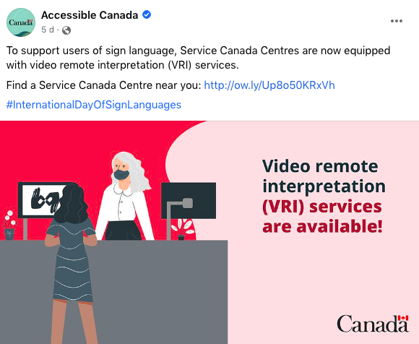

However, it is still too early to collect the Deaf customer’s experience with this newly provided service. This is significant because Service Canada also falls under federal jurisdiction.

The project director decided to try the local Service Canada centre at 855 Meadowlands Drive East, which is in west Ottawa, on November 21, 2022. His experience was mixed. It was very crowded that day, and still required masks although no provincial or federal agencies or businesses in Ontario were legally required to enforce a mask mandate. The masks made it more difficult for this project director to communicate.

Because it was crowded, it was hard to evaluate the video remote interpreting on its own merits without it being influenced by other irrelevant factors. The project director had to wait 45 minutes in line, before advancing to the front to get service. He asked for information on the Canada Pension Plan, and spent another fifteen minutes waiting for an ideal staff person to be available to answer questions. He left at that point. When the initial 45 minutes ended, and he had a service person, he did get an on-line interpreter on a tablet brought in by the service person (who had to go through the doors to the off-limits offices to get the tablet and took about five minutes out of sight) and the tablet was awkwardly placed, being hand held by the official. The tablet kept moving around, being held, so the project director asked for a desk, which was available among a cluster of desks available in the main lobby for the public to use. The on-line interpreter represented her agency as being Sign Language Interpreting Associates Ottawa Inc. The video quality and speed were sufficient.

However, since the official was not trained to answer questions about the Canada Pension Plan (despite the sign for the line-up saying Canada Pension Plan inquiries) the project director, as mentioned above, had to wait another fifteen minutes for a better matched staff person before giving up and walking out.

Another note related to this visit is that the Service Canada graphic showed the interpreter on-line on a swivel-type monitor, but the staff during this visit elected to use a tablet instead. No reason was sought or provided for this discrepancy.

The project director tried again, many months later, on February 14, 2023. The visit the second time was much better, yet still more improvements were needed.

For once, the service centre (same one, Service Canada at 855 Meadowlands drive East in Ottawa) was much quieter, with only a few people in each lineup, and the seating (waiting) area for other categories of service less than half full. When the project director went into the Canada Pension Plan line-up, he was the only one in the line-up. Despite this, it took five minutes to get attention, since there were two other short line-ups in front of the main service desk (each line-up was roped off).

The waits were frustrating. When he got served after five minutes of waiting, he asked for an interpreter. Yet, it took ten minutes for staff to match him with an another official. Same as before, the first staff person disappeared through the double doors to the interior offices (off-limits to the public) and did not emerge again (neither did this staff person emerge again for any other clients) for the ten minutes.

The project director was escorted to a seat on another side of the lobby where there was a row of cubicles where officials worked, one per cubicle, with plexiglass shields for the semi-open space between the seated official and the sitting client. Each cubicle was walled off and had a desk and computer, but the clients remained in the open, one seat opposite each cubicle. The plexiglass window, facing the public, featured a small paper (printed) banner of about three inches height and nine inches width, showing the typical sign language interpreter logo (i.e. two hand silhouettes with opposite rotations) and the terms “ASL / LSQ” in red. The project director did not remember to check if the other booths for sit-down clients also featured this ASL / LSQ banner on their shields, or if this booth was the only one to have this.

The official asked the project director what he wanted to know about Canada Pension Plan. The project director, a little annoyed, asked if the interpreter service was available. The official wrote on a notepad, “My colleague is getting an interpreter.” If it were another unknowing Deaf client, he or she would have thought a sign language interpreter was on the premises and ready to start soon. However, the project director knew that it would be on-line.

After five minutes of waiting, the official wrote on the notepad to the project director, “Your SIN please.” (social insurance number) The project director wrote back, “I am still waiting for the interpreter.”

The official wrote back, “The tablet is charging.” Then the project director finally discovered the tablet was the only device available for the on-line interpreting, and was impatient to learn that the office had not bothered to have an adequately charged tablet (or even more than one tablet) to be ready for any Deaf client walking in.

After ten more minutes (fifteen minutes total since the project director sat down for specialized, individual service) another staff person finally brought in a tablet to the official. Awkward moments ensued, since the staff person tried to angle, from about ten feet away from the project director, behind the desk and standing behind the official, the tablet so that it faced the project director—and through the plexiglass too, with all its glare. Visibility was poor for both the project director and the on-line interpreter at that point. Finally, the project director motioned to have the tablet brought to him. (The interpreter was already on-line on the tablet, waiting to serve). The project director took the tablet through the four-inch gap under the plexiglass shield and propped it up on his own side, facing him, propped up with its back resting against the plexiglass. Then, the eye-to-eye contact between the on-line interpreter and Deaf client seemed adequate. Again, this interpreter was from Sign Language Interpreting Associates Ottawa Inc.

The project director, frustrated that it took him fifteen minutes from sitting down to getting on-line interpreter service, wrote a note, “Why can’t you use your computer monitor for the on-line interpreter service and pivot the monitor toward me?” (The monitor was propped up by a post on one side, and was easy to swivel). The official wrote back, “We are not allowed to show our computer screens.” The project director wrote back, “The policy should be changed. The Deaf must have access in different ways.” Had the computer monitor been available as a viewing screen for Deaf clients, the project director wouldn’t have had to wait fifteen minutes. Also, since every cubicle had a computer monitor, this automatically improves availability.

The discussion proceeded smoothly after that. The project director asked about Canada Pension Plan options, got answers through the on-line interpreter, and left after twenty minutes of productive questions and answers since the substantive discussion began. All in all, the project director was able to leave the Service Canada centre about 50 minutes after he walked in. However, only twenty minutes of that were productive. Given that the line-ups were short, and he got attention after five minutes after walking in, and ideally given another five minutes to sit down and get acquainted and start the on-line interpreter connection, it should have been only half an hour total including the twenty-minute discussion.

In both cases, there was no apparent large, overhead, or posted sign or poster announcing the sign language service option. There is a large overhead screen that features ever-changing, static, worded announcements and simple graphics, including a three-second display of this sign language service. It felt like there would be a one-minute complete turnover on the screen to exhaust all the other announcements before returning to the same one. However, it would be hard for any Deaf member of the public, unknowing of such service, to be alerted. Hence, many Deaf persons who walk in a Service Canada centre may be unaware that this option is available. It is unknown if an official inside would readily offer this option if it became apparent a walk-in was Deaf.

## New Bank Initiative

One major Canadian chartered bank (one of the “Big Six”) notified the project director of a new initiative to improve accessibility for Deaf clients. (It already had ongoing accessibility such as on-line, on-demand and queued sign language interpreting available with a click inside branches, among others.) It was as follows;

1. A sign language interpreter window option will be added to the bank’s Microsoft Teams platform and will be shared with any Deaf client upon verification of identity. This sign language window will be fully integrated into the videoconferencing.
2. A new web-based browser will be available to Deaf clients, primarily those who identify as severely hard of hearing, oral Deaf, or Deafened, who prefer to speak for themselves and get live captioning. While many popular videoconferencing platforms such as Zoom or Microsoft Teams nowadays have automatic voice recognition and captioning, this one will be provided by an on-line captionist listening in to the discussions. Having a live professional skilled at transcription ensures close to 100% accuracy.
3. Speaking of captioning, this bank is also seeking to provided queued, on-demand real-time captioning for severely hard of hearing, oral Deaf, and Deafened clients (those who prefer to speak to communicate) who are inside the branch, without the need to book ahead. This would be essentially the same paradigm as the on-line, queued sign language interpreting like Language Line.
4. Overall, ongoing accessibility will be improved for Deaf clients, such as branch training programs on accessibility, faster response time for booking sign language interpreters, either in person or on-line, committed to one specific meeting (as opposed to queued, on-demand interpreters on-line, who are randomly assigned).

## First Bank to Offer a Dedicated VRS Number

In December, 2022, the Canadian Administrator for VRS (VRS is Video Relay Services) announced that it has partnered with a major Canadian chartered bank, namely TD Bank, to dedicate a VRS number to that bank. That may resolve one ongoing issue, namely the refusal of businesses to accept relay calls where confidential information is required to serve the Deaf client. In establishing a VRS number, this bypasses the concern by banks over the intention of the person making the relay call, since it is certified that a direct VRS number to another VRS number already establishes that it is a federal, regulated, and professionally run and recognized agency that is actually making the call on behalf of the Deaf person.

In turn, CAV always screens its Deaf applicants for identity when they first apply for a VRS number. In adopting an institutional VRS number, the bank ensures that the client is already screened to some degree by a trusted relay organization. Therefore, there are two sets of screening which satisfy the bank. One, the Deaf caller is already screen as to identity by the CAV, and has his or her own VRS number, which lasts for years. Secondly, the VRS connection is a secure one, so the bank also knows it is VRS calling and not anyone else.

While all this deliberation and effort sounds commendable, there are also several Deaf people who feel that such screening is unnecessary and still cumbersome. For one thing, not all Deaf people use VRS. Some use Internet Protocol relay, which is text-based. Secondly, many Deaf may feel they are still discriminated by any screening that is different from those for hearing clients who call. Hearing people can call the bank directly, and must answer security questions such as name, date of birth, and account number, and perhaps any other security questions such as date of last transaction or amount, or a part of their social insurance number. Deaf people feel that it should be no different for them. In their view, if they can answer such security questions, even through a relay operator, then that should be enough. After all, even a relay operator would hardly know such detailed security information, and also, impostors can pretend to be other people and also give the correct security information, if they obtained this information through hacking, so even hearing callers are not 100% verifiable. Call centre operators or staff of a business like a bank are hardly expected to remember and identify a distinct voice pattern of a caller, so recording it as evidence hardly prevents fraud from happening in the first place.

Despite all these technical discussions over what is the best way to verify confidential information, having a dedicated institutional VRS number is still another good option to have, if only as an additional means to access a bank or other business.

Displayed below is the promotional graphic for the new TD Bank dedicated VRS number.

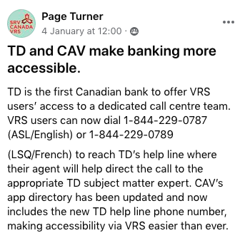

## Unique U.S. Bank Focused on the Deaf

A U.S. bank dedicated to Deaf clients is probably the only one of its kind and is located very close to the only Deaf university in the world, Gallaudet University. It is at Chase bank, located at 501 H St NE, Washington, DC 20002, USA. This was announced around January 2020.  
  
According to the news reports at the time, the branch featured:

* On-demand video remote interpreting service
* T-loop Bluetooth technology that allows employees to speak directly with customers
* Remote control camera technology that allows employees to communicate with customers on screens where they are seated in the branch
* Digital screens with captions enabled
* Six of the branch’s nine employees fluent in American Sign Language (ASL); the other three identify as deaf or hard of hearing
* Visual / light indicators installed to alert deaf / hard of hearing staff when someone has entered secure areas of the branch (teller line, ATM rooms, etc.)

# APPENDICES

## APPENDIX 1 – FIRST DEAF COMMUNITY (ASL) SURVEY

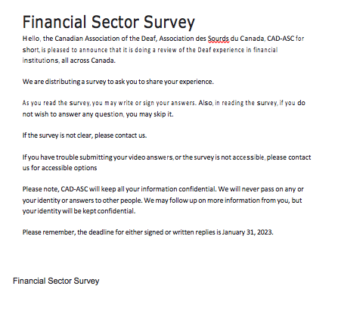

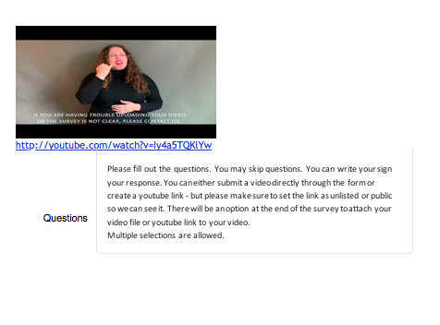

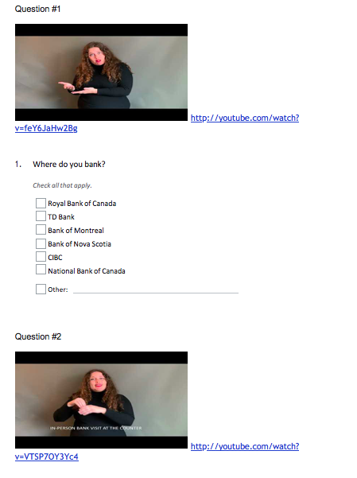

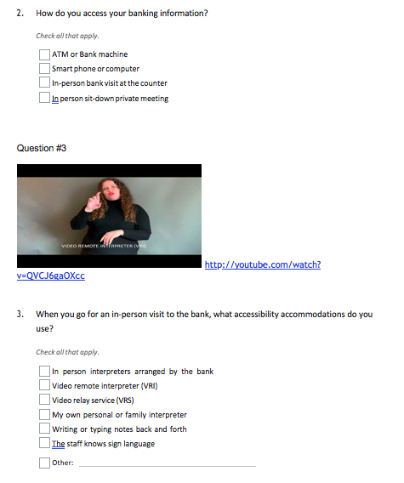

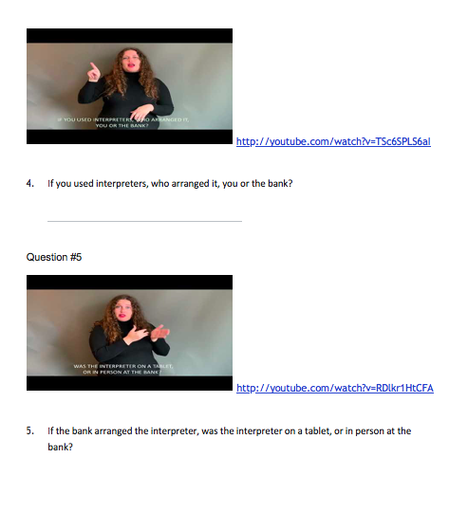

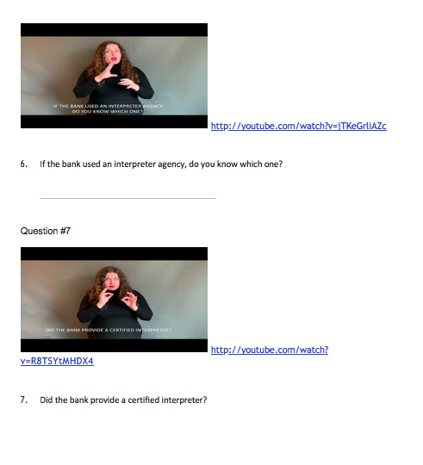

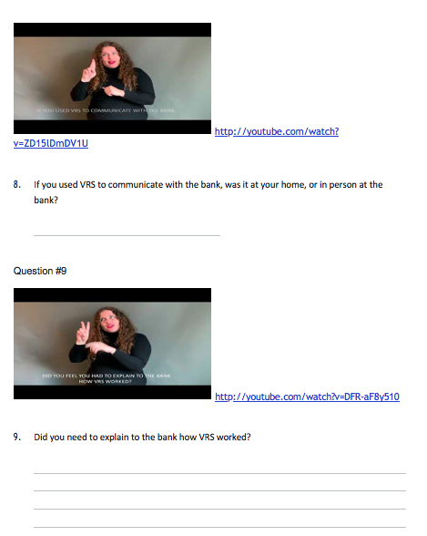

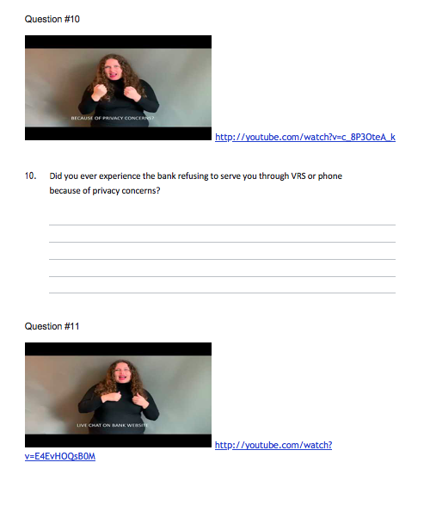

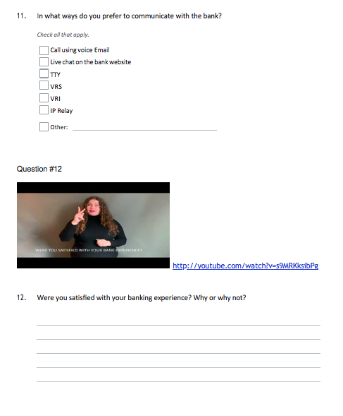

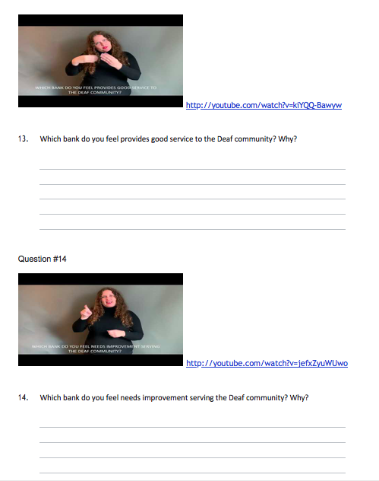



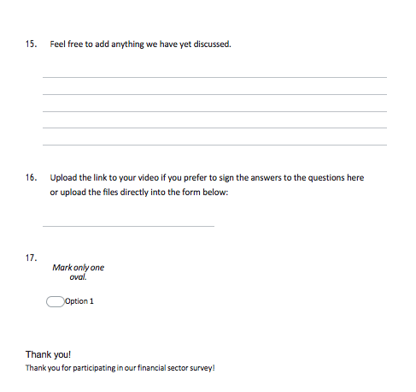

## APPENDIX 2 – FIRST DEAF COMMUNITY (LSQ) SURVEY

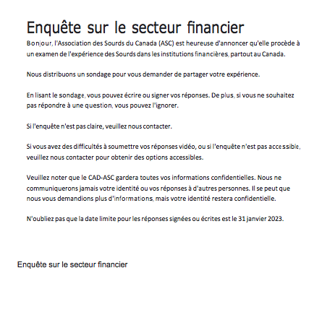

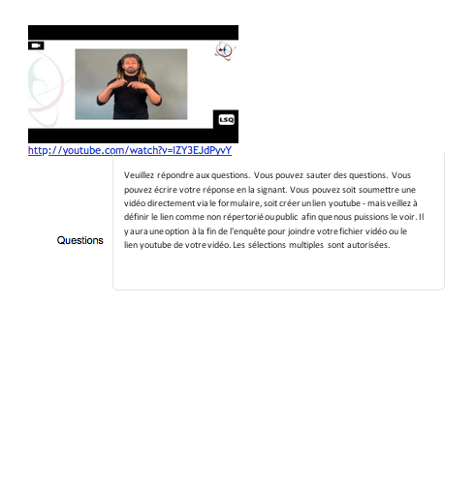

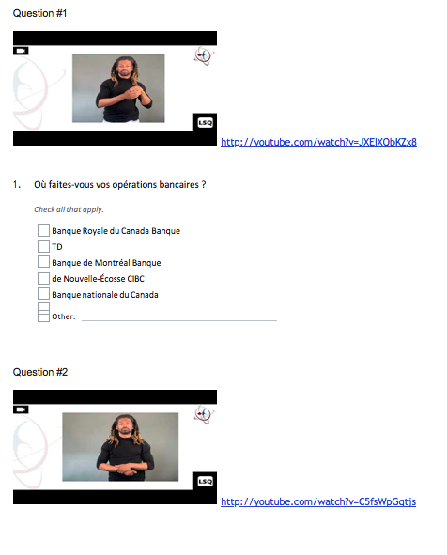

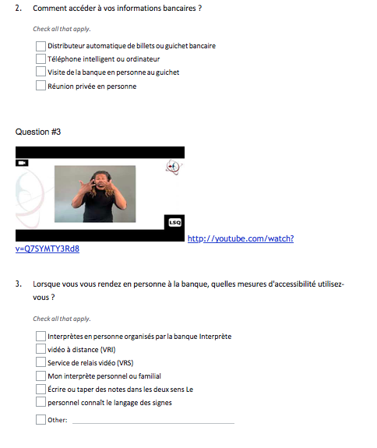

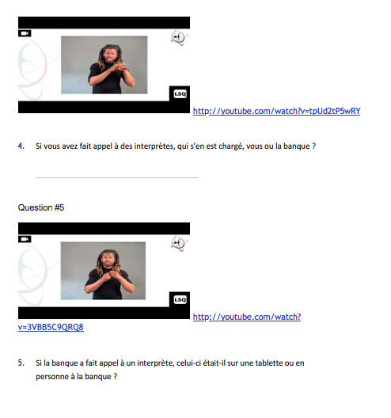

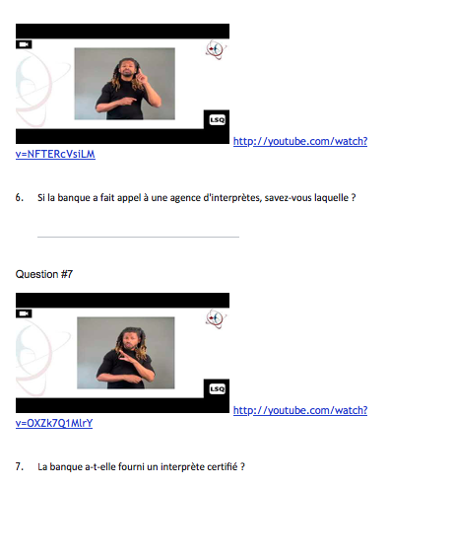

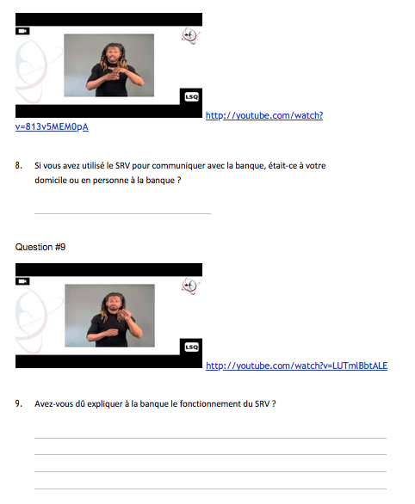

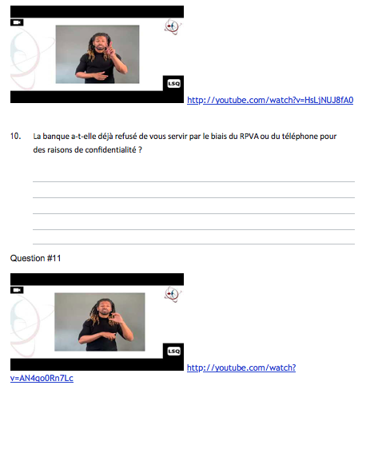

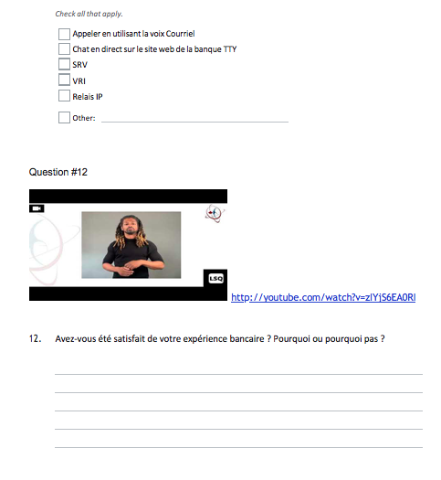

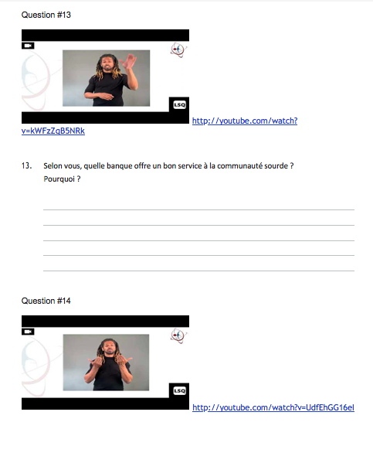

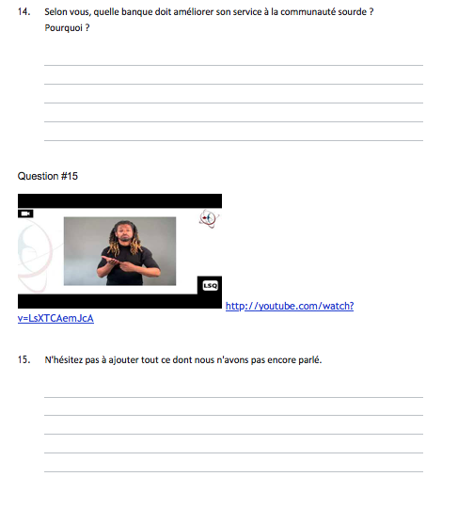

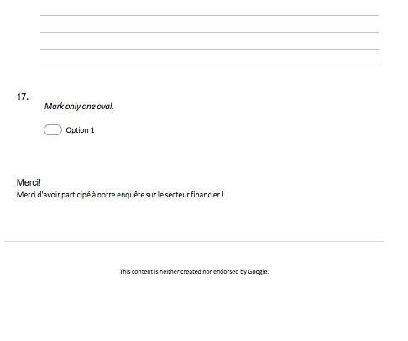

## APPENDIX 3 – SECOND DEAF COMMUNITY (ASL) SURVEY

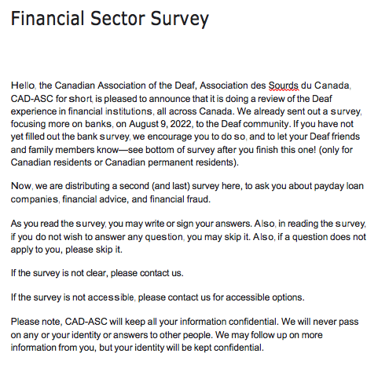

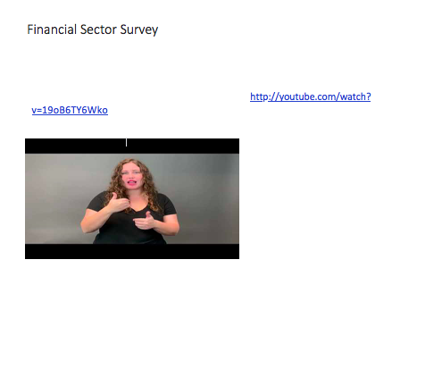

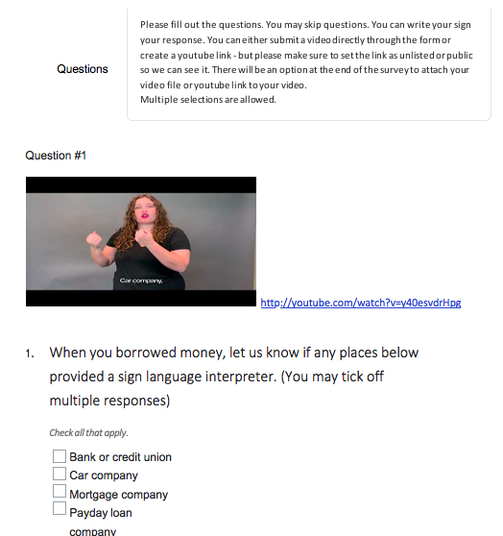

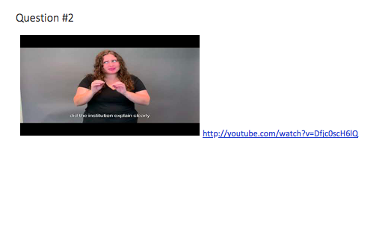

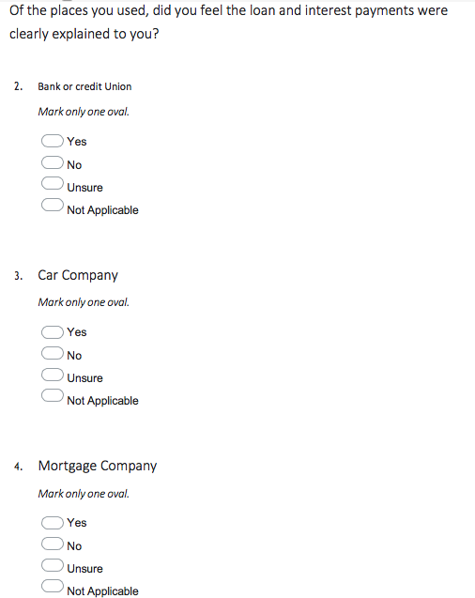

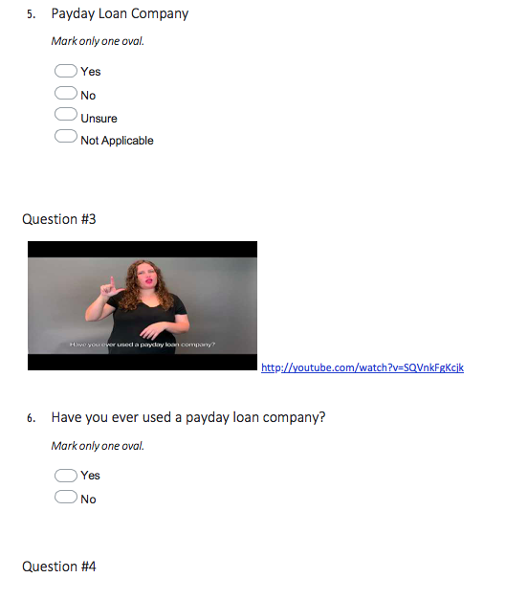

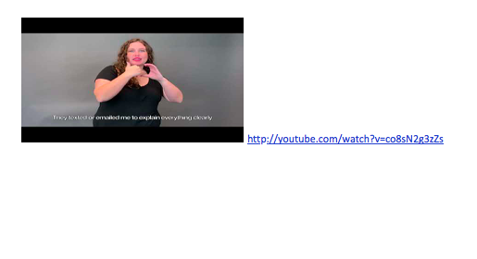

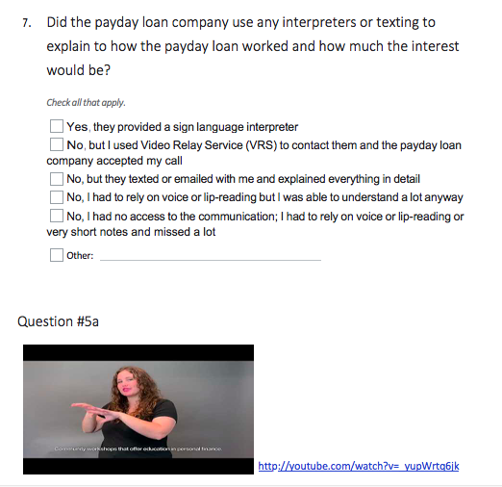

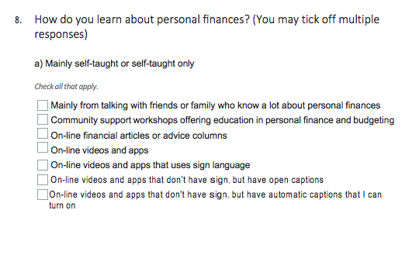

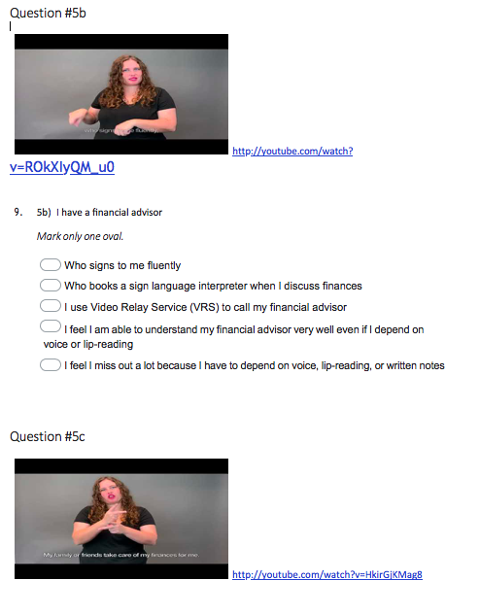

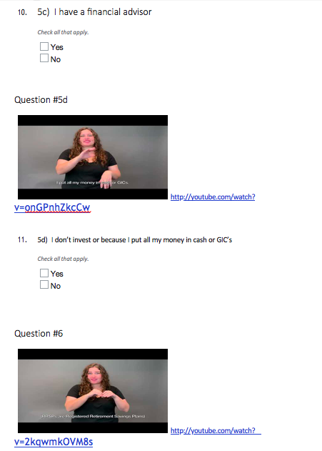

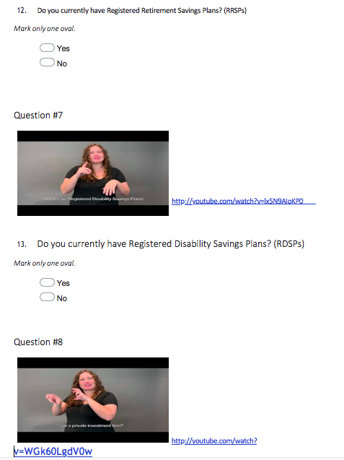

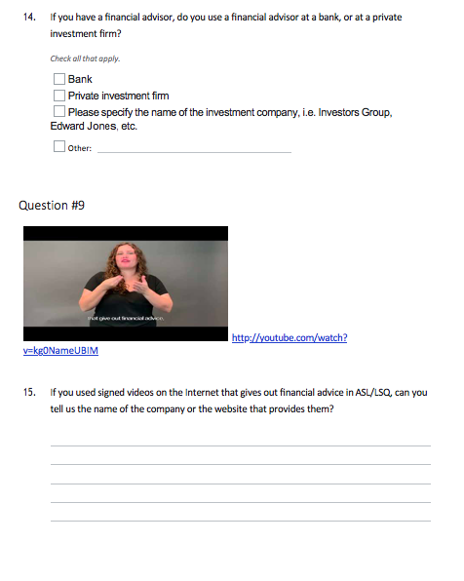

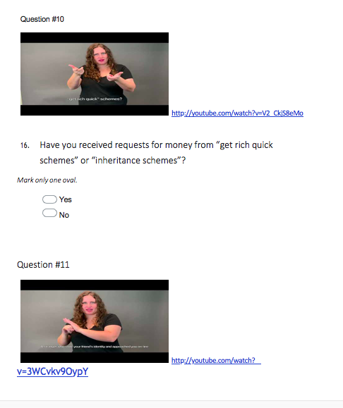

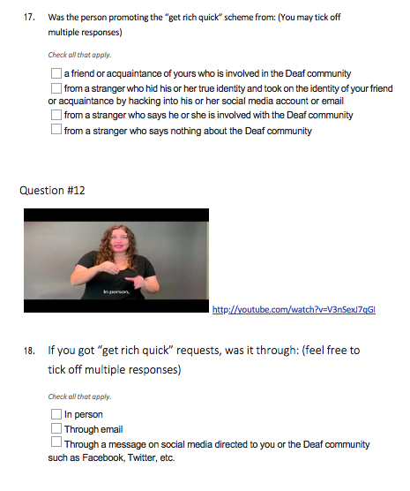

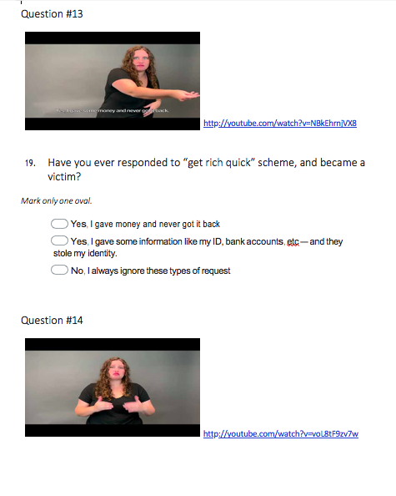

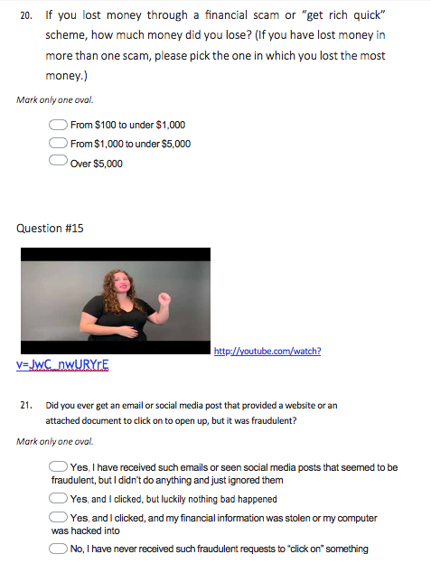

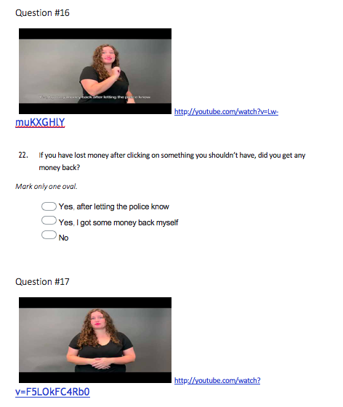

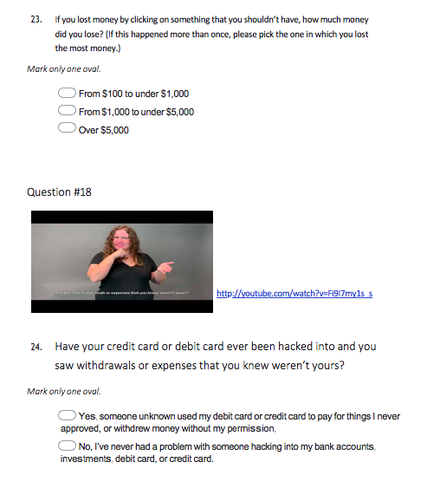

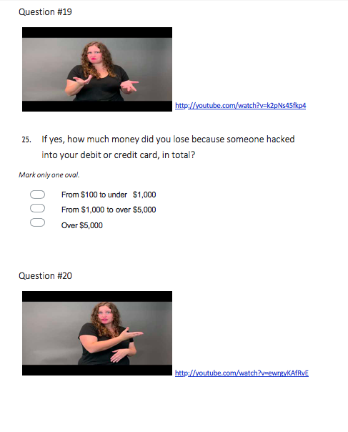

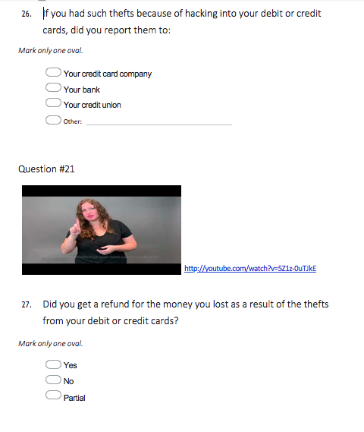

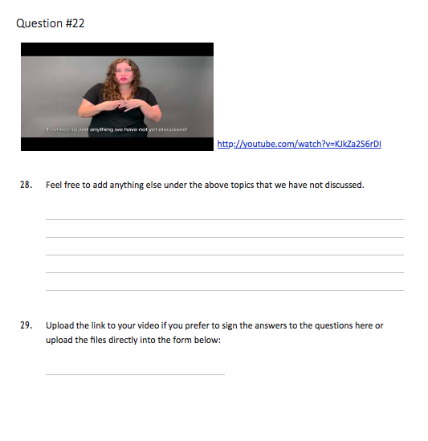

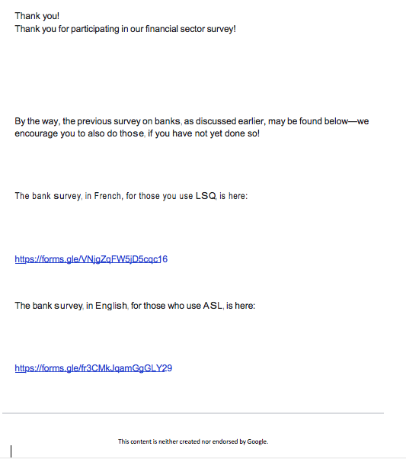

## APPENDIX 4 – SECOND DEAF COMMUNITY (LSQ) SURVEY

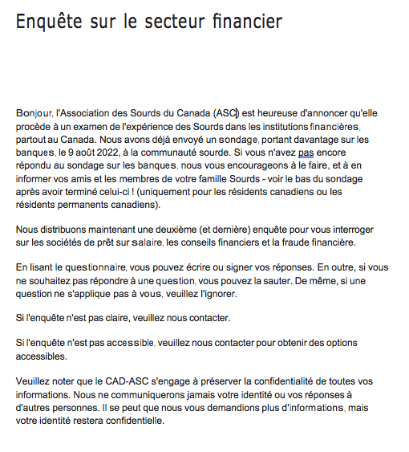

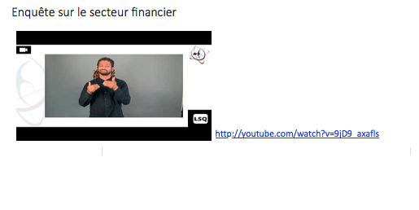

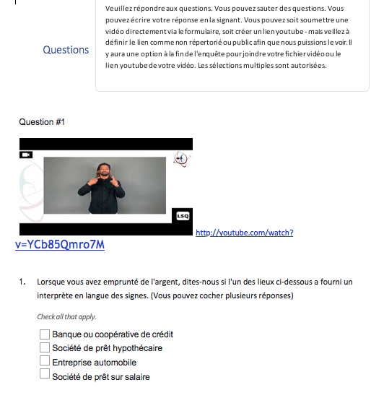

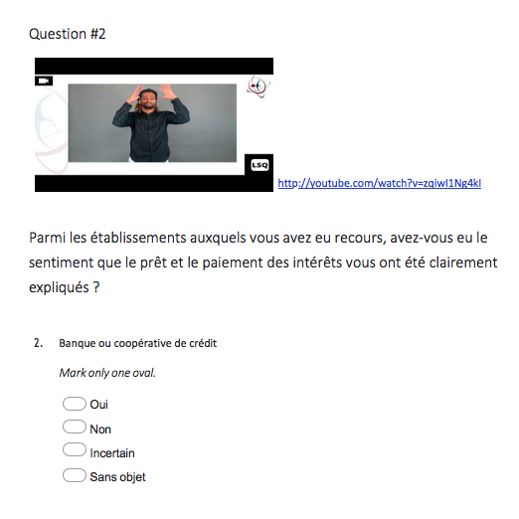

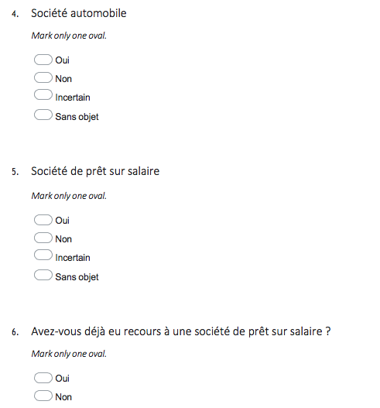

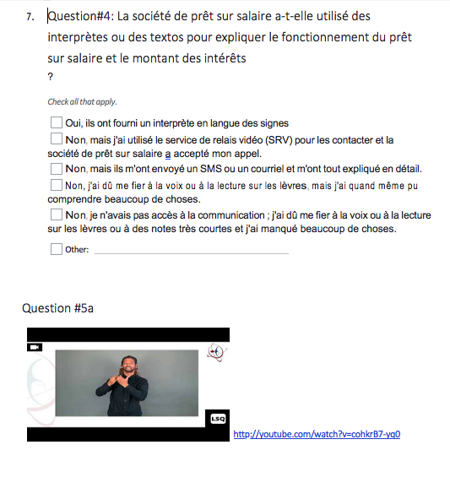

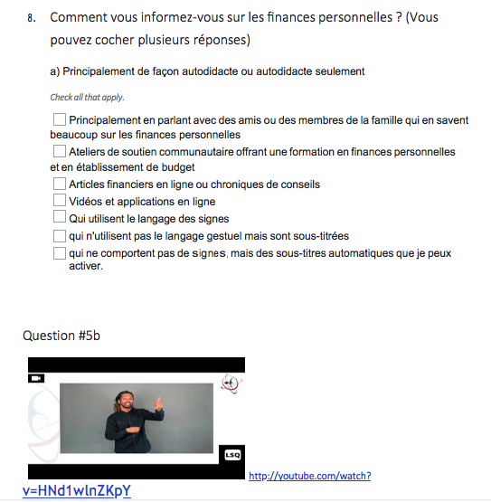



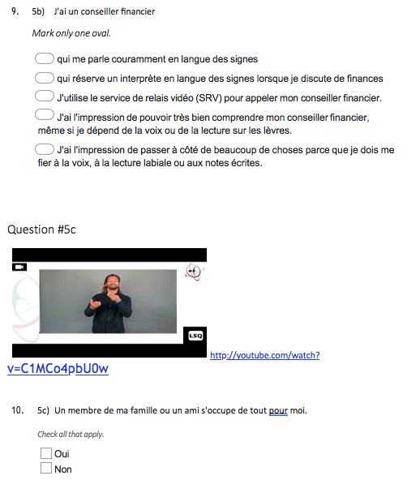

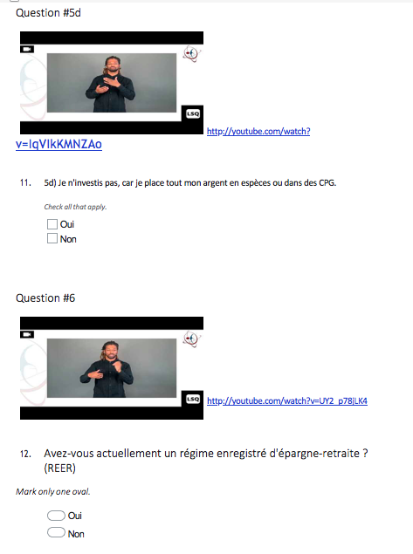

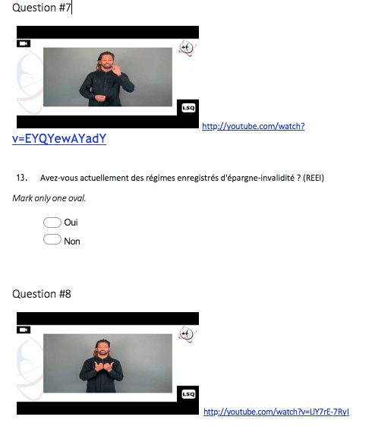

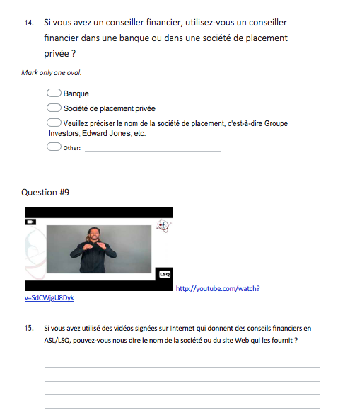

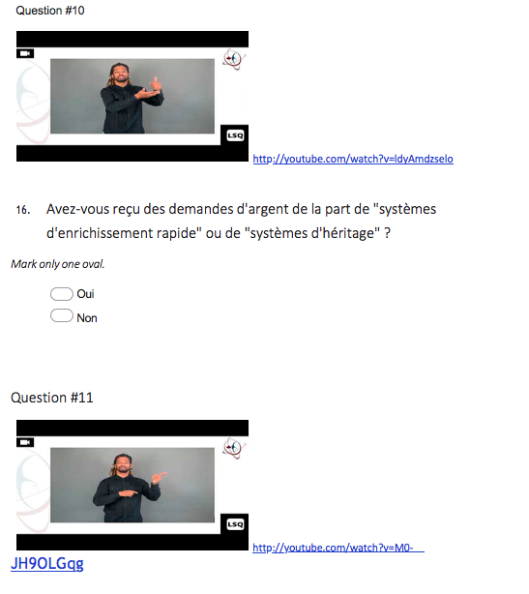

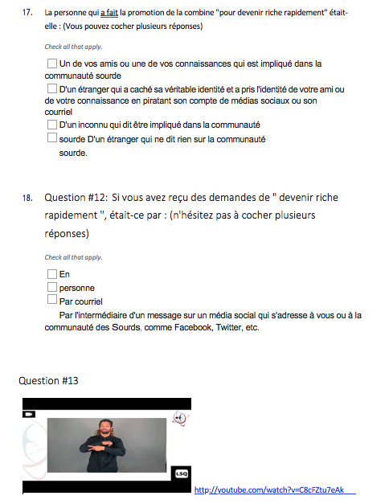

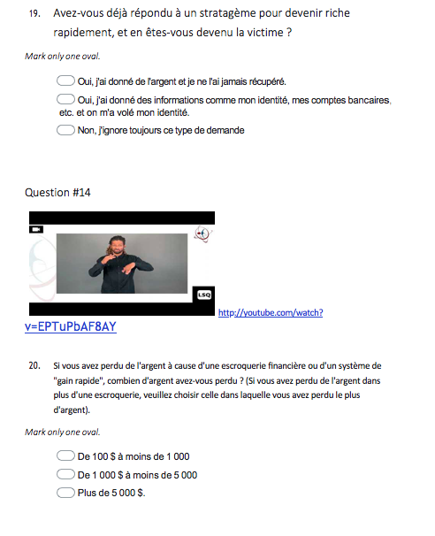

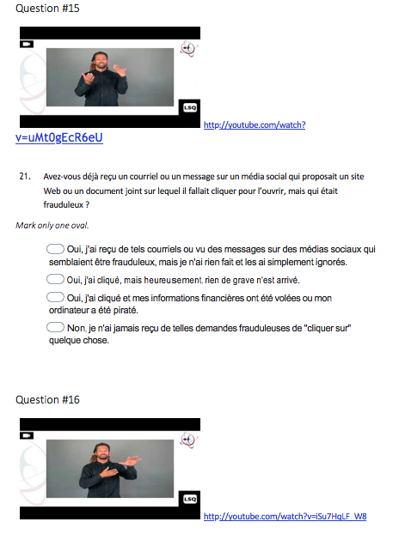

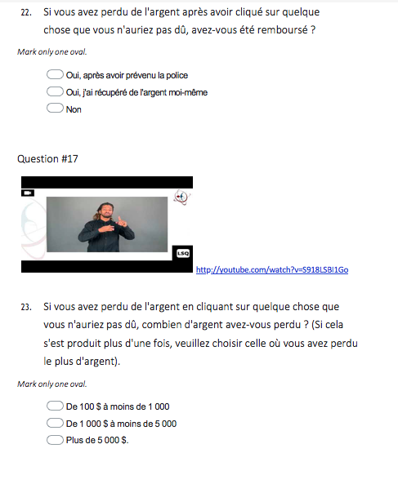

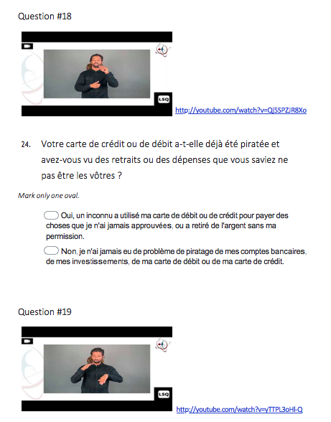

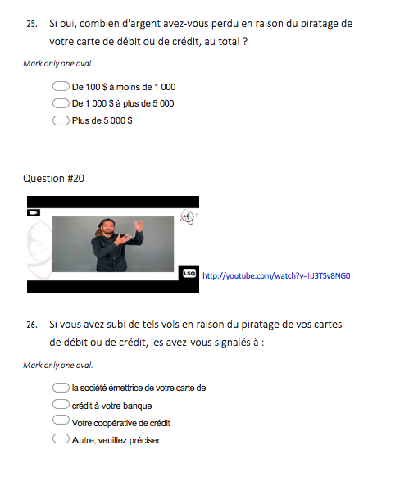

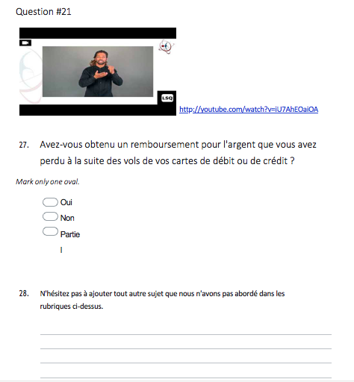

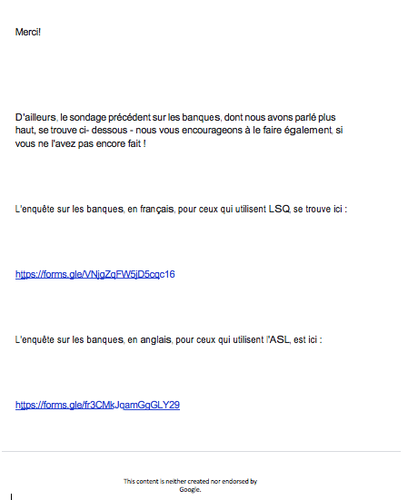

## APPENDIX 5 – DEAF SERVICE AGENCY SURVEY

CANADIAN ASSOCIATION OF THE DEAF—ASSOCIATION DES SOURDS DU CANADA

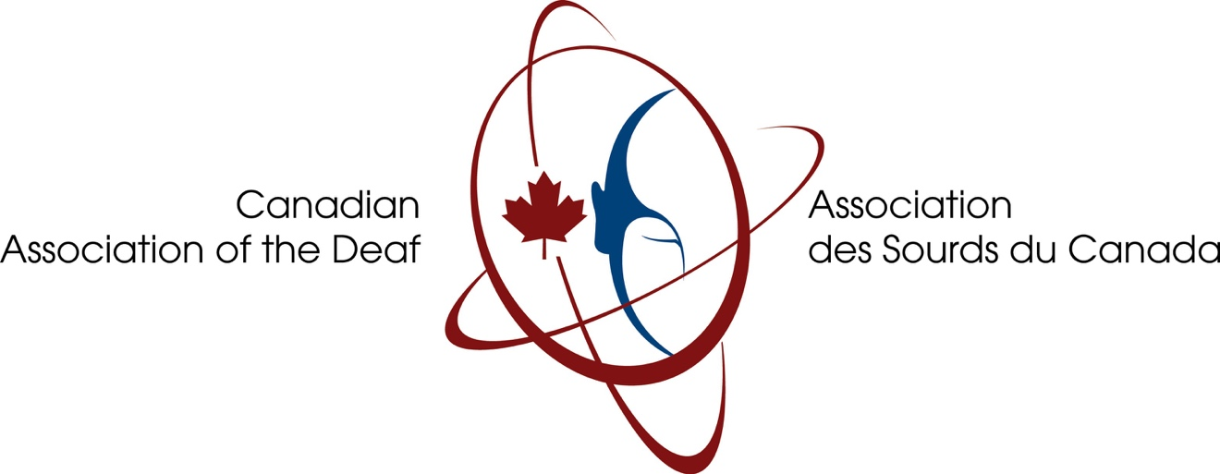

SHORT SURVEY ON FUNDING FOR INTERPRETING COSTS FOR DEAF COMMUNITY’S MEETINGS FOCUSED ON PERSONAL FINANCES

Hello, the Canadian Association of the Deaf - Association des Sourds du Canada, CAD-ASC for short, is pleased to announce that it is doing a review of the Deaf experience in financial institutions, all across Canada.

Here is our project listed on the Government of Canada's website:  
  
<https://ic.gc.ca/eic/site/oca-bc.nsf/eng/ca03106.html>

To that effect, we are doing a short survey related to one main issue: who bears the cost of sign language interpreters for meetings between Deaf clients and financial professionals? We selected your agency because you are one of the agencies in the provinces and territories of Canada that receive government funding for providing sign language interpreter services to the Deaf community.

Thank you for your assistance.

Name of your agency: .

1. If one of the “Big Six” banks (i.e. Royal Bank of Canada, Bank of Montreal, TD Bank, Scotiabank, National Bank of Canada, or CIBC) or a Deaf person calls your agency to request an interpreter, for a meeting between the Deaf client and the bank, whom do you bill?
   1. The cost of the interpreter is provided for free to both the bank and the Deaf client, using the interpreting funds granted by government, without asking who will pay.
   2. We don’t provide this service for free, but we bill the bank if it offers to pay.
   3. If the bank refuses to pay, we ask the Deaf client if he or she can pay, and it is up to the Deaf client to decide to go ahead or not with the appointment.
2. If a Deaf client wishes to book an interpreter through your agency for a meeting with a one-person, or very small professional firm that is part of the financial sector industry (i.e. real estate agent, mortgage broker, investment advisor, real estate lawyer, loan company), whom do you bill?
   1. The cost of the interpreter is provided for free to both the financial services professional and the Deaf client, using the interpreting funds granted by government, without asking who will pay.
   2. We don’t provide this service for free, but we bill the financial services professional if he or she offers to pay.
   3. If the financial services professional refuses to pay, we ask the Deaf client if he or she can pay, and it is up to the Deaf client to decide to go ahead or not with the appointment.
3. If your agency does a screening to determine who will pay for the interpreting because the government funding does not cover all meetings between the Deaf client and the financial sector, does your agency do a quick, proactive review of the size of the financial business or firm offering the service (i.e. one-person real estate law firm, HSBC, Investors Group, five-person real estate group, Edward Jones, Vancity)?
   1. Yes, and if our agency determines the business is small enough, we will use our discretion to allocate the interpreting budget to that meeting, so neither the financial service professional nor the Deaf client has to pay.
   2. No, we always ask the business to pay for the interpreter, and if it refuses, we do not go ahead with booking the interpreter.
   3. No, if we ask the business and it refuses to pay, we ask the Deaf client if he or she wishes to pay. If neither are willing to pay, we do not book the interpreter.

Any comments you wish to add, please state below.

Thank you! Scott Simser

Project Director

## APPENDIX 6 – BANK WRITTEN SURVEY

**“BIG SIX” CANADIAN CHARTERED BANK SURVEY**

**DEAF ACCESSIBILITY IN THE FINANCIAL SECTOR**

**

Thank you for agreeing to reply to this important survey conducted by the Canadian Association of the Deaf- Association des Sourds du Canada. The CAD-ASC provides consultation and information on Deaf needs and interests to the public, business, media, educators, governments and others.

This survey is part of a research project[12], conducted by the CAD-ASC, and funded by the Government of Canada through the Department of Industry. This project will explore the experiences of deaf consumers in the financial sector to better understand the level of accessibility available to deaf Canadians in both in-bank and online banking services.

While we have already been in touch with you and we are collaborating on getting public, positive information from all the “Big Six” Canadian chartered banks out to the Deaf community in Canada, this survey is also an essential component.

For this project, your responses will be aggregated and combined into the final public report, so that your response cannot be discerned individually. We may publish the names of the “Big Six” Canadian chartered banks and the formal titles of the accessibility (or diversity and inclusion) departments in such banks to give some broad overview of the infrastructure in accessibility for Deaf Canadians~~.~~

In this survey, we ask for names of third-party agencies such as sign language interpreting agencies. While we may publish such names of third parties in our final report, we will not match them to any bank, but rather as convey as information in regard to the scope of the market that is widely available to banks and other financial institutions to tap into for accessibility needs.

Thank you.

Kindly complete and return this survey by January 31, 2023, or earlier at your convenience.

While you do not have to answer all questions, we encourage you to answer as many as possible, since more information will directly help the Deaf community and the financial service sector.

A reminder that this survey only applies to operations in Canada. You do not need to answer for any foreign nations in which your bank offers services.

1. Please identify your bank here.
2. Which corporate department would be responsible for setting the national policies and establishing protocols for access for Deaf customers (namely, those who sign) in-person at the bank branches?
3. What corporate department designs on-line (digital) accessibility or apps for Deaf customers who sign?
4. What is the policy for the Deaf in-person banking experience?
   1. Do all your branches offer the same service?
   2. If your bank enforces this accessibility through selected branches, can you tell us what fundamental criteria your bank uses to pick those branches?
   3. If your bank selects certain branches for the enhanced accessibility for Deaf customers, but not all, how would a Deaf person know this?
5. Where or how does the bank advertise this policy to the public?
   * 1. On its website, please provide this website address
     2. In paper-based posters or brochures provided inside the branches
6. If a Deaf customer were to request access in person, does the branch offer:
   1. In house staff who are Deaf and sign
   2. In house staff who can sign
   3. In house tablets with video remote access to
      1. Deaf staff who sign, assisting the Deaf walk-in client
      2. Staff who can sign, assisting the Deaf walk-in client
      3. ASL[13] Interpreters
      4. LSQ[14] interpreters
   4. Automatic captioning feature through on-line applications
   5. Other, please describe
7. If a Deaf customer were to request sign language interpreters for a meeting (i.e. loan application), who would be expected to pay?
   1. The Deaf customer who made the request,
   2. A Deaf service agency or charity that has its own funds for providing interpreters to the local Deaf community, so neither the Deaf customer nor the bank would pay
   3. The branch, from its own operating funds
   4. The bank’s centralized accommodation fund through the branch’s notification
8. If a Deaf customer wishes to book ahead with advance notice for a meeting and asks the bank to do the booking:
   1. How does he or she contact your bank to request this accessibility option?
   2. How many weeks notice is typically required?
9. Who pays for the following access provided:
   1. Interpreters: i) Branch ii) Corporate
   2. Tablets i) Branch ii) Corporate
   3. VRI[15] contract i) Branch ii) Corporate
   4. CART[16] i) Branch ii) Corporate
10. Do the funds for design of digital accessibility for Deaf Canadians come from within the general corporate information technology budget, or from a separate budget for accessibility?
11. Could you send us the organizational structure chart for the bank, with position titles for the chief executive officer and vice-presidents, as well as (as the only in-depth “branch” or offshoot on the chart) the position titles of the department heads you identified as responsible for accessibility policy and budgeting for Deaf customers who sign?
12. What accessibility services/tools does your bank offer Deaf customers?
    1. sign language interpreter arranged and hired by the bank, attending in person at the branch
    2. on-line sign language interpreter arranged and hired by the bank for a Deaf customer’s in-person visit at the branch
    3. bank-owned electronic devices (i.e. tablet) shared between bank staff and Deaf customers during the visit for:
       1. texting
       2. link to sign language interpreter working remotely (i.e. Language Line)
    4. bank-designed software platform for:
       1. on-line texting on the bank-owned devices (i.e. tablet) shared between staff and the Deaf customer in-person for the duration of the branch visit
       2. remotely through the Deaf customer’s personal smartphone or personal computer through:
          1. a bank-designed website
          2. a bank-designed app that can be downloaded by the Deaf person
13. If your bank uses sign language interpreters that charge a fee for services, (either in-person or on-line) where do you get them from?
    1. Canadian Hearing Services
    2. Convo Relay
    3. Sign Language Interpreting Association Ottawa
    4. Wavefront Centre for Communication Accessibility
    5. Ontario Association of Sign Language Interpreters
    6. Deaf and Hear Alberta
    7. Society of Deaf and Hard of Hearing Nova Scotians
    8. Sorenson Communications
    9. In-house interpreter list maintained by the bank
    10. Other, please provide the name
14. Does your bank use a national publicly funded on-line resource like Video Relay Service Canada for Deaf customers communicating remotely?
15. What accessibility does your bank offer to Deaf customers, or to Deaf members of the public, when browsing your bank’s website?
16. If your bank’s website has a Live Chat feature, does the Live Chat feature have any built-in sign language options?
    1. Yes
    2. No
    3. If yes, at what levels
       1. Website Entry point
       2. Only after member sign-in and includes detailed personal financial discussions
17. The Deaf community has brought up occurrences in recent months and years where, like government departments and other major business corporations, bank staff from Canada’s six major banks have declined to accept telephone or video relay calls from Deaf people inquiring about their personal finances. In such cases, the bank staff explain that they only accept direct calls, saying third-party intervenors (like sign language interpreters) are not allowed due to confidentiality reasons.

We at the Canadian Association of the Deaf are aware that several chartered bank websites have stated that they do accept relay calls from the Deaf, however, some bank staff did not know about this policy, and still declined calls about personal finance from Deaf customers, stating confidentiality reasons. 

* 1. Does your bank accept calls from third-party intervenors such as sign language interpreters calling on behalf of Deaf customers who wish to discuss confidential financial information?
     1. If no, does your bank offer a dedicated alternative to Deaf customers, ready to go before ending the initial call, so as to enable a seamless transition to a confidential discussion, such as:
        1. Live Chat feature
        2. Live texting option
        3. On-line sign language interpreting
        4. To third-party intervenor approval forms to be filled out and submitted during the call
  2. Does your bank tag phone calls from identified telephone relay companies in Canada as being automatically pre-approved for clearance as to privacy and confidentiality? (i.e. the national publicly-funded Canada Video Relay Services)

1. Does your bank have any pre-recorded videos on its website that display sign language, explaining your bank and its services to Deaf customers?
2. Does your bank have, and features on its bank website:
   1. a dedicated in-house phone number that is only for accessibility and goes to a live bank employee
   2. bank web form for accessibility requests (and not through a general web form for all inquiries from anyone)
   3. bank’s in-house email address designed only for Deaf customers to book sign language interpreters, real-time captioning, or to inform of other access needs

For each affirmative answer, please specify:

* the bank website address that publicizes this:
  + phone number
  + web form
  + email address
* the phone number itself, and if it is toll-free or local (if local, please specify the phone numbers by province, region, or city, depending on how the bank determines its phone services)
* the email address itself

1. Does your bank offer and pay for, in the case of Deaf customers who choose to speak using voice, but identify as needing text-based access rather than sign language:
   1. Live captioning, either in person or on-line, through a real-time captioning professional listening to the discussion?
   2. Bank-generated on-line meeting links using video conferencing software platforms, such as Zoom, Webex, Microsoft Teams, or Skype, allowing such Deaf customers to rely on the automatic captioning feature that captures the spoken words of your bank staff?
   3. In either case above, does your bank publicize these options on its website?
2. Very recently, it has come to our attention that for some banks, when a credit card (i.e. Visa, Mastercard) is issued to a customer, verification has been changed by requiring a voicemail activation, rather than a text or email as in the past. This greatly disadvantages Deaf customers, because not only they cannot understand the voicemail verification message, but also phone calls by the Deaf using Video Relay Service (VRS) or IP[17] Relay are useless, since the verification message is sent directly and automatically to the customer. Can you advise us if your bank is using, or plans to use, voicemail as the only verification method for its credit cards, and if so, how can your bank ensure that Deaf customers can verify their credit cards? (Please note: the credit card companies have said that access is the bank's responsibility for credit cards issued under the bank—they refer to the “client financial institutions, the banks.”)
3. Please feel free to add anything we haven’t yet covered in this survey. And thank you!

## APPENDIX 7 – CREDIT UNION SURVEY

**CANADIAN CREDIT UNION SURVEY**

**DEAF ACCESSIBILITY IN THE FINANCIAL SECTOR**

**

Thank you for agreeing to reply to this important survey conducted by the Canadian Association of the Deaf- Association des Sourds du Canada. The CAD-ASC provides consultation and information on Deaf needs and interests to the public, business, media, educators, governments and others.

This survey is part of a research project[18], conducted by the CAD-ASC, and funded by the Government of Canada through the Department of Industry. This project will explore the experiences of deaf consumers in the financial sector to better understand the level of accessibility available to deaf Canadians in both in-branch and online banking services at Canada’s largest credit unions.

For this project, your responses will be aggregated and combined into the final public report, so that your response cannot be discerned individually.

In this survey, we ask for names of third-party agencies such as sign language interpreting agencies. While we may publish such names of third parties in our final report, we will not match them to any credit union, but rather as convey as information in regard to the scope of the market that is widely available to credit unions and other financial institutions to tap into for accessibility needs.

Thank you.

Kindly complete and return this survey by January 31, 2023, or earlier at your convenience.

While you do not have to answer all questions, we encourage you to answer as many as possible, since more information will directly help the Deaf community and the financial service sector.

A reminder that this survey only applies to operations in Canada. You do not need to answer for any foreign nations in which your credit union offers services.

1. Please identify your credit union here.
2. What accessibility services/tools does your credit union offer Deaf customers?
   1. sign language interpreter arranged and hired by the credit union, attending in person at the branch
   2. on-line sign language interpreter arranged and hired by the credit union for a Deaf customer’s in-person visit at the branch
   3. credit union-owned electronic devices (i.e. tablet or mounted monitor on desk capable of being rotated to face the Deaf customer) shared between credit union staff and Deaf customers during the visit for:
      1. texting
      2. link to sign language interpreter working remotely (i.e. Language Line or Convo or Canadian Hearing Services)
   4. credit union-designed software platform for:
      1. on-line texting on the credit union-owned devices (i.e. tablet) shared between staff and the Deaf customer in-person for the duration of the branch visit
      2. remotely through the Deaf customer’s personal smartphone or personal computer through:
         1. a credit union-designed website
         2. a credit union-designed app that can be downloaded by the Deaf person
3. If your credit union uses on-line sign language interpreting on its tablets or mounted monitors capable of being rotated, is this on-line interpreting:
   1. Available on demand, upon a click, since the sign language interpreter agency uses a roster of sign language interpreters remotely in a queue, and it does not matter if the Deaf customer arrives without notice, or what time the Deaf customer arrives or finishes the conversation, even if only for five or ten minutes of conversation, or
   2. Booked ahead of time, with a specific start time and finish time expected of a specific Deaf customer who had requested any interpreter ahead of time, usually with a specific interpreter pre-arranged to go on-line by the sign language interpreter agency after availability of such name is determined by the agency.
4. For option 13(a) above, where the interpreter agency offers anytime, on-demand interpreting at the click on the screen without advance notice, is this interpreting agency:
   1. Convo
   2. Language Line
   3. Canadian Hearing Services
   4. Sign Language Interpreting Associates Ottawa Inc. (national service) (SLIAO)
   5. Service d'interprétation visuel et tactile (SIVET)
   6. Interprétation signes et paroles Inc. (ISEP)
   7. Other, please specify
5. If your credit union uses sign language interpreters that charge a fee for services (either in-person in the credit union branch, or on-line in the case of pre-arranged start time, with a specific interpreter picked by the agency) where do you get them from? (i.e. not in the case of being available anytime with the “click” on a screen, with no advance notice).
   1. Canadian Hearing Services
   2. Convo Relay
   3. Sign Language Interpreting Association Ottawa
   4. Wavefront Centre for Communication Accessibility
   5. Ontario Association of Sign Language Interpreters
   6. Deaf and Hear Alberta
   7. Society of Deaf and Hard of Hearing Nova Scotians
   8. Sorenson Communications
   9. In-house interpreter list maintained by the credit union
   10. Other, please provide the name
6. Does your credit union accept calls from a national publicly funded on-line resource, like Video Relay Service Canada, for Deaf customers communicating remotely?
7. The Deaf community has brought up occurrences in recent months and years where, like government departments and other major business corporations, staff from Canada’s credit unions have declined to accept telephone or video relay calls from Deaf people inquiring about their personal finances. In such cases, the credit union staff explain that they only accept direct calls, saying third-party intervenors (like sign language interpreters) are not allowed due to confidentiality reasons.

We at the Canadian Association of the Deaf are aware that several chartered bank websites, for example, have stated that they do accept relay calls from the Deaf, however, some bank staff did not know about this policy, and still declined calls about personal finance from Deaf customers, stating confidentiality reasons. 

* 1. Does your credit union accept calls from third-party intervenors such as sign language interpreters calling on behalf of Deaf customers who wish to discuss confidential financial information?
     1. If no, does your credit union offer a dedicated alternative to Deaf customers, ready to go before ending the initial call, so as to enable a seamless transition to a confidential discussion, such as:
        1. Live Chat feature
        2. Live texting option
        3. On-line sign language interpreting
        4. To third-party intervenor approval forms to be filled out and submitted during the call
  2. Does your credit union tag phone calls from identified telephone relay companies in Canada as being automatically pre-approved for clearance as to privacy and confidentiality? (i.e. the national publicly-funded Canada Video Relay Services that serves the Deaf in Canada)

1. Does your credit union have, and features on its credit union website:
   1. a dedicated in-house phone number that is only for accessibility and goes to a live credit union employee
   2. credit union web form for accessibility requests (and not through a general web form for all inquiries from anyone)
   3. credit union’s in-house email address designed only for Deaf customers to book sign language interpreters, real-time captioning, or to inform of other access needs

For each affirmative answer, please specify:

* the credit union website address that publicizes this:
  + phone number
  + web form
  + email address
* the phone number itself, and if it is toll-free or local (if local, please specify the phone numbers by province, region, or city, depending on how the credit union determines its phone services)
* the email address itself

1. Does your credit union offer and pay for, in the case of Deaf customers who choose to speak using voice, but identify as needing text-based access rather than sign language:
   1. Live captioning, either in person or on-line, through a real-time captioning professional listening to the discussion?
   2. Credit union-generated on-line meeting links using video conferencing software platforms, such as Zoom, Webex, Microsoft Teams, or Skype, allowing such Deaf customers to rely on the automatic captioning feature that captures the spoken words of your credit union staff?
   3. In either case above, does your credit union publicize these options on its website?
2. Very recently, it has come to our attention that for some credit unions, when a credit card (i.e. Visa, Mastercard) or credit union-issued debit card is issued to a customer, verification has been changed by requiring a voicemail activation, rather than a text or email (or on-line in the customer’s credit union account) as in the past. This greatly disadvantages Deaf customers, because not only they cannot understand the voicemail verification message, but also phone calls by the Deaf using Video Relay Service (VRS) or IP[19] Relay are useless, since the verification message is sent directly and automatically to the customer. Can you advise us if your credit union is using, or plans to use, voicemail as the only verification method for its credit cards, and if so, how can your credit union ensure that Deaf customers can verify their credit cards? (Please note: the credit card companies have said that access is the credit union's responsibility for credit cards issued under the credit union—they refer to the “client financial institutions.”)
3. Please feel free to add anything we haven’t yet covered in this survey. And thank you!

# APPENDIX 8 – TRANSCRIPT OF CALL WITH A DEAF CLIENT AND BANK

IP Relay Call with – Transcript

10:17:56 - RELAY SERVICE: Bell IP Relay Service, this is operator RELAY SERVICE, my name is XXXX GA[20]

10:18:06 - RELAY SERVICE: (one moment please)

10:18:47 - RELAY SERVICE: Please enter your card number. GA

10:19:14 - DEAF CLIENT: XXXX XXXX XXXX XXXX ga

10:19:48 - RELAY SERVICE: Thank you, please hold...

10:21:56 - RELAY SERVICE: Hi, how may I have your first and last name ? GA

10:22:01 - DEAF CLIENT: XXXXX XXXXX ga

10:23:01 - RELAY SERVICE: Okay, thank you just a moment .. are you calling for your debit or credit card ? GA

10:23:05 - DEAF CLIENT: Credit card. ga

10:25:49 - RELAY SERVICE: Okay .. just a moment I just need to verify a note .. did you already try to visit one of our branches ? GA

10:25:56 - DEAF CLIENT: No, not yet. ga

10:27:18 - RELAY SERVICE: Okay so since .. are you able to go to the branch? Because we have been advised that there is no authorisation in file for a third party because you need to provide a consent form at the branch. GA

10:27:57 - DEAF CLIENT: The relay service is not a third party, it is a communication facilitator. Plus, your own accessibility page on your website specifically says calls are accepted through relay services. ga

10:33:34 - RELAY SERVICE: Just a moment please .. we cannot assist you since we need a consent authorization form, it is a privacy consent form that need to be attached by the branch, so you don't have any authorization consent form, you need to go to the branch first to fill the authorization consent form. GA

10:34:17 - DEAF CLIENT: Why do I need authorization from myself in order to access my own account? It makes no sense and it is discriminatory against me for my disability. ga

10:35:21 - RELAY SERVICE: It's a privacy concern here at XXX we are committed and respect the privacy of our customers, that's why we need the authorization or the consent has to be allowed, you have to allow the person that can assist you for your account. GA

10:35:54 - DEAF CLIENT: I'm trying to access my own account so that I don’t NEED an assistant! You are violating your own policy that SPECIFICALLY says calls are accepted through the relay service. It doesn't say anything about requiring consent forms for the relay service. ga

10:38:23 - RELAY SERVICE: Yes, I understand that you're trying access your own account, but since there is another person (the operator) on the call, we need to get a consent form to be filled to authorize the transmission of information. GA

10:38:32 - DEAF CLIENT: You are violating your own policy that SPECIFICALLY says calls are accepted through the relay service. It doesn't say anything about requiring consent forms for the relay service. ga

10:41:19 - DEAF CLIENT: Goodbye. sksk[21]

Duration: 00:23:23

# APPENDIX 9 – DETAILED BANK VISITS

## Bank #1

Demonstration

This bank chose a sign language interpreter on-line on a tablet screen on its desk in an office where the interview was held. This arrangement was different from other bank visits in that the interpreter was pre-arranged and was chosen for a specific time slot, rather than a team of interpreters in queue available on demand. The interpreter was booked through Canadian Hearing Services. The project director was advised to be aware of the end time of the time slot, so he could finish the “Deaf customer experience” demonstration on time. Hence, there was no “app” to initiate any on-demand interpreter service.

The interpreter was qualified and easy to see on the tablet screen. The office setting was comfortable and free of distractions, and the interpreter easily understood everyone, including watching the project director sign and listening to the bank official.

There was no straightforward option to use a tablet, which the bank had available, but this tablet did not have a built-in foldable flip stand or portable stand to prop it up, as would have been necessary to see the interpreter while sitting down or standing up. Instead, the bank official propped the tablet against her computer monitor, which worked well but this set-up would be left to each bank employee as to how to prop the tablet up each time for a Deaf client.

The project director noted that the bank did not offer, for the pre-arranged meeting, an option for an on-demand, queued interpreter on-line. There are no apps on the bank’s front desk or client meeting office monitors to link automatically to a sign language interpreter on-line upon demand. However, any bank can add this as an option, and this bank may decide to do so in the near future.

Interview Topics

1. Live Chat

With the bank’s Live Chat option on its website, clients do not need a bank account with this bank; the client’s questions will be directed to the right department and a live bank official will correspond with the client. Confidential information cannot be discussed during Live Chat; a customer account with this bank is required, and then verified. Like a typical Live Chat feature, it is all text-based, which is advantageous to Deaf people.

Live Chat is however also available to all bank clients once he or she logs into his or her account; then confidential information can be texted back and forth.

1. Use of Videoconferencing Platforms

This bank uses Microsoft Teams as its main videoconferencing platform. This bank offers a customer (with account) an option to request a meeting from his or her customer profile. Microsoft Teams does allow live captioning, if a Deaf person wishes to speak (or text) and watch the automatic captions. There is also an option for a texting window on the Microsoft Teams platform, where both sides can text each other as well as see each other.

However, since this bank does not yet offer on-demand interpreting, an interpreter must be booked if the Deaf customer wishes an on-line interpreter to join a Microsoft Teams meeting, which can be arranged. Three business days was said to be the standard waiting time to book an interpreter, either on-line or in person.

1. Interpreter Booking Options

Deaf clients may bring their own sign language interpreters; the bank will pay for the interpreter. If a Deaf client requests the bank to provide its own interpreter, the bank requests advance notice of three business days.

The bank maintains an employee intranet; it has an accessibility webpage which gives the names of sign language interpreting agencies. Among the agencies it lists are;

* Canadian Hearing Services
* Sign Language Interpreting Associates Ottawa
* Ontario Association of Sign Language Interpreters
* Saskatchewan Deaf and Hard of Hearing Services

The bank wasn’t able to inform, before the end of the interview, if it had every province covered in its internal list of sign language interpreting agencies. However, it is noted that on-line interpreter agencies can supply interpreters remotely on a national basis.

1. Dedicated Accessibility Department Outreach

The bank confirmed, during the interview, that it had no dedicated email or web form to directly reach the Diversity and Inclusion Department, which also oversees accessibility. The project director pointed out a number on the bank’s website under accessibility information, a 1-877 number to “request an interpreter.” The bank officials at the interview weren’t aware of any specific number to book a sign language interpreters. Upon calling this line through a relay service, the project director discovered that it is the main bank line, and makes no specific mention of accessibility.

1. Other Topics

The bank mentioned it has annual training for all employees in diversity and inclusion and that this training is mandatory. It said for renewing a credit or debit card, it can be done on-line – there is no mandatory voice activation as the sole option, which if required, disadvantages Deaf clients.

Bank staff get frequent updates from the Diversity and Inclusion Department by email. The bank allows members of the public to leave messages on Facebook and Twitter, notifying that there should be no confidential information mentioned in the messages. Then, bank staff will follow up privately with people who have left messages.

The bank branch had enough tablets to pass around to front line staff as required; not every employee has a tablet. However, as previously mentioned, there is no app used by this bank to click onto on-demand sign language interpreting remotely.

The bank confirmed that it will accept relay calls from the Deaf, without the need to add any further layers of verification as to identity any different from other customers.

## Bank #2

Demonstration

When the project director stepped into the meeting office at the bank branch, a tablet was already set up, standing on its folded flip cover, at an angle geared for a comfortable display toward the Deaf client’s face from its position on the table. When the client experience demonstration started, the bank official clicked onto the app for Language Line, an American company providing on-line interpreting on-demand for dozens of languages, (all voice), including a visual sign language, American Sign Language. (British Sign Language is also available).

Within seconds, an on-line interpreter appeared on-screen, ready to start the interpreting. The bank official notified the project director that this app and option to view the interpreter also could be made available, easily, on the swivel-type monitor on the desk. All bank tablets and stand-up monitors have the app.

The interpreter was qualified and easy to see on this tablet screen. The office setting was comfortable and free of distractions, and the interpreter easily understood everyone, including watching the project director sign and listening to the bank official.

However, Language Line does not have a Langue des signes Québécoise (LSQ) option for its French customers who are Deaf. The bank agreed to convey such a concern to Language Line and suggest perhaps for Language Line to someday add it as a language option, however this third party company is independent of the bank.

Interview Topics

1. Live Chat

The Live Chat for this bank is at the customer level only, after verification has been provided once logged in. Like a typical Live Chat feature, it is all text-based, which is advantageous to Deaf people. There is no Live Chat for general members of the public.

1. Use of Videoconferencing Platforms

This bank uses Microsoft Teams as its internal videoconferencing platform, but Webex instead for its customers. The bank advised that not all its branches in rural and small towns have Webex available, because of the lack of high-speed Internet.

Webex does offer automatic captioning, but in general, at the time of writing this report, Webex does not offer as much accuracy or ease of presentation for its automatic captioning, compared to other platforms such as Zoom or Microsoft Teams.

1. Interpreter Booking Options

The bank maintains an employee intranet; which recommends Canadian Hearing Services as the interpreting agency. The intranet readily provides an email address to bank staff for booking an interpreter: interpreters@chs.ca.

One of the bank’s intranet webpages has a very detailed section on how to book a sign language interpreter, for its employees. It speaks of two options; Language Line on the mobile wicket, or in person, which further explains how to reach the Canadian Hearing Services. It also says that Deaf customers who prefer to bring their own interpreters will have these interpreters compensated for their service. (The project director did not see any qualification inserted into the bank policy that the client’s own chosen sign language interpreter must be certified as an interpreter.)

1. Dedicated Accessibility Department Outreach

The bank confirmed that its Diversity and Inclusion Department (which oversees accessibility) sends email and updates regularly to its staff. However, there is no specific publicly displayed accessibility email address, web form, or phone number directly relevant to accessibility queries only.

The bank’s main website offers a 1-800 phone number to book interpreters, however, when the project director called through a relay service, the message at the end of the line said it was the main customer line, available to all bank customers.

1. Other Topics

Bank staff get frequent updates from the Diversity and Inclusion Department by email. The bank allows members of the public to leave messages on Facebook and Twitter, notifying that there should be no confidential information mentioned in the messages. Then, bank staff will follow up privately with people who have left messages.

The bank branch had enough tablets to pass around to front line staff as required; not every employee has a tablet. However, the Language Line app is easily available on every tablet, and on every swivel-type monitor on the front counter.

This bank billed itself as the first bank in Canada to offer SMS customer service, meaning mobile texting by clients or members of the public through smartphones to a dedicated short code. While easy texting is advantageous for the Deaf, the bank still does not allow confidential information to be transmitted through texts to this bank’s dedicated short code. None of the other banks interviewed had a dedicated SMS short code.

The bank confirmed that it will accept relay calls from the Deaf, without the need to add any further layers of verification as to identity any different from other customers. There is a dedicated webpage on the bank’s intranet that is headlined, “VRS, TTY, and BRS.” Several other intranet pages under accessibility speak of types of disabilities, types of support, accessibility services, best practices, and additional resources. This information is available internally to every bank employee.

## Bank #3

Demonstration

When the project director stepped into the meeting office at the bank branch, a sign language interpreter on-line was ready to go, thanks to Language Line, an American company providing on-line interpreting on-demand for dozens of languages, (all voice), including a visual sign language, American Sign Language. (British Sign Language is also available). The bank official had commenced the interpreter service prior to the meeting by clicking onto the app for Language line on her standing monitor, which could also be swiveled to face the customer. This large screen stood atop her desk and was a regular monitor for everyday bank work, as well.

The interpreter was qualified and easy to see on a large screen monitor. The office setting was comfortable and free of distractions, and the interpreter easily understood everyone, including watching the project director sign and listening to the bank official.

However, Language Line does not have a Langue des signes Québécoise (LSQ) option for its French customers who are Deaf. The bank agreed to convey such a concern to Language Line and suggest perhaps for Language Line to someday add it as a language option, however this third party company is independent of the bank.

Interview Topics

1. Live Chat

The Live Chat for this bank can be offered at two different levels. On the bank’s website, anyone may use it and get a hold of a live agent, however, for confidential information, a customer would have to log in first to be verified. The app on the smartphone for Live Chat can be used by bank clients only after logging in.

1. Use of Videoconferencing Platforms

This bank uses Webex as its videoconferencing platform. Once verified as a bank client, a Deaf client may use Webex to correspond with bank staff, and the on-demand Language Line sign language interpreter can be integrated within Webex. Or, if a Deaf customer preferred to not use an interpreter, automatic captions could be turned on to understand the bank staff speaking.

1. Interpreter Booking Options

The bank maintains an employee intranet; which gives steps on how to serve Deaf customers, how to book an interpreter in person, and how to use Language Line’s remote on-line interpreters. This information is catalogued under the topic Diversity and Inclusion.

1. Dedicated Accessibility Department Outreach

The bank said there is no specific email, public webpage allowing comments, or phone number specifically for accessibility to the public. There is indeed accessibility information, however there is no targeted contact information for accessibility queries from the public.

1. Other Topics

Bank staff get frequent updates from the Diversity and Inclusion Department by email. The bank allows members of the public to leave messages on Facebook and Twitter, notifying that there should be no confidential information mentioned in the messages. Then, bank staff will follow up privately with people who have left messages. This helps the Deaf, since no voice is needed for such messaging.

The bank branch had enough tablets to pass around to front line staff as required; not every employee has a tablet. However, the Language Line app is easily available on every tablet, and on every swivel-type monitor on the front counter.

While the lobby of this bank branch did not have any ceiling-level security monitors of the type that interfere with cochlear implant devices, the offices for client meetings in that branch did. The project director, who uses a cochlear implant, experienced slight, distracting discomfort when sitting inside an office for the interview, as the signals interfered with his cochlear implant. The interference consisted of loud buzzing and hissing noises every few seconds, distracting enough to throw him off topic when he attempted to focus on questions. These noises emanate only within the cochlear implant processor while it is turned on so he can listen; they do not arise in people who do not use cochlear implants. These offices are also used for all client meetings of a private nature, such as discussing loans, mortgages, or investments. To their credit, the bank staff notified the branch’s computer system analyst, who temporarily shut down some functions of the security system, but the beeps and buzzes continued somewhat, although at a lower volume. It should be noted that such high-powered security monitors mounted on ceilings could also interfere with pacemakers.

The bank confirmed that it will accept relay calls from the Deaf, only if Deaf clients sign two forms: 1) release form absolving the bank of this specific liability, and 2) consent to disclosure of personal information through a relay service for the deaf. Once these two forms are filled out, and the bank staff notes that the authorization as above is on record, then the bank will accept the relay calls from such a Deaf client without adding any further layers of verification as to identity any different from other customers.

## Bank #4

Demonstration

The interview took place first, with no interpreter required yet. At the end, the project director asked for the demonstration of the bank experience as applied to a Deaf customer. Upon the click of a command on the monitor, an on-line interpreter appeared. This bank has a contract with the Canadian Hearing Services for on-line, queued interpreters on demand.

Within seconds, an on-line interpreter appeared on-screen, ready to start the interpreting. The bank official notified the project director that there is no interpreter app for the customer; rather the Deaf customer can request a sign language interpreter on-line through Microsoft Teams, which is the videoconferencing platform used by the bank. The bank will then command an on-line interpreter to appear, without the need to pre-arrange. Note that this Microsoft Teams link to an interpreter on-line is only for Deaf customers who have accounts with the bank. For members of the public, the bank can still command an interpreter to offer service, at any time once the Deaf person arrives. This service can be on a tablet or on a monitor.

The interpreter was qualified and easy to see on this monitor screen. The setting was comfortable and free of distractions, and the interpreter easily understood everyone, including watching the project director sign and listening to the bank official.

The service provided by the Canadian Hearing Services allows for the option of requesting an on-line Langue des signes Québécoise (LSQ) interpreter, on demand, and queued.

Interview Topics

1. Live Chat

The Live Chat for this bank is at any level access. If confidential information needs to be communicated, the Deaf client is then asked to log in, thus completing the verification process, and Live Chat can continue. As mentioned, Live Chat is advantageous to Deaf clients because of the text-based communication.

1. Use of Videoconferencing Platforms

This bank uses Microsoft Teams not only internally, but also for clients. For Deaf clients, this bank has ensured greater accessibility through the ability to request an interpreter on-line to join the meeting with the bank staff.

Microsoft Teams already has automatic captioning features for the Deaf customer who decides he or she does not need an interpreter, but still needs captions to understand the spoken words of the bank staff during the videoconference. There is also the chat window where both Deaf client and bank staff can communicate by texting, even if they can see each other.

1. Interpreter Booking Options

This bank has a detailed accessibility public webpage, which gives a 1-800 number (but only upon clicking further for more phone numbers) for booking sign language interpreters. The project director called this number using relay service, and found out it is a TTY line, for teletype messages only (an older technology[22] that is seldom used).

The bank says it will accommodate any Deaf client’s wish for in-person sign language interpreters, including bringing their own interpreter.

1. Dedicated Accessibility Department Outreach

The bank confirmed that its Diversity and Inclusion Department (which oversees accessibility) sends email and updates regularly to its staff.

As mentioned, the bank’s accessibility-specific website offers a 1-800 phone number to book interpreters, however, when the project director called through a relay service, the message at the end of the line said it was only for TTY (teletype) users to leave a message. While TTY lines are only for Deaf persons and are dedicated, few Deaf people nowadays still have TTY machines, it being mainly 1980s and 1990s technology.

There is a specific accessibility department email address offered on this website. The project director tried this email, and his message was replied to by the customer service team, which is not accessibility specific. However, having a dedicated email address helps clients make the proper inquiry about accessibility, and the customer service team responded to the email within two hours.

1. Other Topics

Bank staff get frequent updates from the Diversity and Inclusion Department by email. The bank allows members of the public to leave messages on Linked In, Facebook and Twitter, notifying that there should be no confidential information mentioned in the messages. Then, bank staff will follow up privately with people who have left messages. The intranet for this bank has an accessibility portal, where bank staff can look up advice on how to serve customers with disabilities.

This bank offers an app for its customers, but only those who have an account already.

The bank branch had enough tablets to pass around to front line staff as required; not every employee has a tablet. However, the link to Canadian Hearing Services interpreters is available at the click of an icon on every tablet, and on every swivel-type monitor on the front counter.

The bank confirmed that it will accept relay calls from the Deaf, without the need to add any further layers of verification as to identity any different from other customers.

The bank further added it has an executive accessibility steering committee that meets, at minimum, every quarter.

## Bank #5

Demonstration

At the pre-arranged meeting, there was no sign language interpreter in person or on-screen[23]. The project director continued with the interview using voice and notes. The bank officials present showed a bank-owned tablet, and explained that it could be used for typing notes back and forth between a Deaf customer and a bank official.

Interview Topics

1. Live Chat

The Live Chat for this bank is chatbot only, meaning it is automated and does not go to a live person working at the bank. It will give general instructions using text.

1. Use of Videoconferencing Platforms

This bank uses Microsoft Teams internally. The bank officials were not aware of any Deaf customers requesting Microsoft Teams to communicate on-line, but said it could be arranged if the client has an account with the bank.

1. Interpreter Booking Options

This bank does not have a standing list of interpreter agencies. The bank said it would pay for any sign language interpreter if requested.

1. Dedicated Accessibility Department Outreach

The bank handed the project director two pamphlets about accessibility to the bank, one in English and the other in French. On the pamphlets there are phone numbers listed, and these are general customer service numbers. There are no email addresses, webpages, or phone numbers directly for contact with the accessibility (or diversity and inclusion) department. The bank mentioned a possible contact point: the complaint procedure on its website where any customer or member of the public can submit comments of any nature using a web form.

There are workshops on accessibility for bank employees.

1. Other Topics

This bank specifically lists Facebook Messenger as a click-on option on its “Contact Us” webpage, along with a click-on option for email (which really leads to a web form, not showing an email address for the bank). These are good options for Deaf persons, as they are text-based. However, they are general only, and no confidential information should be entered. There is also a “Make an appointment” option in which a member of the public can keep going, following instructions and entering information as to what the appointment is for, i.e. personal banking, credit card, and so on. Then a map comes up at some point where one is asked to select a branch. Then, a calendar pops up, allowing one to book an appointment directly, and stating number of spots available for any business day. This is a good option for Deaf persons, as a start, since it is all text based.

This bank uses Facebook and Twitter to receive messages, but cautions no confidential information can be entered.

## Bank #6

Demonstration

This was the only bank of the “Big Six” to book an in-person sign language interpreter, who showed up prior to the beginning of the meeting. This interpreter stayed for the entire duration of the meeting, which was 1.5 hours in length, and was booked through the Sign Language Interpreting Associates Ottawa Inc.

The bank official confirmed there is no on-line remote interpreting in place, however he said that the bank would look into adding this as an accessibility option.

Interview Topics

1. Live Chat

For this bank, the Live Chat is not used for confidential discussions between client and bank. It is only for orientation and customer service, but not for discussing financial transactions. Thus, it is of limited use to Deaf clients, who may have otherwise wish to have a text-based option to discuss their finances.

1. Use of Videoconferencing Platforms

This bank uses Microsoft Teams as its internal and external videoconferencing platform, and points out automatic captioning readily, aware that it benefits Deaf clients. The bank also allows logged-in customers to book appointments (either in-person or on-line) using Microsoft Teams. The bank indicates there is a text box where clients can leave in comments about needing an interpreter, but there is no specific prompt, perhaps leading to the situation where a Deaf client may not be aware he or she can notify with such a request. As the bank currently does not have video remote interpreting, there is no option to integrate such on-line interpreters seamlessly into its videoconferencing platform.

1. Interpreter Booking Options

The bank maintains a very detailed list of sign language interpreter agencies on its staff intranet. Even agencies listed in the less populated provinces of Canada, such as Saskatchewan, are listed. The interpreter for the in-person interview and branch visit was booked through Sign Language Interpreting Associates Ottawa Inc.

The accessibility information is presented to bank employees on an intranet titled “Clients with Disabilities Resource Hub.” It sets out very distinct terminology for the Deaf community, such as Deaf, Deaf-blind, Deafened, and hard of hearing.

One of the bank’s intranet webpages has a very detailed section on how to book a sign language interpreter, and says that Deaf customers who prefer to bring their own interpreters will have these interpreters compensated for their service.

This was the first time a bank has offered indigenous sign language interpreters in writing. Even for voice interpreting, the bank has listed different indigenous languages that can be accommodated with voice translators.

1. Dedicated Accessibility Department Outreach

The bank confirmed that its Diversity and Inclusion Department (which oversees accessibility) sends email and updates regularly to its staff. Interestingly, the video that leads off the Clients with Disabilities Resource Hub (intranet only) features one of the bank’s vice-presidents speaking about accessibility topics. Inserted in that video is a window of a sign language interpreter conveying the vice-president’s remarks. However, there is no specific publicly displayed accessibility email address, web form, or phone number directly relevant to accessibility queries only, for Deaf clients to use.

The bank official said that the diversity and inclusion department is also planning external events where the bank would go out into the community to meet the public, and to educate and correspond about the bank.

1. Other Topics

The bank empathically confirmed that it will accept relay calls from any agency, even stating the specific means of relay services, such as Internet Protocol Relay and Video Relay Services. This is outlined on its accessibility webpage designed only for the Deaf community.

The bank confirmed it does not have a short code, for SMS texts (short message service). The bank’s intranets mentioned it has mobile sales teams, meaning the bank’s financial and insurance advisors that will go out and meet clients outside the bank, outside bank hours such as evenings and weekends. Such external meetings will bring about new applications of accessibility, but the bank said it will provide access as equally as it does on-line and in-branch already. The interpreter agencies state they will send interpreters to clients’ homes.

# APPENDIX 10 – GRAPHICAL RESPONSES FROM DEAF COMMUNITY SURVEYS

## Graphical Highlights from Surveys

(Note: the results of all surveys below, continuing under the previous general heading “Deaf Community Survey Results) are from Deaf Canadian respondents only.)

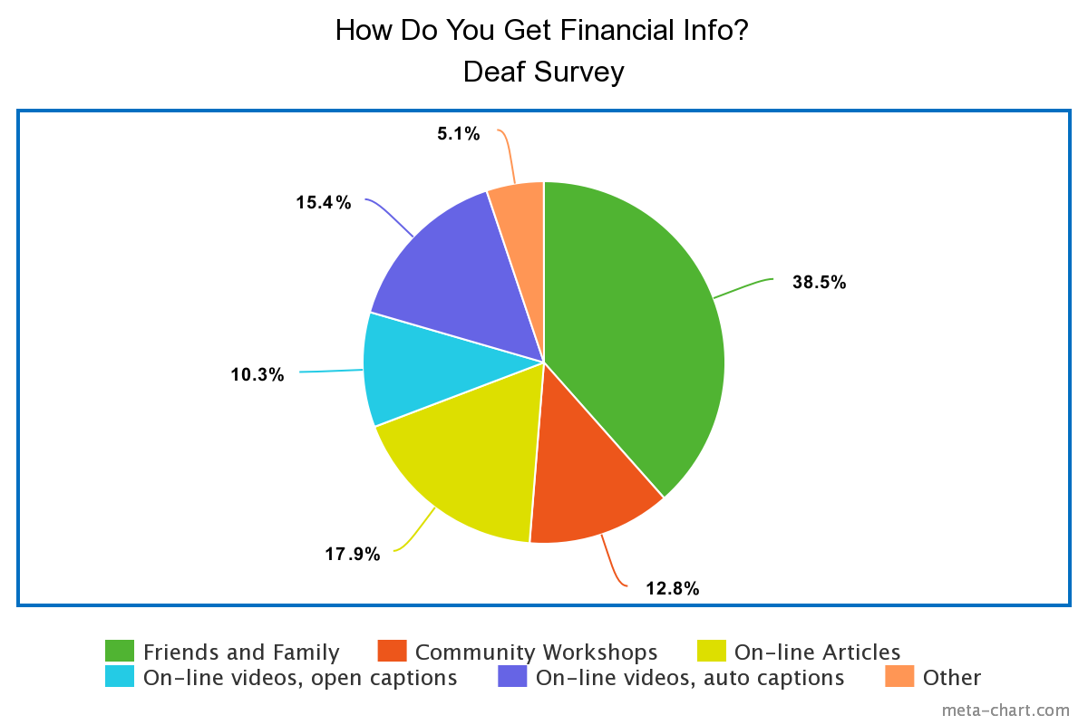

Note: For the above question, multiple responses were possible.

Note: For the above diagram, “Other” meant on-line videos with no captioning, not even automatic captioning.

Note: “Open captions” means captioning is fixed onto the screen (and is usually accurate because it is inputted manually as part of the video), while “auto captions” means that the video has allowed for software voice recognition to generate captions (without screening for accuracy).

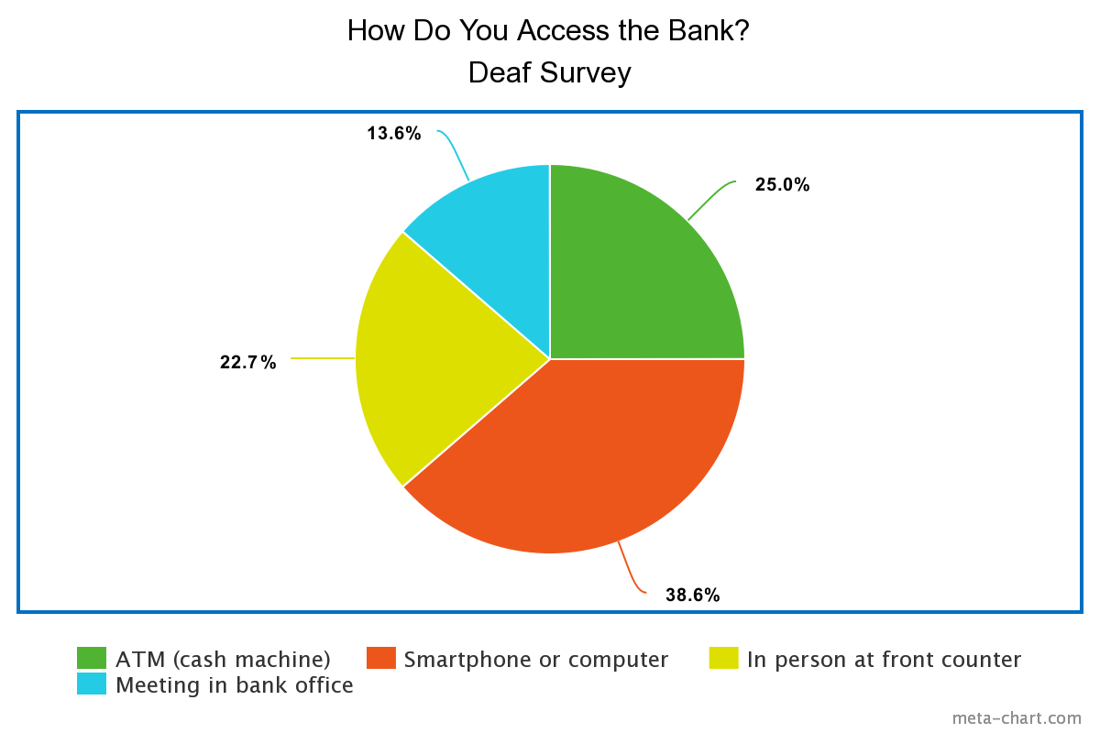

Note: For the above diagram, multiple responses were possible.

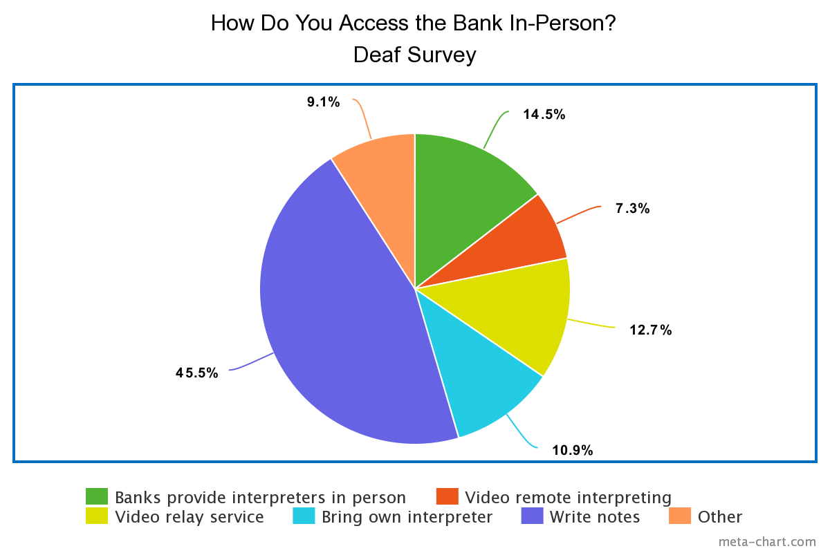

Note: For the above diagram, “Other” includes lipreading, speech, talk and hear, bring community support worker (freeform responses)

Note: Includes multiple responses

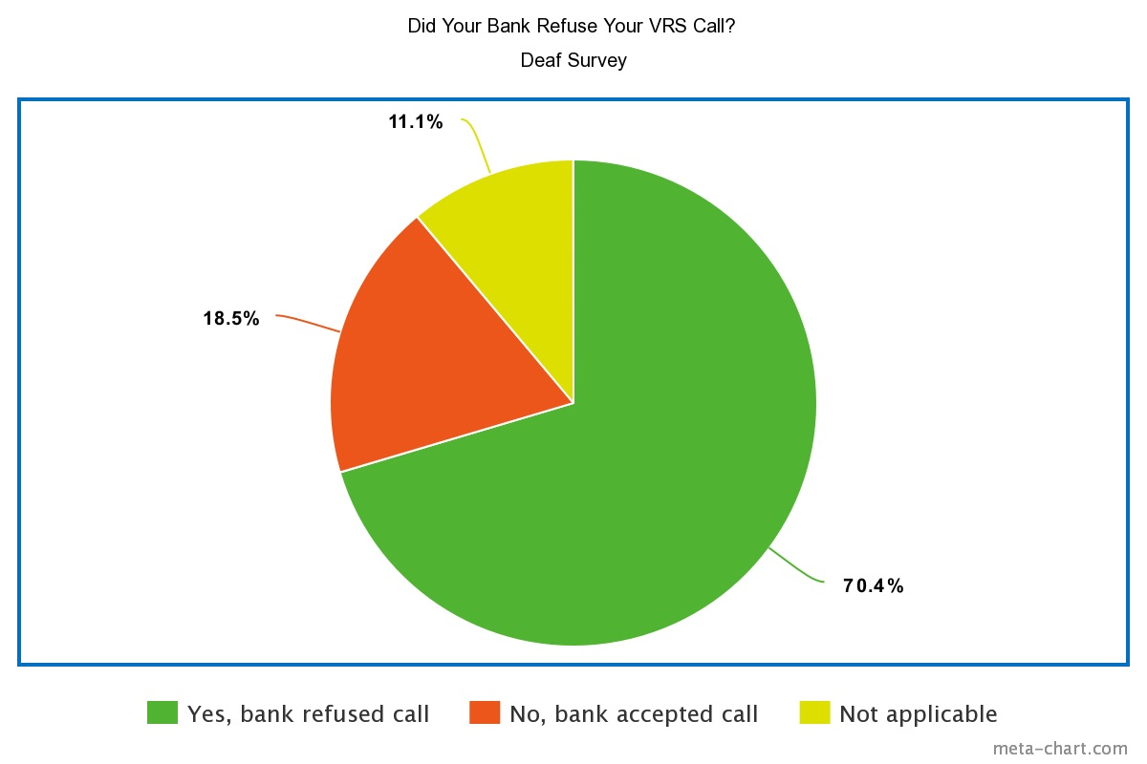

Note: For the above diagram, multiple responses were possible.

Note: Numerous comments were volunteered, making this the most commented-upon issue of both Deaf community surveys. For all issues noted below, each was from a separate Deaf individual.

* In one instance, the bank put an unwanted hold on a Deaf customer’s account only because the client tried to call. The Deaf customer then had to struggle later on to ask that the hold be removed.
* A Deaf client had to wait for a long time to go through the supervisor’s approval of the call going ahead because significant time was spent by the bank official tracking down the supervisor and explaining the concerns over confidentiality (from the bank’s perspective).
* A Deaf client says it is a human rights issue to use an interpreter to make a confidential phone call without differential treatment in comparison to hearing people who call the bank directly using voice.
* One Deaf client who phoned and navigated the hassle of getting clearance to make the call, afterwards, urged the bank official to put a note on his customer on-line account (internally for the bank) to from now on allow his calls and not have to repeat the screening process all over again each single time he or she called.
* One Deaf client said that even when he was with an interpreter in person at the bank, both standing together, the bank staff still refused to accept the Deaf client’s relayed instructions from the interpreter, thus even dismissing the Deaf client’s own physical presence.
* One Deaf customer pointed out every certified interpreter is required to attest to a code of ethics, while being registered as an interpreter by a governing body, and this code of ethics includes strict confidentiality, so why does the bank need a second confidentiality screening from the Deaf client?

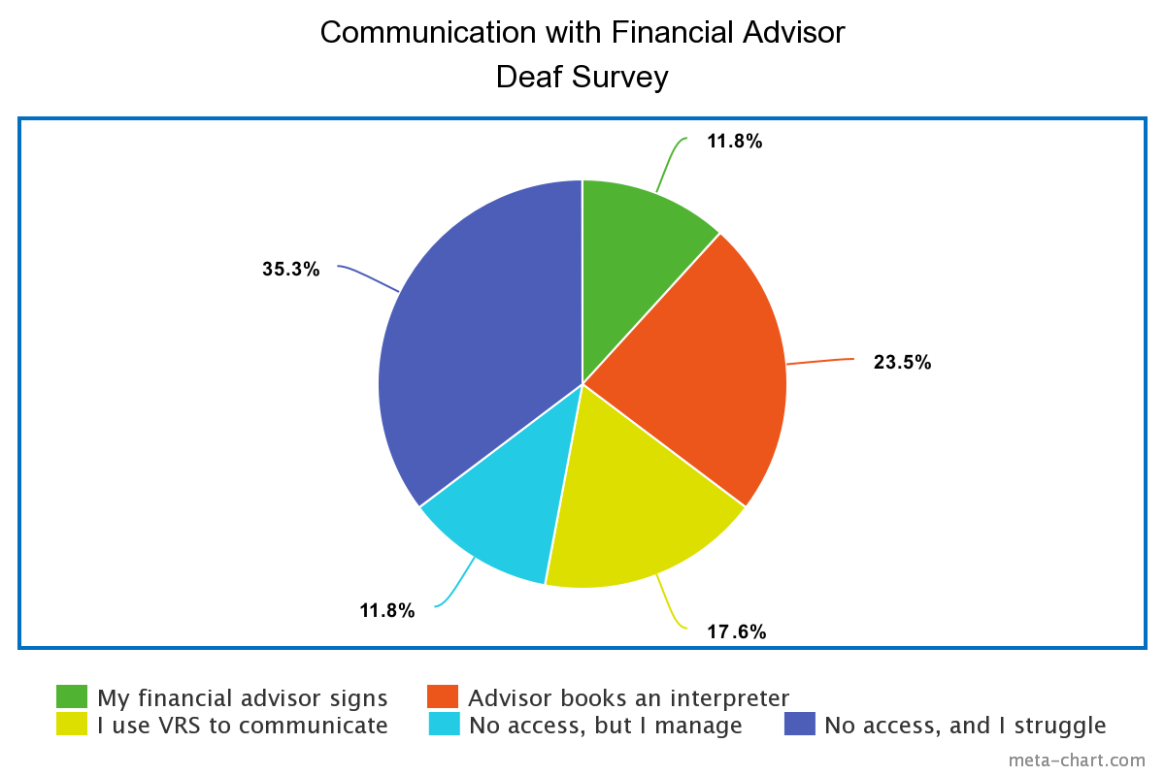

Note: only one selection allowed

Note: “I use VRS to communicate” means the Deaf client would rather discuss finances with the financial advisor using video relay service rather than meet in person. This can be understandable since the VRS is a free service, with interpreters on-line available on demand.

Binary Results from Surveys

|  |  |  |
| --- | --- | --- |
|  | **Yes** | **No** |
| I have a RRSP | 60.0% | 40.0% |
| I have a RDSP | 50.0% | 50.0% |
| I have a financial advisor | 55.5% | 44.5% |
|  |  |  |
|  | **Bank** | **Private investment firm** |
| My financial advisor is from a: | 64.7% | 35.3% |

Note: For the above table, RDSP is Registered Disability Savings Plan.

Note: Two respondents volunteered comments that their relatives did the investing for them.

More Results from Surveys

|  |  |  |
| --- | --- | --- |
|  | **Yes** | **No** |
| I’ve been asked to join “get rich quick schemes” | 45.0% | 55.0% |
|  |  |  |
|  | **Always ignore** | **Got involved and lost money** |
| How responded to “get rich quick schemes” | 85.0% | 15.0% |
|  |  |  |
|  | **Under $1,000** | **$1,000 to $5,000** |
| If you lost money from a “get rich quick” scheme, how much? | 60.0% | 40.0% |
|  |  |  |
|  | **Yes** | **No** |
| Has your credit card or debit card been hacked? | 57.1% | 42.9% |
|  |  |  |
|  | **Under $1,000** | **$1,000 to $5,000** |
| How much did you lose when your debit or credit card was hacked? | 90.9% | 9.1% |
|  |  |  |

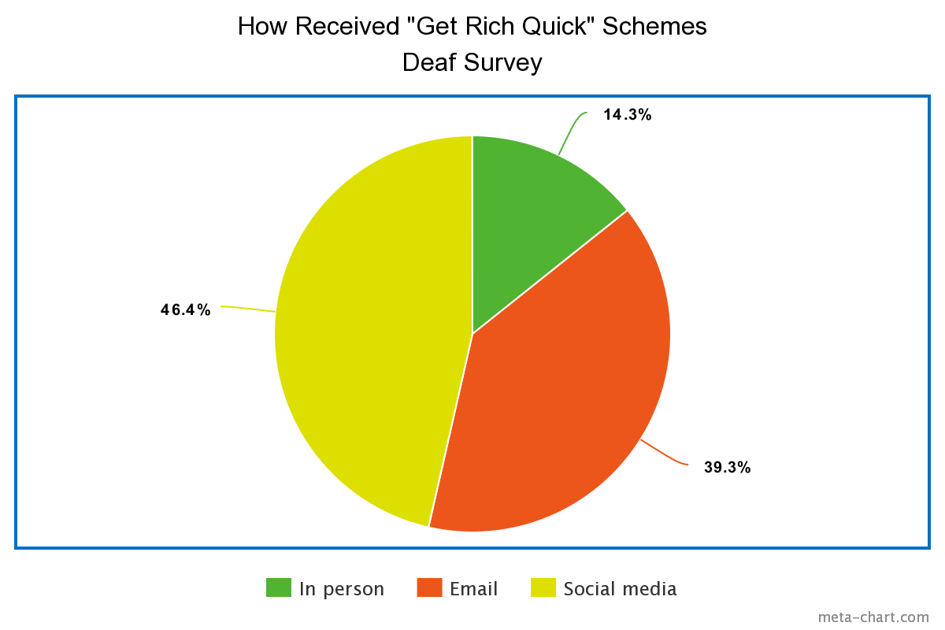

Note: Multiple responses allowed.

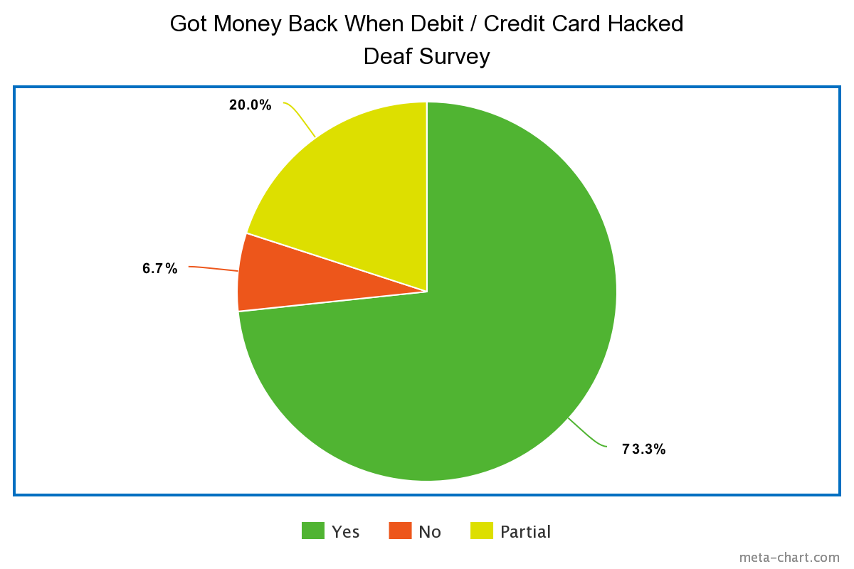

Note: Only one response allowed.

# APPENDIX 11 – Government Deaf-Centric Alerts and Educational Materials

In the United States, under the authority of the Securities and Exchange Commission, they have a signing Deaf narrator to lead a video that warns of financial scams.

https://www.sec.gov/news/sec-videos/protecting-hearing-loss-communities-fraud

[10 ½ minute video in two parts. One is a Deaf narrator, speaking of his misfortune in investment fraud, for 2 minutes. Remaining 8 ½ minutes are three participants, two of which are SEC fraud experts and an interpreter, discussing how to spot fraud and to get valid investment information. Dated September 29, 2020.]

As well, the Internal Revenue Service of the United States, commonly known as the IRS, has several videos explaining tax concepts to Deaf Americans using American Sign Language:

https://www.irs.gov/newsroom/videos-american-sign-language-asl

While there are dozens of American-based websites that offer financial advice in sign language, these below seem to be the most comprehensive, as of the date of writing this report. Canada has no known on-line sign language-based videos that match the depth of these. Notably, these videos use a lot of American-only financial, tax, government, and investment-based concepts that do not exist outside the United States, so they may be of limited use to Canadian Deaf viewers. Some concepts on the websites, however, have some widespread applications to Canadians, i.e. debt to income ratio calculator, presented in sign language, which is useful for calculating how much one can borrow.

However, there was added recently a course on-line for Deaf youth in Canada, by Silent Voice, a Deaf organization in Ontario. The website is at <https://258hub.ca/course/financial-literacy/>. However, one has to register, and wait to be approved by the administrator, to access this course. After one business day, he was still not approved as a member of Deaf Hub (no response) and he used the Contact webform to express his wish to be added as a member so he could view the course. The webform had a technical problem; his message did not get through. Eventually, though, somehow, Silent Voice contacted him by email, without further prompting from the project director, and let him know the course was available for viewing. Hence, it seems that this is not a resource that the general Deaf community would feel is easily browsed. Specifically, a Deaf person has to register and give up personal information and wait a length of time (waiting for a direct response by a staff person during business hours, not through an instant computer algorithm) in order to be allowed to take the course. Also, the financial course is offered through a website that at first, heavily promotes Deaf youth, thus others who are not “youth” may feel they must, at first, need to be a Deaf youth, and skip it if they feel they are not part of this target community.

The project director navigated this financial literacy course. There is a series of videos in American Sign Language, with a fully laid out (scroll-able) transcript for each video, if chosen. The topics covered in the 258 Hub financial literacy course are earning money, borrowing money, investing money, spending money, and saving money. This on-line course is simple, and easy to follow. There is a sample budget worksheet as an additional resource. The student cannot input any figures in the spreadsheet on-line, but could download it as an Excel spreadsheet, and then input figures.

The links below are privately supported websites that touches on basic financial concepts and has links to financial professionals who serve the Deaf community in the United States, including several videos using American Sign Language;

<https://fyifi.org/>

https://kramerwealth.com

The project director reviewed the investment advice and scam warnings of the websites of the following:

* Financial Consumer Agency of Canada
* Canadian Bankers Association
* Ombudsman for Banking Services and Investments

However, none contain videos for any audiences with disabilities, including Deaf.

1. “Queued, on-line” interpreter service is an instantaneous form of VRI, which is Video Remote Interpreting. Broadly speaking, VRI can be booked in advance, or ready without advance notice; the only delay is if all pooled sign language interpreters on standby are busy, similar in concept to a call centre, where phone-in clients wait for the “first available operator.” Therefore, while “queued, on-line” sign interpreter services is actually VRI, it is only one of possible applications of VRI, which also includes booking interpreters on-line with a single specific interpreter, who commits to being available for a certain time slot, and has no automatic back-up (therefore, if this interpreter falls ill, then the meeting might need to be postponed or re-booked with a different interpreter). As for “click of a command,” this would be done in a bank branch, only by bank staff, on an app or link on the bank’s own stand-up monitor or tablet, designed to face a Deaf client in person. To clarify, the bank staff would initiate this connection to on-demand VRI, not the Deaf walk-in client.
2. CAD-ASC supports at a minimum the adherence to Web Compliance Accessibility Guidelines (WCAG) 2.1 Level AA.
3. By “standard confidentiality questions,” we mean those that are well-known to everyone, for example, name, date of birth, account numbers, and perhaps one extra question that would be difficult for a stranger to obtain, such as the first three digits of a social insurance number, a mother’s maiden name, or the amount of the last transaction on the last available customer statement.
4. Canadian Association of the Deaf knows of one Canadian Deaf service agency that has developed on-demand real-time captioning service on-line. It is based on an advance booking platform at the moment, but this agency is working on developing a queued call centre for real-time captioning, with a pool of real-time captionists available.
5. This information should be displayed on the public-facing website as well.
6. The professional captioning offered by a live person, a highly trained certified captionist, attending and listening in. This is also called CART, Communication Access Realtime Translation.
7. Either the sign language-based calls, such as Video Relay Service (VRS), or the text-based calls such as Internet Protocol (IP) Relay.
8. <https://ccua.com/app/uploads/2022/09/top100-2Q22-20-Sep-22.pdf>
9. i.e. First West Credit Union, one of the top ten credit unions in Canada (by size, outside Quebec).
10. The Registered Disability Savings Plan (RDSP) was introduced by the Government of Canada in 2008 to help people with disabilities improve their long-term financial security by providing a tool to encourage them and their families to save for the future. With annual limits, similar to how the Government of Canada adds funds to Registered Education Savings Plans (RESPs), the Government of Canada will proportionally match contributions made by the disabled person, or family of the disabled person, into the RDSP. Thus, RDSPs can be important financial savings for persons with disabilities.
11. Including, but not limited to, the Big Six banks.
12. Project identified at: <https://ised-isde.canada.ca/site/office-consumer-affairs/en/consumer-interest-groups/contributions-program/contributions-program-non-profit-consumer-and-voluntary-organizations-awarded-amounts-and-funded/2021-23-project-summaries-canadian-association-deaf-cad>
13. ASL = American Sign Language
14. LSQ = Langue des signes québécoise
15. VRI = Video Remote Interpreting, i.e. a sign language interpreter available remotely to interpret the discussion between a Deaf person and a hearing person, and can be seen on a tablet, smartphone, or computer screen through a link. (i.e. Language Line)
16. CART = Computer Assisted Real-Time Transcription, also known as real-time captioning, where a professional captures spoken dialogue between two people and converts it into instantaneous text, here the purpose is for a Deaf person to follow the discussion by reading the text (no sign language involved).
17. IP Relay = Internet Protocol Relay, where a Deaf customer uses only text on a screen to communicate with a publicly funded telephone relay operator, who also uses text only. Similar to VRS in placing phone calls, but no sign language is used.
18. Project identified at: <https://ised-isde.canada.ca/site/office-consumer-affairs/en/consumer-interest-groups/contributions-program/contributions-program-non-profit-consumer-and-voluntary-organizations-awarded-amounts-and-funded/2021-23-project-summaries-canadian-association-deaf-cad>
19. IP Relay = Internet Protocol Relay, where a Deaf customer uses only text on a screen to communicate with a publicly funded telephone relay operator, who also uses text only. Similar to VRS in placing phone calls, but no sign language is used.
20. Standard relay telephone call by text: “GA” means “Go ahead,” signifying that the caller is finished typing and is waiting for the respondent to answer back.
21. Standard relay call by text: “SK” means “Stop keying,” signifying that the caller wishes to end the entire conversation and is ready to hang up (usually when the call is completed to satisfaction or cannot logically continue because new information important to the caller is not answered or is being denied.)
22. TTYs (telephone teletype) were the dominant mode of phone communication for Deaf persons, either direct between Deaf, or from Deaf to hearing (or vice versus) through an older relay service, called Bell Relay Service in Canada, in the 1980s and the 1990s. Starting in the 2000s, TTYs started gradually being disregarded by the Deaf community in favour of smartphones, and the discontinuance of TTYs by the Deaf community is nearly universal today. Today, for more formal business calls, or where a business or institution email address is not known, or interactive answers are desired, and where the Deaf caller is not texting a friend or colleague, Video Relay Services (VRS) or Internet Protocol (IP) Relay services are used by the Deaf community.
23. For every bank visit, the project director always indicated weeks ahead of time that he would like a “demonstration” of how a bank would greet a Deaf customer, offering himself as a Deaf customer, but asking client-type questions that did not require confidential personal information (i.e. asking about mortgage rates).