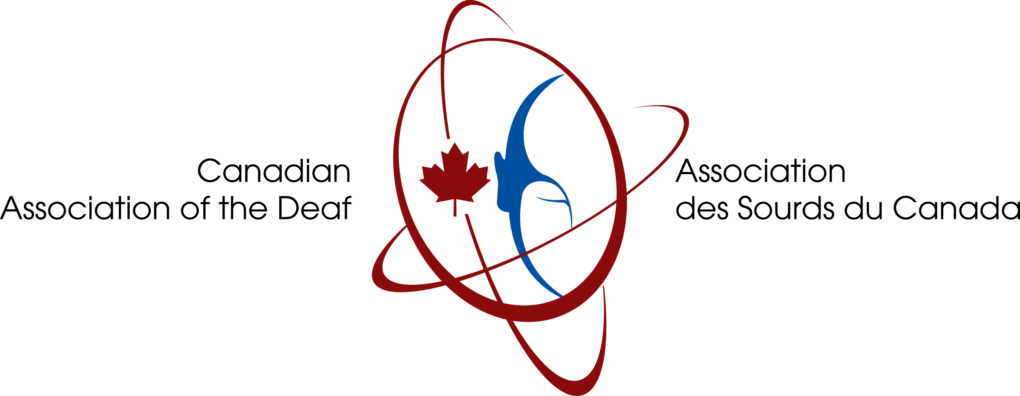

**For Immediate Release September 20, 2024**

**Canadian Association of the Deaf – Association des Sourds du Canada announces 2024 International Day of Sign Languages and International Week of the Deaf People**

***(Ottawa, Ontario)*** --- The Canadian Association of the Deaf – Association des Sourds du Canada (CAD-ASC) is proud to be hoisting the Deaf Flag at the Parliament Hill for the first time in the history on Monday September 23, 2024 at 4 p.m. EST. The event will include speeches form invited guest from 3:30p.m. to 4:30 p.m. The Deaf Flag was approved at the World Federation of the Deaf’’s 20th General Assembly in July 2023, and it represents a powerful symbol for our sign language communities around the world.

The CAD-ASC is proud to endorse World Federation of the Deaf (WFD)’s global campaign: **“Sign up for Sign Language Rights”** to promote International Day of Sign Languages and International Week of the Deaf People on September 23 to 29, 2024. Including:

* Monday 23 September 2024 - International Day of Sign Languages:
* Tuesday 24 September 2024: Inclusive Education
* Wednesday 25 September 2024: Sign Language Advocacy
* Thursday 26 September 2024: Building Resilient Deaf Communities
* Friday 27 September 2024: Diversity in Deaf Communities
* Saturday 28 September 2024: Deaf Cultural Celebrations
* Sunday 29 September 2024: Investing in the future of deaf communities

The **International Day of Sign Languages** aims to raise awareness on sign languages, which take places during the **International Week of Deaf People**. The event is celebrated through various activities by respective sign language communities in Canada and around the world. These activities call for the importance of sign languages and human rights of our communities for its participation and involvement of various stakeholders including families, and governmental bodies.

Along with Parliament Hill, the following cities across Canada will raise the Deaf Flag to support the International Day of Sign Languages including;

* The WINNIPEG Sign, Winnipeg, Manitoba: 7:30 p.m. to 8:30 p.m. CST.
* Toronto City Hall, 100 Queen Street West, Toronto, ON: 11:45 a.m. to 12:30 p.m. EST.
* St. John’s City Hall, 10 New Gower St. St, John’s, Newfoundland and Labrador: 10:00 am NDT.
* Confederation Building, Prince Philip Drive, St. John’s, Newfoundland and Labrador: 1:00 pm NDT.
* Milton Townhall, 150 Mary St., Milton, Ontario: 11 a.m. to 12:00 p.m. EST.
* City of Calgary Municipal Complex Plaza (Outdoor), 800 Macleod Trail SE, Calgary, Alberta: 12 p.m. to 1 p.m. MST.
* University of Alberta Humanities Centre Building, 11121 Saskatchewan Dr NW Edmonton, Alberta: 4:30 p.m. MST.
* City Hall, City of New Westminster, 511 Royal Ave, New Westminster, British Columbia: TBC
* Legislative Assembly of British Columbia, 501 Belleville St., Victoria, British Columbia: 2:00 p.m. PST.

In addition, CAD-ASC is pleased to publicize Blue Light Campaign that will be happening across Canada to mark the International Day of Sign Languages. This initiative will strive to promote the rights of our sign language communities and highlight human rights issues on sign languages and accessibility. These following cities across Canada that will be illuminated in blue on Monday September 23, 2024, which are:

* CN Tower, 290 Bremner Blvd, Toronto, Ontario
* Calgary Tower, 101 9 Avenue SW, Calgary, Alberta
* High Level Bridge, Edmonton, Alberta
* Esplanade Riel Pedestrian Bridge, Winnipeg, Manitoba
* The WINNIPEG Sign, Winnipeg, Manitoba
* New Westminster City Hall, 511 Royal Ave, New Westminster, British Columbia
* Surrey Civic Plaza, 13450 104 Ave, Surrey, British Columbia
* Science World, 1455 Quebec St, Vancouver, British Columbia
* BC Place, 777 Pacific Blvd, Vancouver, British Columbia
* Canada Place, 999 Canada PI., Vancouver, British Columbia
* And Niagara Falls, thanks to the Niagara Falls Illumination Board decision to honour the IWD and the IDSL by lighting the falls blue on Sunday, September 22, 2024 at 10 p.m. You can watch this through the live link at: <https://www.earthcam.com/canada/niagarafalls/?cam=niagarafalls_str>

We invite you to join us across Canada as we celebrate the importance of sign languages as a fundamental human right and continues our efforts to increase public awareness on sign languages by joining this year’s theme: “**Sign Up for Sign Language Rights.”**

Shawna Joynt, President  
Canadian Association of the Deaf – Association des Sourds du Canada

[shawna.joynt@cad-asc.ca](mailto:shawna.joynt@cad-asc.ca)

Richard Belzile, Executive Director  
Canadian Association of the Deaf – Association des Sourds du Canada

[richard.Belzile@cad-asc.ca](mailto:richard.Belzile@cad-asc.ca)