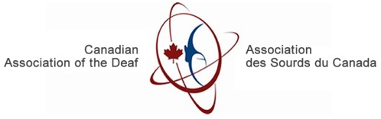

Quiet Waves

**Firsthand Experiences of Deaf, DeafBlind,**

**and Hard of Hearing Individuals**

Reports of

B

arriers in

C

ommunication in the

B

uilt

E

nvironment

**Table of Contents**

Land Acknowledgements 3

From the Executive Director 4

From the Project Director 5

Key Terms 6

Executive Summary 7

Introduction 7

Review of Laws and Literature 7

United Nations Convention on the Rights of Persons with Disabilities (UNCRPD) 9

Canadian Charter of Rights and Freedom 14

Canadian Human Rights Act 15

Accessible Canada Act 16

Accessibility Standards Canada 17

Provincial and Territorial Accessibility Acts 17

National Building Code of Canada 19

Provincial and Territorial Building Codes 19

Elridge v. British Columbia 19

Canadian Association of the Deaf, et. al. v. Her Majesty the Queen 20

DeafSpace Guidelines 20

Overview of the Research 20

Research Results 21

Methodology 21

Responses Garnered from International Survey 22

Responses Garnered in Interviews with Deaf and Deaf-Blind Canadians 24

Recommendations 32

Conclusion 33

Appendix 35

Demographics of Focus Groups and Individual Interviews 35

# Land Acknowledgements

We acknowledge that CAD-ASC has its head office on the traditional unceded territory of the Algonquin Anishinaabeg people. The Peoples of the Algonquin Anishinaabe

Nation have lived on this territory for thousands of years. Each of us stand on

Indigenous land in our respective regions and we honour the elders and their teachings, as we strive to be responsible caretakers of that land for the seven generations that will follow us.

# From the Executive Director

The Canadian Association of the Deaf – Association des Sourds du Canada gratefully acknowledges the funding support from Accessibility Standards Canada (ASC), which made it possible for us to develop this project.

This project/s aim was to survey Deaf and Deaf-Blind individuals in-person and in sign language about the barriers within the Built Environment. However, ASC has recognized the incredible value of interviewing people with lived experience. Therefore, in our application to ASC, our definition of the Built Environment was widened to include the virtual world and the interactions between federal and federally regulated employees.

Although building codes have evolved to adapt to the physical requirements or changes needed to provide access to someone in a wheelchair, the social environment is fraught with barriers. A contractor may provide the “keys” to a public building, but access to public buildings also include the websites, the reception and the interaction with their employees.

It is this understanding that brought to life this project and I am thoroughly indebted to our project director, Anna Wren, who coordinated the many interviews, accommodation needs, travel arrangements, including the coordination of CAD-ASC’s first international booth and survey at the 2023 Congress of the World Federation of the Deaf.

Her work has brought not only the input from Deaf Canadians, both in American Sign Language (ASL) and la Langue des signes Québécois (LSQ), but for the first time, we were able to survey over 400 Deaf people from across the world. I am truly thankful that the funding of the ASC and its foresight to support Deaf-led and Deaf produced research has enabled us to produce this report.

It is our hope that the recommendations within, will ripple like the Quiet waves we foresee, into the future work of those responsible for Accessibility laws, regulations, policymaking and funding programs.

Thank you very much, *merci beaucoup*, and *chi-miigwech*.

Richard Belzile

Executive Director,

Canadian Association of the Deaf

# From the Project Director

As the project director, I am pleased to present the final Quiet Waves report. We gratefully acknowledge the support from the Accessibility Standards Canada of the Federal government for making it possible for us to do the necessary work.

In no particular order, I want to thank members of the team for their support, Richard Belzile, Joseph Antle, Pavel Koval, Scott Simser, Stéphanie Lamy-Therrien, and Lisa Anderson from the Deaf Wireless Canada Committee, and their Chair, Jeffrey Beatty.

Special thanks go out to all the individuals who participated in our interviews and survey, for sharing their lived experiences and identifying solutions.

Thank you very much, *merci beaucoup*, and *chi-miigwech*.

Anna Wren, Project Director

# 

# Key Terms

ASL – American Sign Language

LSQ – Quebec Sign Language (Langue des signes Québécoise)

ISLs – Indigenous Sign Languages

DDBHHD+ - Deaf, DeafBlind, Hard of Hearing, Deaf with Disabilities

UNCRPD – United Nation Convention on the Rights of Persons with Disabilities

ACA – Accessible Canada Act

NBC – National Building Code

DWCC – Deaf Wireless Canada Committee

# Executive Summary

From July 2023 to January 2024, data was collected from members of the Deaf, Deaf Blind, Hard-of-Hearing, and Deaf Plus individuals (DDBHHD+) focusing on their awareness and understanding of the United Nations Convention on the Rights of Persons with Disabilities (UNCRPD) and Canadians with lived experiences regarding accessibility barriers.

The findings show that obstacles remain for DDBHHD+ individuals in accessing services. More work is needed to improve accessibility standards across Canada to achieve a barrier-free Canada by 2040.

# Introduction

CAD-ASC received funding from Accessibility Standards Canada to explore the firsthand experiences of Deaf people who use sign languages, and the significant impact of the social, legislative and logistical barriers they face in accessing the built environment, including the virtual environment.

The purpose of this report is to identify barriers reported by affected individuals and outline best practices for communicating and sharing information with Deaf, DeafBlind and Hard-of-Hearing persons and to offer recommendations to minimize the impact of identified barriers.

The research process used in completing this report included a review of existing legislative and regulatory frameworks and prior research materials, as well as extensive interviews conducted with Deaf and DeafBlind people which were conducted by Deaf interviewers in their shared primary languages, either American Sign Language (ASL) or Langues des signes du Quebec (LSQ). The survey questions were designed to encapsulate the experience of sign language users in an environment that focused on communication needs within the built and virtual environment.

# Review of Laws and Literature

Accessibility and inclusion are new concepts, relatively speaking. Many of the accessibility and disability laws that exist in Canada are less than 60 years old. To begin with, how does one define disability?

As stated on the Ontario Human Rights Commission (OHRC) website, disability is defined as:

Any degree of physical disability, infirmity, malformation or disfigurement that is caused by bodily injury, birth defect or illness and, without limiting the generality of the foregoing, includes diabetes mellitus, epilepsy, a brain injury, any degree of paralysis, amputation, lack of physical co-ordination, blindness or visual impediment, deafness or hearing impediment, muteness or speech impediment, or physical reliance on a guide dog or other animal or on a wheelchair or other remedial appliance or device,

Furthermore, the OHRC website lists:

A disability may be the result of combinations of impairments and environmental barriers, such as attitudinal barriers, inaccessible information, an inaccessible built environment or other barriers that affect people’s full participation in society.

The United Nations’ *Convention on the Rights of Persons with Disabilities* (*UNCRPD*) recognizes that “disability is an evolving concept and that disability results from the interaction between persons with impairments and attitudinal and environmental barriers that hinder their full and effective participation in society on an equal basis with others.” [1]

In other words, the Ontario Human Rights Code (the Code) establishes that the definition of a disability is itself diverse, complex and non-static. In providing the required adaptations, it is not the disability *per se* that presents challenges; it is the lack of accommodations and frequent misperception of what those accommodations require. As technology and standards for accessibility and communication change over time, the status and impact of such barriers will also change over time. Thus, a constant review of these barriers is required to maintain consistency in responding to status versus need.

Currently, with the absence of any regulations under the Accessible Canada Act, 2019

(ACA), communication standards vary across Federally regulated buildings and nonFederally regulated buildings. The literature review in this report, attempts to answer the following questions by analysing the legislative and regulatory frameworks and existing research:

1. What laws guarantee the rights for Deaf, DeafBlind, and Hard-of-Hearing people to be accommodated in Federally regulated buildings?

1. How are Deaf, DeafBlind, and Hard-of-Hearing people who sign affected in spaces where undue hardship is claimed?

Our hope is that we will be able to present, after an analysis of the comments and input from the Deaf and Deaf-Blind community recommendations that will address some of the challenges and gaps within the current legislative and regulatory framework to improve the Built Environment for all.

## United Nations Convention on the Rights of Persons with Disabilities (UNCRPD)

The United Nations Convention on the Rights of Persons with Disabilities (UNCRPD) is an international treaty launched on December 13, 2006, that outlines the fundamental human rights of people with disabilities.

The UNCRPD has four Articles that are noteworthy in the context of Deaf people. They are Article 9, Article 21, Article 24, and Article 30. It is important, for a fulsome understanding of the direction and implementation of accessibility laws in Canada, that we review the tenets of the UNCRPD as it affects Deaf people who sign. The following attempts to do that with the specific sections bolded by the author.

To begin, Article 9 states that its objective is:

1. To enable persons with disabilities to live independently and participate fully in all aspects of life. States Parties shall take appropriate measures to ensure to persons with disabilities access, on an equal basis with others, to the physical environment, to transportation, to information and communications, including information and communications technologies and systems, and to other facilities and services open or provided to the public, both in urban and in rural areas. These measures, which **shall include the identification and elimination of obstacles and barriers to accessibility**, shall apply to, inter alia:

* 1. **Buildings, roads, transportation and other indoor and outdoor facilities, including schools, housing, medical facilities and workplaces;**

* 1. **Information, communications and other services, including electronic services and emergency services.**

1. States Parties shall also take appropriate measures:

* 1. To develop, promulgate and monitor the implementation of **minimum standards and guidelines** for the accessibility of facilities and services open or provided to the public;

* 1. To ensure that private entities that offer facilities and services which are open or provided to the public take into account **all aspects of accessibility for persons with disabilities**;

* 1. To provide training for stakeholders on accessibility issues facing persons with disabilities;

* 1. To provide in buildings and other facilities open to the public signage in Braille and in easy to read and understand forms;

* 1. **To provide forms of live assistance and intermediaries, including guides, readers and professional sign language interpreters, to facilitate accessibility to buildings and other facilities open to the public;**

* 1. To promote other appropriate forms of assistance and support to persons with disabilities **to ensure their access to information**;

* 1. To promote access for persons with disabilities to new information and communications technologies and systems, including the Internet;

* 1. **To promote the design, development, production and distribution of accessible information and communications technologies and systems at an early stage, so that these technologies and systems become accessible at minimum cost.[2]**

Article 21 goes on to say:

States Parties shall take all appropriate measures to ensure that **persons with disabilities can exercise the right to freedom of expression and opinion**, including the freedom to seek, receive and impart information and ideas on an equal basis with others and through all forms of communication of their choice, as defined in article 2 of the present Convention, including by:

* 1. **Providing information** intended for the general public to persons with disabilities **in accessible formats and technologies** appropriate to different kinds of disabilities in a timely manner and without additional cost;

* 1. **Accepting and facilitating the use of sign languages, Braille, augmentative and alternative communication**, and all other accessible means, modes and formats of communication of their choice by persons with disabilities in official interactions;

* 1. Urging private entities that provide services to the general public, including through the Internet, to provide information and services in accessible and usable formats for persons with disabilities;

* 1. **Encouraging the mass media,** including providers of information through the Internet, **to make their services accessible to persons with disabilities;**

* 1. **Recognizing and promoting the use of sign languages. [3]**

Article 24 further provides that:

1. States Parties recognize the right of persons with disabilities to education. With a view to realizing this right without discrimination and on the basis of equal opportunity, **States Parties shall ensure an inclusive education system at all levels and lifelong learning directed to:**

* 1. The full development of human potential and sense of dignity and self-worth, and the strengthening of respect for human rights, fundamental freedoms and human diversity;

* 1. The development by persons with disabilities of their personality, talents and creativity, as well as their mental and physical abilities, to their fullest potential;

* 1. Enabling persons with disabilities to participate effectively in a free society.

1. In realizing this right, States Parties shall ensure that:

* 1. **Persons with disabilities are not excluded from the general education system on the basis of disability**, and that children with disabilities are not excluded from free and compulsory primary education, or from secondary education, on the basis of disability;

* 1. Persons with disabilities can **access an inclusive, quality and free primary education and secondary education on an equal basis** with others in the communities in which they live;

* 1. **Reasonable accommodation of the individual’s requirements is provided**;

* 1. Persons with disabilities **receive the support required**, within the general education system, to facilitate their effective education;

* 1. Effective **individualized support measures** are provided in environments that maximize academic and social development, consistent with the goal of full inclusion.

1. States Parties shall enable persons with disabilities to learn life and social development skills to facilitate their full and equal participation in education and as members of the community. To this end, States Parties shall take appropriate measures, including:

* 1. Facilitating the learning of Braille, alternative script, augmentative and alternative modes, means and formats of communication and orientation and mobility skills, and facilitating peer support and mentoring;

* 1. **Facilitating the learning of sign language and the promotion of the linguistic identity of the deaf community**;

* 1. **Ensuring that the education of persons, and in particular children, who are blind, deaf or deafblind, is delivered in the most appropriate languages and modes and means of communication for the individual, and in environments which maximize academic and social development.**

1. In order to help ensure the realization of this right, States Parties shall take appropriate measures to **employ teachers, including teachers with disabilities, who are qualified in sign language** and/or Braille, and to train professionals and staff who work at all levels of education. Such training shall incorporate disability awareness and the use of appropriate augmentative and alternative modes, means and formats of communication, educational techniques and materials to support persons with disabilities.[4]

Finally, Article 30 provides that:

1. States Parties recognize the right of persons with disabilities to take part on an equal basis with others in cultural life, and shall take all appropriate measures to ensure that persons with disabilities:

1. Enjoy access to cultural materials in accessible formats;

1. Enjoy access to television programmes, films, theatre and other cultural activities, in accessible formats;

1. Enjoy access to places for cultural performances or services, such as theatres, museums, cinemas, libraries and tourism services, and, as far as possible, enjoy access to monuments and sites of national cultural importance.

**4.** **Persons with disabilities shall be entitled, on an equal basis with others, to recognition and support of their specific cultural and linguistic identity, including sign languages and deaf culture. ￼**

Canada ratified the United Nations Convention on the Rights of Persons with Disabilities on March 11, 2010. As a signatory to the Convention, Canada is obligated to submit regular reports to the UN Committee on the Rights of Persons with Disabilities describing how the rights are being implemented. The UNCRPD Committee will review the reports and make suggestions and recommendations for action.

In 2017, the UN Committee on the Rights of Persons with Disabilities released the first report in response to Canada’s initial report, *Concluding Observations on the Initial Report of Canada*, that highlights the work that the government on all levels needs to do to improve its implementation of certain provisions of the UNCRPD. This report points to a few concerns that are worthy of attention.

...25. The Committee takes note of several policy measures at the Federal, provincial and territorial levels that provide for comprehensive plans on preparedness and disaster risk management and reduction and that are inclusive of disability requirements. However, the Committee notes with concern the absence of disaggregated information about the situation of asylum seekers and refugee persons with disabilities in the State party.

...26. The Committee recommends that the State party:

1. Conduct research on the effective access of asylum seekers and refugee persons with disabilities to the protection of their rights under the Convention;
2. Ensure the provision of accessible information, including easy-read versions of official documents, during asylum-seeking processes and with respect to social protection and rehabilitation programmes for asylum seekers and refugees with disabilities;
3. Set up programmes to build capacity among international cooperation and assistance officials with regard to the rights of persons with disabilities; (d) Consider endorsing the Charter on Inclusion of Persons with Disabilities in Humanitarian Action.

...39. The Committee is concerned by:

1. **The lack of official recognition of sign languages and that the training programmes for sign language interpreters do not meet minimum requirements to provide a high quality of interpretation**;
2. The limited amount of information in easy-read or any other augmentative and alternative modes, means and formats of communication and communication technologies for persons with disabilities;
3. The absence of information about compliance with standards of accessibility for websites in the public and private sectors.

...40. The Committee recommends that the State party:

1. **Recognize, in consultation with organizations of deaf persons, American Sign Language and Quebec Sign Language (Langue des signes Québécoise)**

as official languages and their use in schools, and establish jointly with organizations of deaf persons a mechanism to certify the quality of interpretation services and ensure that opportunities for continuous training are provided for sign language interpreters;

1. Promote and facilitate the use of easy-read and other accessible formats, modes and means of communication and grant persons with disabilities access to information and communications technology, including through the provision of software and assistive devices to all persons with disabilities;
2. Redouble its efforts to ensure the accessibility of government websites and ensure that private entities providing services through the Internet do so in formats accessible to all persons with disabilities;
3. **Translate the Convention on the Rights of Persons with Disabilities into sign languages.**

...51. The Committee observes that the State party and different provinces have developed programmes and strategies to facilitate the right to vote of persons with disabilities. However, it notes that those measures do not specifically include persons with psychosocial and/or intellectual disabilities.

...52. The Committee recommends that the State party set up measures to facilitate and ensure access to the election process for persons with psychosocial and/or intellectual disabilities, including through easy-read information on electoral campaigns and other accessible multimedia material, including tutorials on how to vote, to support participation political life by all persons with disabilities.[5]

Since the UNCRPD Committee report was issued in 2017, some work has been done to rectify the identified issues, the most obvious being the introduction of the ACA in 2019. However, the ACA remains without regulations five years after the introduction and passage of the ACA. This leaves only 15 years until the 2040 deadline is met. As the reader will observe, and as noted in our interviewees, both domestically and abroad there are still profound concerns about the rights, or lack of human rights for Canadians who identify as Deaf, Deaf Blind, Hard of Hearing, and Deaf with disabilities (DDBHHD+) who sign.

The UN Special Rapporteur published a second report on December 19, 2019[6]. And the Canadian government regularly responds to the UN reports. However, without any regulations, the response by the Canadian government to the UN and to the Canadian people on its progress on the implementation to the UNCRPD remains vague and nonspecific.

## Canadian Charter of Rights and Freedom

It is well known that section 15 of the Canadian Charter of Rights and Freedoms guarantees fundamental rights and freedoms to all individuals regardless of **“... race, national or ethnic origin, colour, religion, sex, age or mental or physical disability.”**

The Charter was enacted on April 17, 1982, and section 15 came into effect three years later. In our read of section 15 includes Deaf, DeafBlind and Hard-of-Hearing.

Section 15. (1) Every individual is equal before and under the law and has the right to equal protection and equal benefit of the law without discrimination and, in particular, without discrimination based on race, national or ethnic origin, colour, religion, sex, age or mental or **physical disability. ￼**

## Canadian Human Rights Act

The Canadian Human Rights Act (CHRA) was Canada's first Federal human rights law and the first Federal law against discrimination. This Act was passed in 1977 and later amended in 1985. The purpose of this act is to ensure all individuals have equal opportunities and have their needs accommodated without being hindered in or prevented by discriminatory practices based on race, national or ethnic origin, colour, religion, age, sex, sexual orientation, gender identity or expression, marital status, family status, genetic characteristics, disability or conviction for an offence for which a pardon has been granted or in respect of which a record suspension has been ordered.

Section 5 of the Canadian Human Rights Act states

It is a discriminatory practice in the provision of goods, services, facilities or accommodation customarily available to the general public

1. to deny, or to deny access to, any such good, service, facility or accommodation to any individual, or
2. to differentiate adversely in relation to any individual

However, section 15 (2) of the CHRA makes it **legal to discriminate against a person who needs accommodation if the accommodation presents undue hardship**:

For any practice mentioned in paragraph (1)(a) to be considered to be based on a bona fide occupational requirement and for any practice mentioned in paragraph (1)(g) to be considered to have a bona fide justification, it must be established that accommodation of the needs of an individual or a class of individuals affected would impose undue hardship on the person who would have to accommodate those needs, considering health, safety and cost. [7]

As you can see, sections 5 and 15(2) are sometimes contrasting provisions, with section 15(2) inserted to provide businesses and individuals serving the community a

justification for being unable to comply with non-discrimination requirement of the legislation by either reason of 1) due to exorbitant costs that the business owner cannot afford, or 2) due to safety concerns that cannot be addressed differently.

While the relief provision of undue hardship exists for business owners, it should be noted that it is a high burden for a business or individual to prove.

Still, many small and medium businesses are claiming undue hardship, when they note the financial costs of paying for interpreters, or of installing an elevator in a two-storey building. Leaving many people with disabilities in difficult situation.

Let’s imagine a class of young graduates looking to find employment once they have graduated from college or university. Consider the situation of a Deaf person who graduates and seeks their first work experience in their chosen field. They apply for many positions, but are often denied even entry-level positions, legally, by small and medium firms because of the high costs of sign language interpreters or the undue hardship claim.

Fast forward five to ten years after graduation. When graduates from that same class are now applying for coveted federal government positions. In this case, the government cannot claim undue hardship, but they can and do state that the decision to hire the a person is based solely on merit. Merit, in most cases, includes the education and work experience listed on a person’s resume.

This situation is fraught for Deaf applicants who couldn’t get their first jobs in smaller or medium-sized businesses. Although, on paper, the government’s hiring system seems to be non-discriminatory and fair, it fails to recognize how the current exemptions in Human Rights Code, limits the work experience of DDBHHD+ people and puts them far behind able-bodied applicants or classmates who worked for years in their chosen field when federal job opportunities arise.

## Accessible Canada Act

The Accessible Canada Act (ACA) came into force on July 11, 2019. The expressed purpose of the ACA is to make the following areas barrier-free by January 1, 2040: employment, the built environment (buildings and public spaces), information and communication technologies, the design and delivery of programs and services, transportation, and more.

The ACA **does not apply** to provincial and territorial governments or to private organizations and businesses that are regulated by the provinces and territories. Rather, it is specific to organizations and business that are regulated by the Provinces or Territories.[8] Since the ACA is federal in its reach, it also does not apply to most

schools, universities, colleges, hospitals, medical clinics, long-term care homes, and provincial or municipal police forces.[9]

The ACA does recognize ASL, LSQ, and ISLs as the primary languages of Deaf people in Canada. Furthermore, it adds a new standard, previously unseen in Canada’s accessibility laws, for a communication standard what will deal with issues other than information and communication technologies. And although, section 5 1.1 states that this communication standard is to specifically address ASL, LSQ and ISLs, it removes any application of this specific standard to the Broadcasting Act and the

Telecommunications Act.[10] The limitation, or the reason for it, is unclear and left to be define by the standard – or eventually the courts.

Currently, the one of the few requirements of the ACA is that all federally-regulated departments or agencies are to prepare and publish accessibility plans and progress reports, consult with people with disabilities, and set up an accessible feedback processes. [11]

As was previously said, the ACA does identify ASL, LSQ, and ISLs as the primary languages for Deaf people, but of note, is that they were not “officially” recognized not given the same status as English and French.

Previous calls to include ASL and LSQ in the Official Languages Act have gone unheeded. It is hoped that the development of regulations, especially the new communication standard, under the ACA will help meet the goals of the UNCRPD and remove many barriers to communication for the DDBHHD+ communities.

## Accessibility Standards Canada

The Accessible Canada Act established Accessibility Standards Canada (ASC).   
ASC develops and revises accessibility standards and recommends them to the government for regulation. It also supports research on accessibility and inform best practices for identifying, removing, and preventing barriers.

## Provincial and Territorial Accessibility Acts

Currently, only seven provinces have their own accessibility laws: Manitoba,

Saskatchewan, Newfoundland and Labrador, Nova Scotia, Quebec, Ontario, and British Columbia.

Ontario was the first province to establish accessibility in Canada with the enactment of the Accessibility for Ontarians with Disabilities Act (AODA) in 2005. The AODA is based

off the 2001 Ontarians with Disabilities Act. The aim of AODA is to create a barrier-free Ontario by 2025. The AODA has 5 areas of standards:

* Information and Communications Standards
* Employment
* Transportation
* Design of Public Spaces
* Customer Service

The development of two new AODA standards are also being currently explored:

* Health Care
* Education

Quebec was the first province to pass an accessibility law, in 1978. In 2004, Quebec amended the legislation, and it is now the Act to secure handicapped persons in the exercise of their rights with a view to achieving social, school and workplace integration. This Act only applies to the public sector and there are no clear timelines, goals, or penalties.

The Accessibility for Manitobans Act was enacted in 2013 and has 3 areas of standards:

* Customer service
* Employment
* Information and communications

And two more standards are currently being developed:

* Built environment
* Transportation

The Act Respecting Accessibility in Nova Scotia was enacted in 2017, making Nova

Scotia the third province to establish an accessibility act. The aim is to make Nova Scotia inclusive and barrier-free by 2030. The Act will cover 6 areas of standards that are currently under development

* Goods and services
* Information and communication
* Transportation
* Employment
* Education
* Built environment

Newfoundland and Labrador Bill 38- An Act Respecting Accessibility was enacted in 2021, making them the 6th province to establish an accessibility act.

The Accessible British Columbia Act was enacted in 2021. The aim of this Act is to create a more inclusive province by 2024. This act recognizes ASL and ISLs as primary languages for the people of British Columbian. It does cover 7 areas of standards:

* Employment
* Delivery of services
* The built environment
* Information and communications
* Transportation
* Health
* Education
* Procurement

The Accessible Saskatchewan Act was enacted in 2023 and the areas of standards are:

* Built environment
* Information and communications
* Employment
* Transportation
* Service animals
* Procurement
* Service delivery

## National Building Code of Canada

The National Building Code (NBC) was published in 1941 and has undergone several revisions, the most recent being in 2020. It identifies the technical provisions for the designs and constructions of new buildings and existing buildings. The NBC establishes requirements for the safety, health, accessibility, fire and structural protection of buildings and the environment. [12]

This NBC is a minimum; each Province and Territory has its own legislated building code that expands the expectations for designs and constructions. The NBC is updated every five years. The National Building Code of Canada does not establish who is responsible for ensuring standards are met; this decision is left to the adopting provinces and territories.

The NBC addresses accessibility in parts 3 and 9. Part 3 covers large buildings, and part 9 covers small buildings.

## Provincial and Territorial Building Codes

All provinces and territories have building codes based on the principles of the National Building Code of Canada but adjusted to accommodate their specific geographical needs.

## Elridge v. British Columbia

The plaintiffs in this court case challenged the British Columbia Medical Services Commission and the Ministry of Health in 1997 for failing to provide sign language interpretation during medical appointments and at the hospital, which was a violation of their equality rights under Section 15 of the Charter.

The Supreme Court of Canada ruled in their favour and determined that the government must accommodate individuals with disabilities accessing medical services.

## Canadian Association of the Deaf, et. al. v. Her Majesty the Queen

In 2006, the Canadian Association of the Deaf and three Deaf individuals sued the Federal government for failing to provide access. In this case, the Federal government had guidelines for the provision of interpreter services only to public events hosted by the government or for Federal employees only. It was argued that although the provision of interpreters met the needs of the Deaf employees, individuals who needed to access Federal programs did not receive interpreters and this was discrimination. The court ruled in their favour and found that this violated Section 15 of the Charter and the government had to accommodate the needs of Canadians when accessing federal government services.

## DeafSpace Guidelines

The DeafSpace Guidelines was developed by Gallaudet University, the only liberal arts university in the world dedicated to the ASL community. The Guidelines contain over 150 architectural design elements to be considered when constructing an environment that is inclusive to Deaf people. The design elements connect the deaf experiences and the built environment through sensory reach, space and proximity, mobility and proximity, light and colour, and acoustic. [13] In this study, we used the principles of DeafSpace design guidelines to provide a baseline for improved experience for DDBHHD+ in all settings.

# Overview of the Research

From the reviews of materials, we have conducted and from what has been provided in proposed and existing regulations, acts and guidelines, our goal in this report was to provide a space where those experiencing the need for greater accessibility could annotate both direct, personal encounters with discriminatory practice on the basis of disability and express their assessment of the effectiveness of proposed measures to address those experiences.

What follows is an outline of the processes used to conduct, assess, quantify and outline individual experiences and to collate those into a cohesive response to DDBHHD+ barriers to inclusion in the built environment.

# Research Results

## Methodology

In July 2023, data was collected from individuals who attended the World Federation of the Deaf Congress in Jeju regarding their understanding of UNCRPD and from August 2023 to January 2024, people in Canada regarding their lived experiences with barriers in Canada. Responses were collected from focus groups and interviews.

#### Intenational Survey

In July 2023, the World Federation of the Deaf hosted its Congress in Jeju, Korea. Three representatives were selected to attend. A booth was rented for 4 days, and a survey was created using Jotform. There were 5 questions. The survey was translated into 7 written languages: Korean and the official languages of the United Nations; English, Chinese, French, Russian, Spanish, and Arabic. The three representatives also translated the written language into ASL, LSQ, and International Sign (IS) as needed. Over 423 responses were collected via the survey method.

#### Domestic Focus Groups and Individual Interviews

The majority of our interviews regarding people’s experiences with barriers in Canada occurred via focus groups. A member of our team led all the LSQ focus groups while DWCC led all the ASL focus groups. To collect lived experiences from Deaf, Deaf-Blind, hard-of-hearing, and Deaf with disabilities, interviews were held via Zoom or in person in either ASL or LSQ. Interviews were conducted in a group setting that averaged 3-5 people. After the interviews were conducted, participants were emailed a link to fill out a brief demographic survey, although it was not a requirement to answer the demographic questions, one had to complete the contact e-mail portion of the survey to receive their honorarium. The focus groups were semi-structured with 7 general guiding questions meant to foster a discussion.

In addition, some interviews were one-on-one either in person or on Zoom. Some individuals’ schedules didn’t align with the focus group timing, or they preferred to be interviewed alone, while some individuals required the use of tactile sign language for communication which meant it was better to interview in person, or one-on-one situations.

## Responses Garnered from International Survey

This research collected data from Deaf people on an international scale to determine how well the United Nations Conventions on Rights of Persons with Disabilities were known and understood in the wider Deaf community.

A total of 423 participants completed the survey. Below is a breakdown of the number of respondents from each continent. Several of the participants noted they were from several places, so the total number of persons represented is higher than the actual total number of respondents.

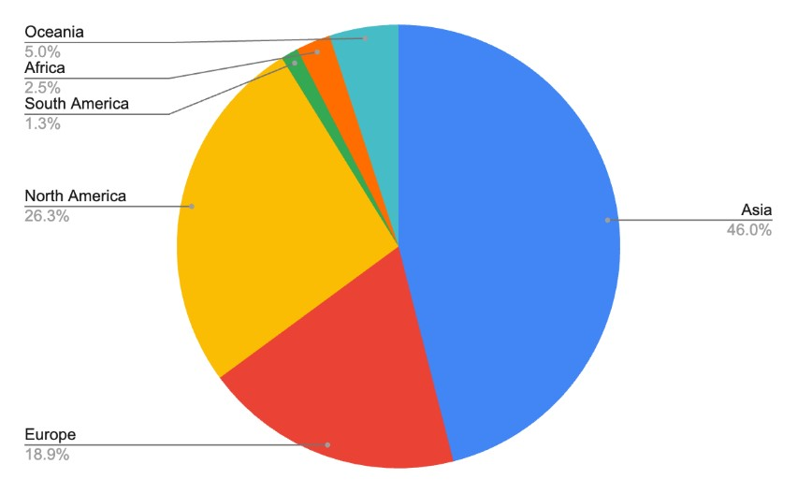

One of the survey questions asked for the respondent's opinion on which country has the best rights for Deaf people, as well as the best human rights record overall. In hindsight, this question has two components that should have been addressed separately because one country could have progressive rights for Deaf people but severe human rights violations. Nevertheless, what is interesting about this question is that out of 423 participants. Interestingly enough, 30 of participants identified as being from Canada, and two of them did not answer the last question. Of those 28 Canadian respondents, only 4 or felt Canada was the best country in the world for Deaf people.

The top 15 countries identified by individuals as the best countries in their opinion for Deaf rights and human rights were:

|  |  |  |  |  |  |  |  |  |  |  |  |  |  |  |  |  |  |  |  |  |  |  |  |  |  |  |  |
| --- | --- | --- | --- | --- | --- | --- | --- | --- | --- | --- | --- | --- | --- | --- | --- | --- | --- | --- | --- | --- | --- | --- | --- | --- | --- | --- | --- |
|  | |  |  | | --- | --- | | United States | 70 | | Canada | 19 | | Finland | 19 | | United Kingdom (UK) | 18 | | Sweden | 14 | | Norway | 11 | | Australia | 10 | | Japan | 9 | | South Korea | 8 | | Denmark | 7 | | New Zealand | 7 | | Nordic countries (general) | 3 | | Scandinavia (general) | 4 | |

Clearly, this data reflects that the United States was the popular choice for our respondents. Many who chose the United States were familiar with the Americans with Disabilities Act and felt that the country was the best one for Deaf people.

The second most popular choice was Canada, tied with Finland. Some people stated that they picked one country, but thought that as a whole, the Nordic countries were the best for human rights overall. If we group all of the votes for European/Nordic countries (i.e. Sweden, Norway, Denmark, Finland, Iceland, Nordic and Scandinavia countries) the tally would be 60 votes and place them just slightly behind the U.S.

Finland was a popular choice, some’s people rationale for picking Finland was because that is where the World Federation of the Deaf’s headquarters were located.

19 people voted for Canada, but a few mentioned they voted for Canada only because they were the only country that had a Deaf Association that had a booth at the event.

## Responses Garnered in Interviews with Deaf and Deaf-Blind Canadians

Interviews were performed to gather firsthand experiences of DDBHHD+ individuals in communications within the built environment. It is important to acknowledge that these experiences are purely anecdotal, but it highlights the challenges and unique perspectives that DDBHHD+ individuals face in navigating and interacting with the environment. It is a reminder of the ongoing work that is needed to create spaces and technology that are inclusive. By documenting and analyzing these firsthand experiences, we can better understand the gaps in the built environment and identify solutions to adequately address the barriers.

A total of 88 people were interviewed for this project. 25 participants were interviewed in LSQ, and 63 were interviewed in ASL. One hour was spent on each interview and responses were given to 14 guiding questions, including a discussion of first-hand experiences in medical, the built environment, employment, and emergency settings. A breakdown of the demographics, including gender and identity, is given below.

There was over 1500+ comments made on the issues brought up. All told the major categories were, 270+ comments for the general built environment, 260+ comments for communication, 170+ comments for emergency preparedness, and 320+ comments made for employment.

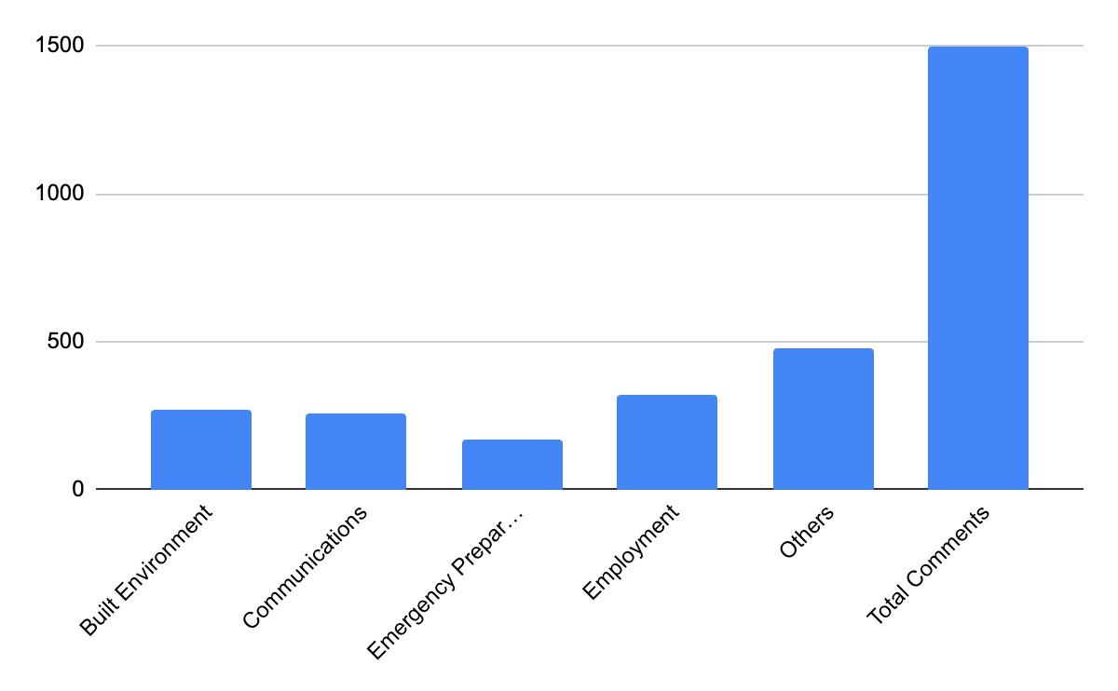

Below are some common themes of concern noted by individuals.

#### Physical Buildings

Entry systems present challenges for DDBHHD+ individuals. Businesses and condominiums often have a buzzer or phone-based system to control access to their buildings, which makes it difficult for DDBHHD+ individuals to explain the nature of their visits. Some buildings have a physical security guard at the door, which can alleviate this issue to some extent but still presents challenges due to communication barriers between the individual and security personnel.

Alarm systems and emergency alerts are often audio-based. Ontario was the first province to change its Building Code to remove audio smoke alarms and require audio and visual alarms in 2015 for public and multi-residential buildings. While the DDBHHD+ community has welcome this change – there still needs to be timely and significant changes to building codes that see visual smoke and CO2 in place in all public and residential buildings adapt to include visual alarms in all Provinces and Territories.

Currently, some buildings have visual alarms in select areas like hallways and kitchens, but places like bedrooms and bathrooms lack these safety features. In addition, some individuals have noted that the flashing light can be too small and difficult to notice in brightly lit areas. Several individuals reported that they noticed the visual alarms in Federal buildings such as Passport Canada, but not every provincial government building has them.

Verbal announcement systems in public spaces create an obvious significant barrier for DDBHHD+ individuals who cannot rely on verbal cues to understand what is happening. Public transportation, fast food restaurants, and medical clinics often use verbal announcement systems as a tool for communication to announce a stop is approaching, a meal is ready or a patient needs to be seen. Some places do offer video-based announcements, but they are pre-recorded and not adequate to use in an emergency.

There are applications that DDBHHD+ people use to improve their communication access in public spaces, such as speech-to-text apps that require access to WIFI or data to utilize. This presents challenges when public spaces do not have a reliable or steady WIFI connection. Expecting DDBHHD+ individuals to use data when WIFI is not available to utilize apps that improve accessibility is an unfair burden because it presents financial barriers. Data is expensive and limited, not everyone can afford the privilege of data.

Sightlines over tables presents challenges for DDBHHD+. Some agencies such as

Passport Canada and banks uses tables that are high which creates poor sightlines. This is further exacerbated when these individuals are short, wheelchair users, or cannot otherwise see over the table for visual communication.

In addition, there are privacy concerns while using sign language in public spaces such as Passport Canada and banks. If the client and personnel speak in a lower tone about the nature of the business, it is difficult for others to overhear. However, if the client is signing, anyone who is in the vicinity and knows sign language will understand.

#### Communication Technologies

The TTY is a significantly outdated technology that is simply not available to most Deaf and Hard-of-Hearing individuals. The system requires both the caller and the receiver to have a Telecommunication Device for the Deaf (TDD) or to use the Bell Relay System (BRS) operator to read the typed communication to a hearing participant. It is rarely used, except for one major exception, prisoners who are not allowed access to the internet.

Many service providers continue to advertise accessibility through this means. For those who manage to find a teletypewriter (TTY) system still in use, many find that service providers do not understand how TTY works or what to do if a TTY call does get through to their service. As the system also requires an analog or “land” line, the personal use of TTDs or TTYs is falling into disfavour.

Today, the preferred choice of the Deaf community is a Video Relay Service (VRS) call. In this case, a DDBHHD+ individual download the VRS application and calls a hearing person or a business using Video Relay Service (VRS). The application will open a video window for the Deaf person with a sign language interpreter in ASL or LSQ. The sign language interpreter will relay the information to the hearing participant.

However, many reports that the business has limited understanding of what the service is for and believes that it is a scammer contacting them. Often, they will refuse to discuss the nature of the call with the caller and interpreter, citing privacy concerns or internal policies about third parties on a call. DDBHHD+ individuals have reported that the businesses have hung up on them because they refuse to speak to them with an interpreter present. In addition, callers often must explain the purpose of the call, why the interpreter is there, why they can’t call the business directly themselves. Often the case must be escalated before an agreement is made on the business end, sometimes in writing, that they can speak with the client through VRS. This practice of selfadvocacy wastes time. DDBHHD+ individuals reported that this experience is common with both small businesses and federally regulated businesses.

Sometimes when a DDBHHD+ individual calls a business using VRS, the business will inform them that they have a line available only for DDBHHD+ people and they can call that number for help. When the call gets transferred, it is discovered that the line is a TTY number, which defeats the purpose of having a sign language interpreter since TTYs are text-based technology.

Some DDBHHD+ individuals have noted that their interpreter, whether accessed though

VRS, or through a remote work accommodation such are VRI (Video Remote

Interpreting) are outsourced. It is well known that some interpreter services are sending overflow calls to interpreters in the United States. We have heard concerns that these interpreters are not familiar with Canadian context, politicians, or cities. It was mentioned that American interpreters may not be fully aware of cultural nuances, regional signs, terminologies, specific accessibility laws, and more that are unique to Canada. This gap in knowledge could lead to misunderstandings.

In addition, some individuals shared frustrations about interpreters not being able to understand them even though other Deaf people can. While misunderstandings do happen, it was noted that more screening should happen to ensure that interpreters are qualified to understand the Deaf individual and can communicate accurately.

Technology devices such as kiosks available at the airport often offer written language options in multiple languages other than English and French, yet they have no sign language options.

Language applications like Google Translate can adapt, understand and translate most spoken and written languages, yet sign language interpretation by AI or a computer application are not fully developed. It may take years before a technical solution is in place.

Interpreting the news, was a topic mentioned but picture-in-picture interpretation is too small to be easily understood. The information during news cast, and especially during important news broadcast like an oncoming flood or forest fire. Picture-in-picture interpretation, resembles a small square at the bottom of the screen for the interpreter, but it is still challenging to understand what is being signed because the size of the interpreter is too small to be seen.

#### Medical Settings and Mental health

In our interviews with Deaf individuals, we found many serious implications in the lack of services provided. There was a report from a patient receiving instructions from medical personnel that was standing outside the examining room. The procedure was delayed, and the health of the attending medical staff was compromised.

There are frequent reports of Deaf patients being required to use written

communication, despite having limited ability to use written forms of communication and

often while experiencing pain, discomfort or illness that limits their use of text communication. The video terminals as provided by most health care settings are inadequate, often lack privacy and are of poor quality and do not address the concerns of patients who may not be able to see the screen.

There are currently no counsellors on staff at the national 988 suicide prevention and mental health lines who can respond to the phone for Deaf persons experiencing mental health crises. While the barriers existing in society are often a large part of the reason for a Deaf person’s isolation, anxiety and depression that could be exacerbated by inefficient sign language interpreters. Canada does not currently offer the kinds of support available to individuals in mental health crisis in the United States.[14]

In addition, most conventional medical practitioners have a very limited understanding of the vital role of Deaf culture and Deaf experience. Most Deaf children are born to hearing parents. In those cases, many practitioners convince parents of Deaf children towards Cochlear implants which are poorly understood and can have significant downsides for Deaf children. There is limited government support of hearing aid costs, parents are not advised of cultural options, are not taught sign language, nor explained the options for the child to learn both languages. Parents are overwhelmingly exposed to the consent materials for cochlear implants, but they do not have an opportunity to meet successful Deaf professionals and members of the Deaf community who may provide a more balanced approach to success for Deaf and Hard-of-Hearing children.

#### Educational Setting

Canada does not have a single post-secondary institution or campus dedicated to learning for sign language users, similar to Gallaudet University in Washington, D.C. This leads to a significant lack of access for Deaf adults and youth to higher education and advanced skills learning. Though this is a Provincial jurisdiction, it should be a discussion between all levels of government to devise cost-sharing plans and implement effective, welcoming programming for post-secondary learning.

Furthermore, many Deaf schools are closing and require the mainstreaming of Deaf students into a hearing curriculum. This leads for increased isolation, lack of access to learning and to social networks and exclusion for many Deaf and Hard-of-Hearing children. Education for Deaf children in mainstream schools does not address the need for cultural sharing among the Deaf and does not provide sufficient training to non-Deaf people to respond to concerns created by the built environment.

#### Employment Settings

Hiring interpreters is an expensive cost, one that some workplaces would rather forgo. Oftentimes, during important meetings the DDBHHD+ individuals. Individuals report that employers are often reluctant to offer these accommodations.

In some cases, employers are willing to provide interpreters to DDBHHD+ but they are simply not available. Some employers will postpone meetings, but some will not. And in some cases, if the issue deals with people in the BIPOC or 2SLGBTQI+ communities, there is only a small pool of culturally competent interpreters who would be able to accurately interpret for people with the nuances needed to communicate effectively in those communities. Nuances that may be overlooked or misunderstood by other interpreters.

Some employers have firewalls that block accessibility services such as VRS speechto-text apps. Corrections Services Canada in most cases does not allow Deaf prisoners access to computers, smartphones and Wi-Fi.

DDBHHD+ individuals report not feeling fully included in the work environment. An example of this is being forced to sit through a meeting with no interpreter and to get a short summary of what was discussed. This limits their opportunity for engagement, motivation and promotion.

#### Emergency Services

One individual experienced a lockdown due to a shooting at the House of Commons and there was no information at all. Another reported that they informed the hotel they were staying at that they were Deaf and to notify them in case of an emergency. The hotel lost power and the firemen showed up. The person was supposed to evacuate but didn’t know because nobody in the hotel informed them. A third individual was involved in a public shooting. The police made verbal announcements of what to do but they didn’t hear it. Other people had to communicate what to do through gestures.

Individuals who are DDBHHD+ depend on “reading the room”. If everyone is looking panicked or frustrated, then they know that something is going on. If they are alone, they will often remain unaware of emergencies until it is too late.

One individual reported that during a provincial emergency TV broadcast, there was an interpreter next to the announcer, but it wasn’t shown on TV. It was seen on FB or YouTube but not on the news, which limited DDBHHD+ people’s ability to get real-time information straight from the source.

During local emergencies, sometimes the police go knocking on door to door in an emergency, but individuals who are DDBHHD+ are more likely to not realize the police service is at the door and if they do, they will miss vital information, while the police may assume that the Deaf person has understood the evacuation order and that it is safe to move on to the next house.

#### Web technology

The current web Content Accessibility Guidelines (WCAG) 2.1 Level AA requirements do not include sign language. So in most cases, to access computer information, Deaf people have to read what is written. Deaf people cannot use speech recognition papers and unfortunately, many federal government websites use complicated language and for some members of the DDBHHD+ community, it can be confusing. With a lack of sign language interpretation options on the website, video or in-person access to Deaf employees, if any, information can be difficult to understand.

Accessibility features are not consistent across federal websites. Some websites have easier interfaces than others. Some website uses fonts that are illegible, or the colour choices offers little contrast, making it difficult to read. On some websites, the accessibility features are easily shown while on others it is harder to find.

For the few websites with sign language translation, it is sometimes embedded directly underneath the text, while in others it is given as a link, which isn’t always clear. Sometimes, the videos are in English only. People need to remember that Deaf people do not have the liberty of an English reader to look up a word that is challenging or unknown to them, Deaf people do not have that option when looking at a taped message in ASL or LSQ. This can be a problem for new Canadians who are Deaf, and their primary language is neither ASL nor LSQ.

#### Airports/Airplanes and Transportation Hubs

While most airports have made adaptations to services and environments for many disabled travellers, there are none found that provide sign language interpreters or visual airport announcements, in-flight announcements, or in-flight communications, in particular emergency instructions.

Although LaGuardia airport in New York, as an example of adaptation in place for disabilities, uses AIRA for the blind[15], they, nor has any airport, have yet to provide any VRI services at their facilities. A deaf person with access to VRI at an airport could manoeuvre through the ticket agents, security, gate agents and customs.

Announcements are not provided by visual means in any transportation hubs, including train stations and bus terminals.

#### Interactions with Hearing Individuals in Public Spaces

There are many reports of concerns regarding staff attitudinal barriers and of staff that may have been impatient with the DDBHHD+ person communicating via non-oral methods. A lack of Deaf sensitivity training in many governmental organizations makes advocating for one’s needs challenging. Many instances of discrimination and neglect exist, such as refusal to provide interpreters or other accommodations. These issues are common in schools and communicating with the police.

Attitudinal barriers were encountered by many respondents, who noted a lack of understanding and misunderstanding about Deaf, DeafBlind and interpreters. Also noted to be of concern is the lack of interpreter certification nationwide that should be Deaf-led. While this is another issue in Provincial jurisdiction, a cohesive Federal mandate would have a greater impact in the training and education of interpreters and intervenors for Deaf and DeafBlind persons.

Staff may have limited understanding of sign language or understanding in how to communicate with someone who is Deaf effectively. Often, they rely on written communication, which is not effective, as written forms of spoken language are challenging for some Deaf people. A lack of knowledge and awareness also results in staff impatience and misunderstandings.

There is a disparity between the accessibility services provided by Federal and Provincial government buildings. The options for accessibility or the method on how to request them are not always clear or shown on websites.

As mentioned hospitals do provide interpreters, but it is difficult to get an in-person interpreter, which is often preferred. Interpreters are often provided by video remote are not always appropriate. Suppose the patient has a migraine and finds it difficult to look at the screen. What if the patient has a neck injury and needs to lie in a particular way? An in-person interpreter could get on the floor to sign if needed or position themselves in the most effective communication method, but a VRI interpreter would not be able to do that. And though hospitals have been guided by Eldridge for years, many participants noted that doctors in private clinics do not have to provide interpreters, which results in misunderstandings and affects patients' quality of care.

# Recommendations

As a result of our study of DDBHH experience in access and communication in an unaccommodated space, we propose the following recommendations as measures to address the difficulties identified by those barriers:

### *Recommendations for Physical Buildings*

1. Implementation of digital communication that is exercised consistently across the board. Use of visual announcements whenever verbal announcements occur, including schools, libraries, courthouses, police stations, airports, train stations and other public buildings and residences.
2. Standardized accessibility features led by Deaf, Deaf-Blind and Hard-of-Hearing persons that are offered by federal and provincial and territorial governments.
3. All federal government locations must have VRI provided on-demand, especially in airports, Service Canada offices, and emergency services.
4. Install visual fire alarms in all areas and harmonize all federal and provincial building codes to include visual alarms in public buildings and housing. This includes any room that a person could be alone in.

### *Recommendations for Communication Technologies*

1. Implementation of text messaging notifications in all public settings, including but not limited to, office buildings, medical centres, airports, judicial, police and educational settings where announcements and/or alerts are made over voice broadcast systems. This would include both emergent and non-emergent messaging.

### *Recommendations for Medical Settings – and Mental health*

1. Develop and design mental health services delivered by Deaf counsellors, psychologists and social workers. Ensure that Deaf people, especially in the 988 national crisis line environment access mental health services in sign language.
2. Allow walk-in clinics and private doctors’ offices to use VRS technology to communicate with their patients in the same room.

### *Recommendations for Educational Setting*

1. Consider a nation-wide, cost-sharing post-secondary campuses or universities to support the development of Deaf academics in ASL, LSQ and ISLs.

### *Recommendations for Employment Settings*

1. Sensitivity training for all public and large private institutions, including medical, courts, legal, justice and public service areas, taught by Deaf people.
2. Further training on VRI and VRS is needed on all federally regulated businesses and periodic reminders are encouraged.

### *Recommendations for Emergency Services*

1. Ensure all first responders have access to VRS 911 on their devices. If they encounter a Deaf person while working, they can initiate the conversation by using the VRS 911 app on their own devices or smart phones.
2. Involve Deaf individuals in accessibility assessments and emergency planning to ensure the plans consider the needs of Deaf people.

### *Recommendations for Web technology*

1. Standardized accessibility features led by Deaf, Deaf-Blind and Hard-of-Hearing persons offered by federal and provincial and territorial government.
2. Consider expanding VRS and VRI services to allow for government offices to open dedicated video chat or phone lines, answered by Deaf employees

### *Recommendations for Airports/Airplanes and Transportation Hubs*

1. Recommend the contracting of AIRA and VRI for travellers at all airports to facilitate the travel from arrivals, through check-in, security, customs and gate attendants – as well as initial contacts with airline attendants for both Deaf and Blind travellers.

### *Recommendations for Interpretation*

1. Improved minimum standards for sign language interpreters, including national Deaf-Led Certification of interpreters.
2. Interpreting services should not be limited to only ASL or LSQ, a variety of sign languages should be offered to accommodate Indigenous, immigrants, and individuals who use other sign languages.

# Conclusion

It is clear in reviewing the literature and our interviews that there are significant obstacles for DDBHHD+ people in accessing services in the built environment.

The goal of the ACA is for Canada to be barrier-free by 2040 but achieving this will require efforts from multiple sectors.

Yet, there remain challenges, as noted by our interview participants: Accessibility standards need to be uniformly implemented, increased public awareness and understanding.

Ongoing consultants with the DDBHHD+ communities are crucial to developing policies and practices that are effective and inclusive and enrich the experience of all those who access them.

While access to information through qualified nationally certified interpreters by Deaf people will go far in ensuring that quality interpretation is occurring between Deaf people will improve the Deaf and Deaf-Blind access to schools, medical services and employment.

# Appendix

## Demographics of Focus Groups and Individual Interviews

Percentages were rounded up or down. Some questions allowed multiple choice responses.

### Participants’ Hearing Level Identities

* 95.5% identified as Deaf and uses sign language
* 1.1% identified as Deaf and does not use sign language
* 11.4% identified as DeafBlind
* 5.7% identified as Hard of Hearing
* 5.7% identified as an oral Deaf
* 1.1% identified as late-Deafened

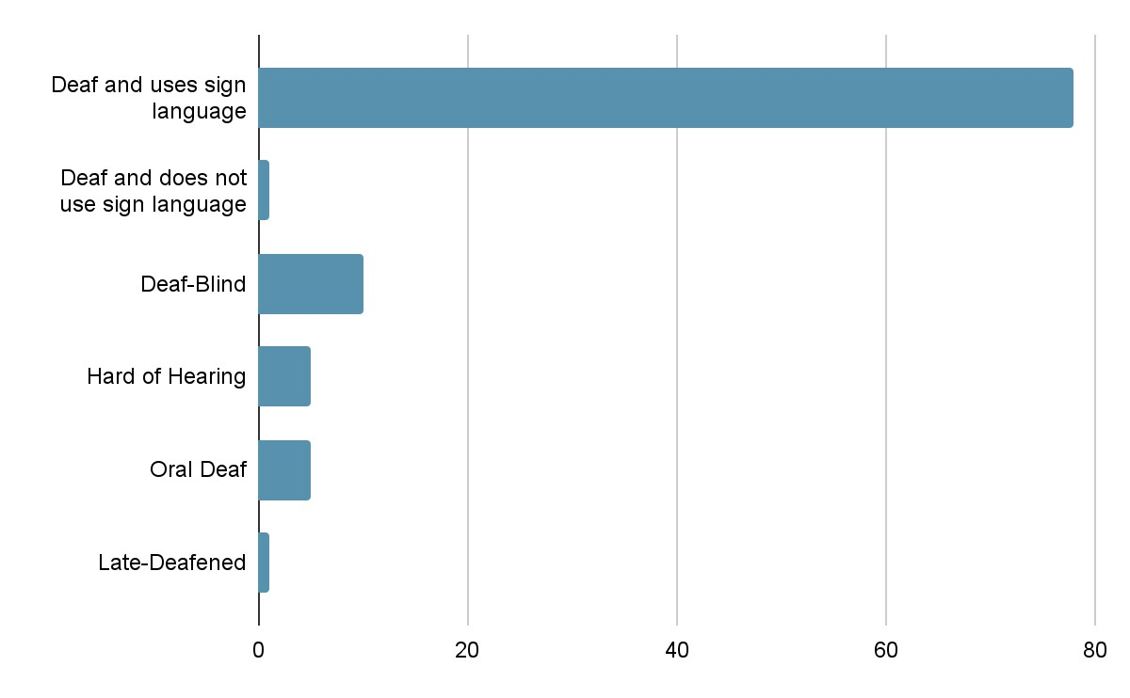

### Gender Identities of Participants

* 51.1% identified as women
* 46.6% identified as men
* 2.2% identified as non-binary

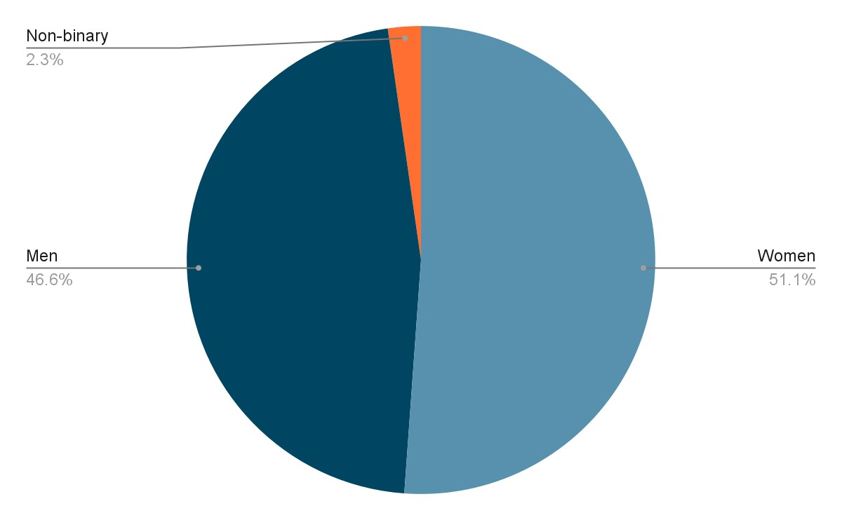

### Participants’ Identities’

* 6.8% identified as Indigenous
* 13.6% identified as a visible minority
* 2.3% identified as a youth (age 28 and younger)
* 9.1% identified as a senior citizen (age 65 and older)
* 23.9% identified as a member of 2SLGBTQIA
* 18.2% identified as a person with another disability

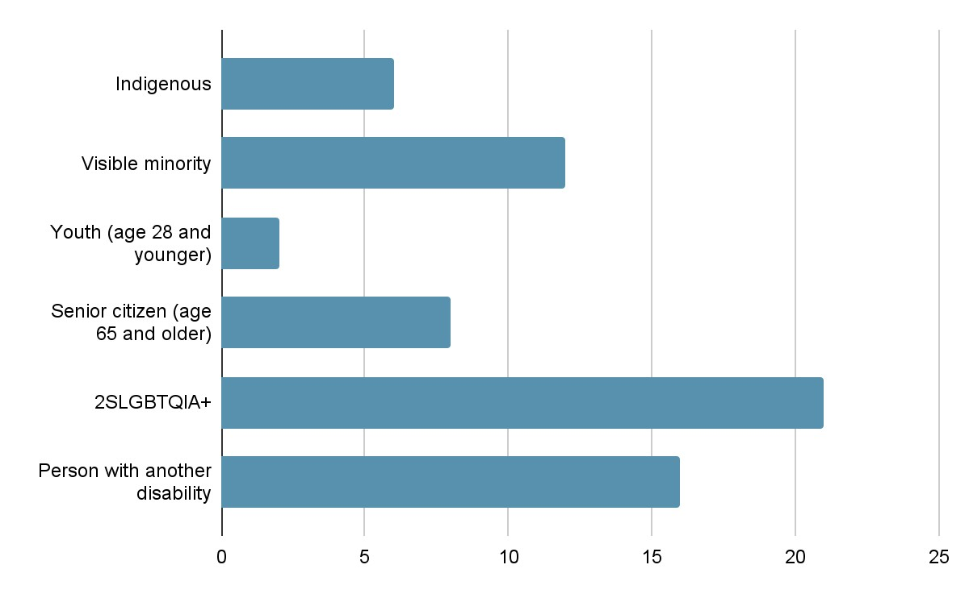

### Ages of Participants

* 1.1% identified as being younger than 18
* 2.3% identified as being 18-24 years old
* 14.8% identified as being 25-34 years old
* 30.7% identified as being 35-44 years old
* 26.1% identified as being 45-54 years old
* 17.0% identified as being 55-64 years old
* 8.0% identified as being 65 years or older

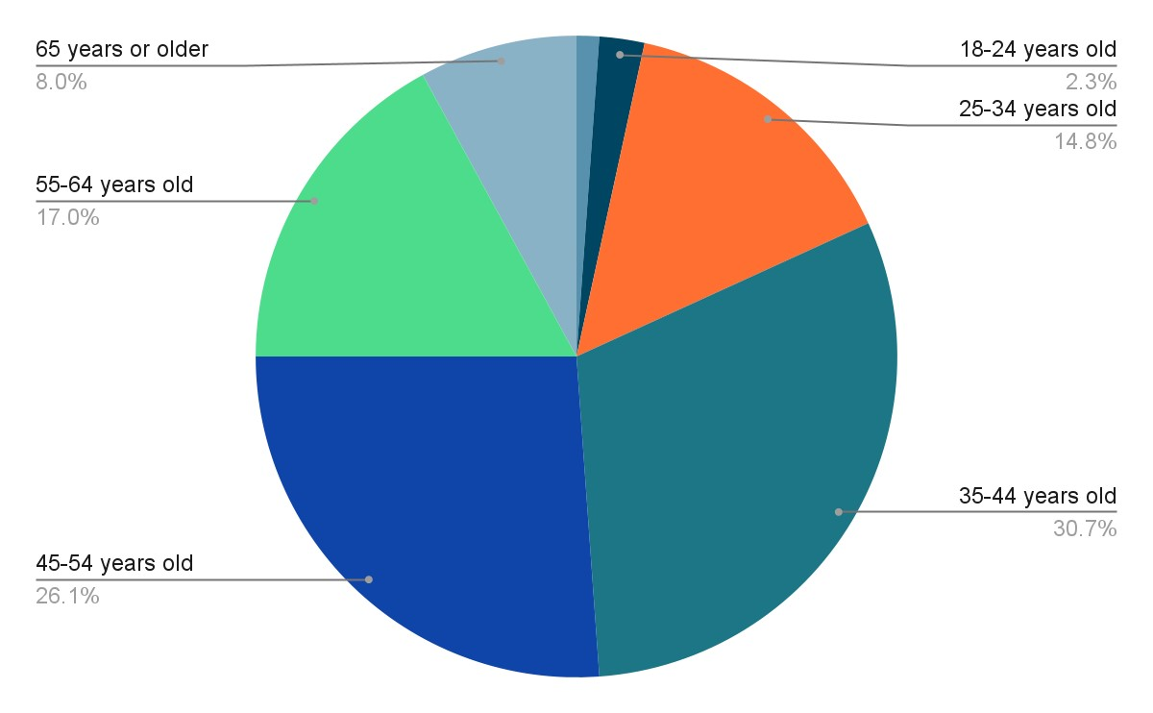

### Province and Territories Participants Live In

* 2.2% from Indigenous ancestral lands
* 19.8% from British Columbia
* 6.6% from Alberta
* 1.1% from Saskatchewan
* 5.7% from Manitoba
* 27.5% from Ontario
* 29.7% from Québec
* 5.5% from Newfoundland and Labrador
* 2.2% from Nova Scotia

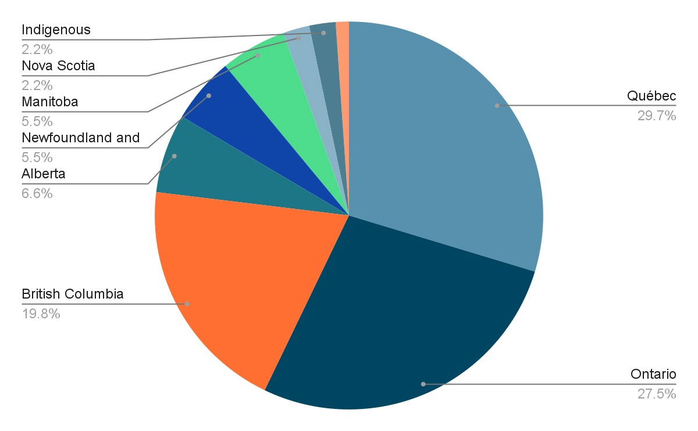

### Types of Communities Participants Live In

* 79.5% from a large city (50,000 or more people)
* 11.4% from a medium city (between 2,500 - 50,000 people)
* 5.7% from a small community (fewer than 2,500 people)
* 2.3% are nomadic, living from town to town
* 1.1% preferred not to answer

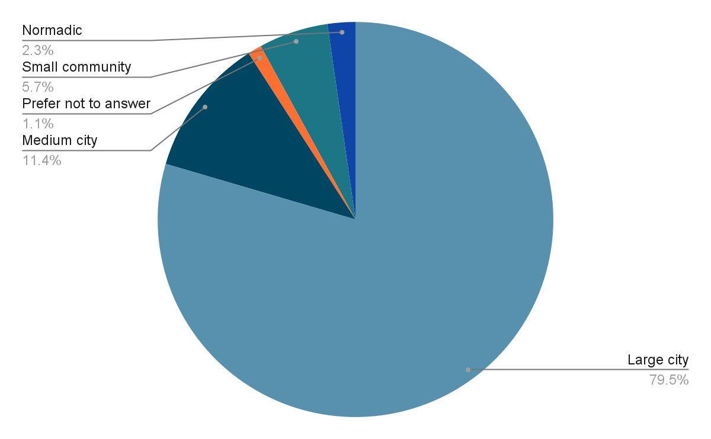

1. https://www.ohrc.on.ca/en/policy-ableism-and-discrimination-based-disability/2-whatdisability#:~:text=A%20disability%20may%20be%20the,people's%20full%20participation%20in%20society.
2. https://social.desa.un.org/issues/disability/crpd/article-9-accessibility
3. https://social.desa.un.org/issues/disability/crpd/article-21-freedom-of-expression-and-opinion-andaccess-to-information
4. https://www.un.org/development/desa/disabilities/convention-on-the-rights-of-persons-withdisabilities/article-24-education.html
5. <https://cad>[-asc.ca/wp-content/uploads/20 1](https://cad-asc.ca/wp-content/uploads/20)7/04/CRPD-Concluding-Observations-on-the-initial-report-ofCanada.pdf
6. [A/HRC/43/41/Add.2: Visit to Canada - Report of the Special Rapporteur on the rights of persons with disabilities |](https://www.ohchr.org/en/documents/country-reports/ahrc4341add2-visit-canada-report-special-rapporteur-rights-persons)

   [OHCHR](https://www.ohchr.org/en/documents/country-reports/ahrc4341add2-visit-canada-report-special-rapporteur-rights-persons) 
7. https://laws-lois.justice.gc.ca/eng/acts/h-6/
8. https://www.accessibilitychrc.ca/en/overview-accessible-canada-act
9. https://www.accessibilitychrc.ca/en/overview-accessible-canada-act
10. [Accessible Canada Act (justice.gc.ca) s](https://laws.justice.gc.ca/eng/acts/A-0.6/page-1.html)ubsection 5.1(1) b
11. https://www.canada.ca/en/employment-social-development/programs/accessible-canada/actsummary.html
12. https://nrc-publications.canada.ca/eng/view/ft/?id=515340b5-f4e0-4798-be69-692e4ec423e8
13. https://gallaudet.edu/campus-design-facilities/campus-design-and-planning/deafspace/
14. https://deafcounseling.com/
15. [We’re Aira, a Visual Interpreting Service.](https://aira.io/) 