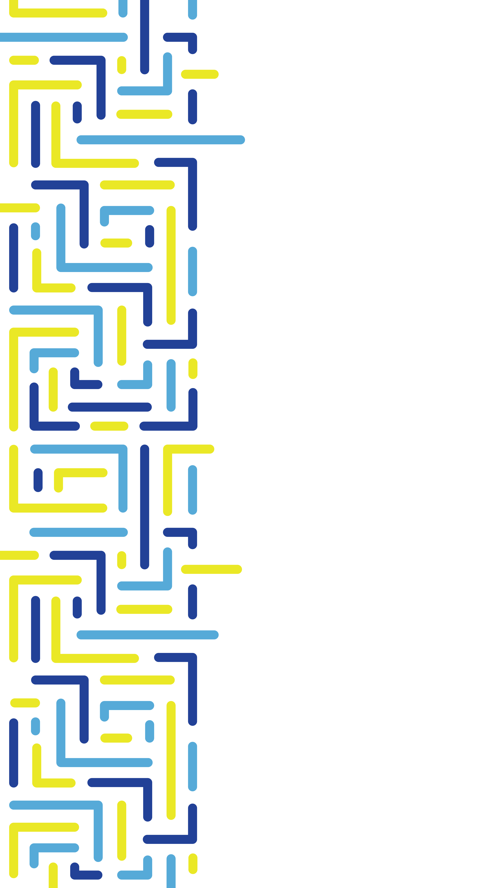

**Accessible and Equitable Artificial Intelligence Systems**

Review by Canadian Association of the Deaf – Association des Sourds du Canada

May 2025

Contents

Section 4 – Definitions 3

Equity 3

Harm 3

Informed consent 3

Section 5 – Preface 3

5.1.1.1 Engaged in the Creation of AI systems. 5

5.1.1.2 Deploying AI systems. 5

5.1.1.3 Oversight of AI systems 6

5.1.2 People with disabilities as users of AI 6

5.1.2.1 Accessible transparency and documentation 6

5.1.2.2 Accessible feedback mechanisms 6

5.1.2.3 Statistical discrimination in AI 6

5.2 Equitable AI 6

5.2.1 Equitable access to benefits 7

5.2.2. Assessment and mitigation of harms 7

5.2.3 Upholding of rights and freedoms 8

5.2.4 Preservation of agency and respectful treatment 8

5.3 Organizational and equitable AI 8

5.3.5 Design of AI systems 8

5.3.8 Impact assessments, ethics oversight, and harm monitoring 9

5.3.9 Train personnel in accessible and equitable AI 9

5.3.12 Feedback on the accessibility and equity of AI systems 10

5.3.13 Review, refinement, and halting mechanisms. 10

Section 1 – About us

About us. Although the ASC speaks to meetings the requirements of the ACA, the current WCAG 2.0 standards Level AA do not require sign language until Level AAA – and that is only in rare circumstances. In this context, the ACA will fail the Deaf community and its communication needs in primary sign languages.

**CAD-ASC recommends revising this to ensure the ACA is interpreted in a way that meets both the requirements and the spirit of the Act.**

## Section 4 – Definitions

Equity **–** We appreciate the expanded definition of equity, in realizing that the focus is to enable all individuals to achieve equal outcomes.

Harm **–** Consider adding the word “**linguistic”** to the definition, for the lack of sign language can be a true barrier for some. And it will add the cultural component when dealing with the Deaf community that uses primary sign languages as a means of communication.

CAD-ASC noted the absence of the term **“Moral Misalignment”** even though the document refers to it. CAD-ASC recommends defining moral misalignment in an AI context in this section.

Informed consent **–** CAD-ASC is concerned about the undefined term of “mechanisms” to ensure that the consent is informed, valid, meaningful and modifiable in the realm of computerized consent or approval.

The current practice of checking boxes to ensure that the terms and conditions have been met seems inadequate for some members of the Deaf, Deaf-Blind, and Hard-of-Hearing community that rely on their primary language of communication.

**CAD-ASC recommends adding an option to receive Human interaction, including sign language or tactile interpreters, when seeking or approving consent from individuals with a disability.**

## Section 5 – Preface

This section reads well – ensuring the full participation of people with disabilities with the use of the word “shall” and speaks to a principle of not losing “rights and freedoms”. However, currents rights and freedoms are missing due to existing legislation that often creates loopholes or gaps.

CAD-ASC offers a few examples.

1. Current legislation supports WCAG 2.0 or 2.1 Level AA in government or agency’s standards. However, WCAG level AA does not require any sign language on websites. That obligation doesn’t arise until Level AAA criteria is implemented and that in very limited cases.
2. Current human rights codes include an “undue hardship” definition that relieves many organizations from the obligation of even creating a tool that would benefit Deaf people, hiring Deaf people, or even serving Deaf people.
3. Current National Building and Fire Codes do not require virtual or tactile fire alarms for buildings.

If generational AI is to learn from our past data, legislation and precedents – they will continue to create AI systems with barriers to people with disabilities. New language is needed that recognizes current and historical wrongs and aims for true equality.

Although the sentiment in the preface is laudable, CAD-ASC recommends that the standard should recognize

1. **That the federal government has committed to go above and beyond current standards to remove all barriers by 2040 without delay.**
2. **That the 3rd principle replaces the words “not lose” rights and freedoms – with “achieve their full” rights and freedoms**

**Section 5.1.1. Full participants in AI lifecycle**

CAD-ASC feels that the AI lifecycle should be expanded to include two more examples: testing and AI learning.

One reason we see this expansion as necessary is the recent development of AI sign language interpreters. This learning will only come with the data collected from the Deaf community as it provides Sign language data to the AI during the beta phase.

Note: CAD-ASC also notes that the involvement of the Deaf community does not speak to compensation, during and after the AI learning has happened. A revenue sharing principle **should be included in the benefit derived from Deaf people’s involvement.**

In this section and its subsets, However, CAD-ASC has interpreted the ambiguous term “engaged” to refer to employment.

This obligation should be supported by the employment standards or requirements of an employer. However, the undue hardship exemptions would still exempt most small and medium sized employers from even hiring a person who is Deaf and uses sign language as a primary language, due to the costs of accommodation. This legal allowance for small and medium size private companies to not hire a person with a disability and high accommodation cost. This will create an “experience” gap in a Deaf person’s resume and a subsequent hiring gap for HR screening criteria will dismiss many applications from people with disabilities because of their lack of experience. This further enforces the standard to recognize these gaps and advise regulated entities to provide accommodations and opportunities for people with disabilities to be included and engaged in the creation, deployment and the oversight of AI systems.

### 5.1.1.1 Engaged in the Creation of AI systems.

Although this section seeks to engage people with disabilities by ensuring that tools that are created and their outputs for users of AI systems and developers of AI systems, the clauses referred to in EN 301 549-2024 – often fail people with disabilities, specifically Deaf people. For example,

Section 4 Functional performance statements do not take into consideration if a person is multi-disabled. For example, Deaf-Blind.

Section 9 recognizes the pre-recorded Sign language interpretation for “audio content” in synchronized media. Failing to recognize the need to provide sign language formats for written documents.

Section 12.2.4 – which speaks to accessible documentation only requires only one accessible web format or non-web format. Sign language formats are often sacrificed when only one format is chosen.

Even though, the paragraph repeats that the regulated entity shall “at a minimum” meet the requirements of EN 301. CAD-ASC recommends to add the following.

**Regulated entities shall recognize that the minimum will often fail to include people such as people with multi-disabilities, people who communicate through primary sign languages, or others. Regulated entities shall establish a protocol in creating AI tools, systems and their output to consider these groups and allow accessible channels of communication to allow staff and users to request accommodation.**

### 5.1.1.2 Deploying AI systems.

Once again, though we recognized the forward thinking of ASC, the reality is that the full inclusion of sign language is one of a voluntary nature and not obligated by law.

CAD-ASC repeats the recommendation of 5.1.1.1

### 5.1.1.3 Oversight of AI systems

CAD-ASC repeats the recommendation of 5.1.1.1.

## 5.1.2 People with disabilities as users of AI

CAD-ASC repeats the recommendation of 5.1.1.1.

### 5.1.2.1 Accessible transparency and documentation

CAD-ASC repeats the recommendation of 5.1.1.1.

### 5.1.2.2 Accessible feedback mechanisms

CAD-ASC repeats the recommendation of 5.1.1.1.

The standard should note that feedback mechanisms often fail to consider the time and costs to accept video feedback. At a minimum, the option of submitting ASL or LSQ videos should be advertised and communicated to the clients in a prominent location and fashion.

### 5.1.2.3 Statistical discrimination in AI

Regulated entities are not the expert to evaluate “potential inequities”. This clause does not address statistical discrimination when implementing AI assistive technology. The introductory line should state that.

**CAD-ASC recommends adding “In order to address statistical discrimination in developing AI systems to assist in accommodation, regulated entities shall develop policies and options for people with disabilities to refuse, modify or adapt AI systems that are offered as accommodations to people with disabilities.”**

## 5.2 Equitable AI

The clause speaks to “not suffering a loss of rights and freedoms” due to the use of AI systems. CAD-ASC wonders if the “loss” of rights and freedoms” existing under the current Human Rights legislation will remain. Specifically, will AI systems adapt to provide accommodation up to and including “undue hardship” exemptions.

For example, the current exemptions for the provision of accommodations in Canada under the human rights code, allows for the non-hiring of employees whose accommodations are too expensive or the retrofits of buildings that are too old, to include accommodations for wheel chairs or to upgrade for visual fire alarms. For wheelchair users and Deaf people, they would not suffer a “loss of rights” if these gaps were to remain in place, for they don’t currently enjoy these rights.

Perhaps the standards should recognize this inequality and speak to going above and beyond the Canadian Charter and seek to meet our international obligations under the UN CPRD.

In the meantime, at a minimum, CAD-ASC recommends changing the principle #3 to

**3. gain their full rights and freedoms due to the use of the AI systems**

### 5.2.1 Equitable access to benefits

Bullet point #2 – Underrepresentation of PWD in the training data. This point should not only be limited to the training data, but for all data collected throughout the lifecycle of the AI system.

Bullet point #4 – Include disaggregated results for people with disabilities. The agency should avoid aggregating every disability together. The effect on a Deaf person or a blind person or a wheelchair user might be lost in the statistical data if it showed the overall success of a system that measures and reports on all disabilities together.

CAD-ASC recommends

**To include disaggregated results separately for people with different types of disabilities and include those with multiple disabilities, such as Deaf-Blind to measure if barriers still exist.**

### 5.2.2. Assessment and mitigation of harms

When an agency uncovers harm and fails to find effective measures to fully avoid harm, AI systems will for reason of economic necessity still be deployed. In these cases, a process to evaluate the remaining harm and compensation should be commenced.

In the paragraph for Fairness and non-discrimination, CAD-ASC suggests that people with disabilities should not be subject to AI-assisted decisions without their consent and full understanding. **CAD-ASC would suggest that consent and full understanding be defined in section 4.**

CAD-ASC suggests that in any definition of consent and full understanding, **that the requirement for offering sign language interpretation, be included as a default**.

This would be vitally important the more serious the decision. For example, if a federal agency were to deploy an AI verification system to ensure informed consent during a MAiD procedure, CAD-ASC would argue that the consent cannot be assumed without the active offer of sign language interpretation.

### 5.2.3 Upholding of rights and freedoms

At the first bullet point, suggest including the term **“without their informed consent”.**

On occasion the need for surveillance could be required, such a residential child in a school for Deaf children or the surveillance of individuals threatening to harm themselves or others.

### 5.2.4 Preservation of agency and respectful treatment

Support of human control and oversight –

This clause should refer to include (5.3.11) allowing human control to override decisions made by an AI system when faced with decisions that are inequitable or unaccommodating.

## 5.3 Organizational and equitable AI

CAD-ASC recommends amending paragraph i to the following:

1. train **and hire** personnel or consultants with lived experience in accessible and equitable AI

CAD-ASC finds that the standard is biased to writing as if people with disabilities are outside the organizations developing the AI. This will create a mindset that is more inclusive of involving people with disabilities in the process.

### 5.3.5 Design of AI systems

The paragraph speaks to engaging and compensating people with disabilities during the testing phase. Although the standard speaks to including people with disabilities throughout the lifecycle it is only during the testing of the AI systems designed, the next to last phase of the lifecycle before deployment, that the standard discusses compensation.

CAD-ASC is concerned that quality input will only be received at the final stages. Although the standard calls for involvement of people with disabilities throughout the lifecycle, it rarely talks of hiring or compensating people with disabilities except here – during testing. Regulated entities could expect volunteers or people suffering from consultation fatigue to provide input in other areas. CAD-ASC is concerned that the quality input, because of compensation, will only arrive near the end, when changes or adaptations are too hard or expensive.

**CAD-ASC recommends that the ASC should consider expanding the use of the concept of compensation throughout the document and the lifecycle of the AI system to ensure qualified persons with disabilities are employed throughout.**

### 5.3.8 Impact assessments, ethics oversight, and harm monitoring

CAD-ASC welcomes the maintenance of a public registry but notes the lack of an arm’s length role without a federally legislated registry outside of the regulated entity.

The standard, as it is now written, could be interpreted to require self-regulations by the over 7,000 federally regulated agencies.

**CAD-ASC recommends that the standard call for the establishment of a disability-led registry or organization to ensure the proper review, maintenance and resources for the defaulting agencies and impacted individuals.**

### 5.3.9 Train personnel in accessible and equitable AI

Again, the bias in this clause is that training is needed since the agency will have very few employees with disabilities, and in some cases, none. Especially if we aggregate the employees through the major disability groups.

**CAD-ASC recommends a clause that speaks to hiring people with disabilities, not only people with the necessary experience, or refer to the standard that directs regulated agencies to the (now non-existent) ACA employment standards for people with disabilities.**

**CAD-ASC recommends that regulated agencies meet their employment statistics for people with disabilities that is comparable to the Canadian statistics for the different types or classes of disabilities.**

**CAD-ASC finds that the training should also include Canada’s obligation to people with disabilities under the UN CPRD and the Accessible Canada Act. As well as a history of discrimination against people with disabilities. To achieve this CAD-ASC recommends**

1. **legal considerations, including international and national obligation and privacy laws.**

### 5.3.12 Feedback on the accessibility and equity of AI systems

Often, due to the customizable nature of accommodation, the privacy of a person who complains of discrimination against a person with a disability is easily identifiable and may be lost in the registry's filing system. The ability for a person with a disability to allow the registry to deposit their information, for the benefit of other members of the disability community, must be allowed.

### 5.3.13 Review, refinement, and halting mechanisms.

“AI systems that use machine learning shall be designed to learn from mistakes and failures.”

CAD-ASC bemoans the lack of attention in this standard given to machine learning or generational learning by an AI system. CAD-ASC feels that it should not only learn from its mistakes, but that all AI systems should initially be programmed and designed to resolve issues for people with disabilities, from the beginning of its creation and throughout its virtual life. This ‘moral alignment’ within the AI system, or ‘AI thinking’ should be inherent throughout its design or procurement.

**CAD-ASC recommends**

**AI systems that use machine learning shall be designed to learn from mistakes and failures and to improve during its generational growth to design and deliver services to all, specifically including people with disabilities by incorporating their needs and accommodations in their generational growth and updates.**