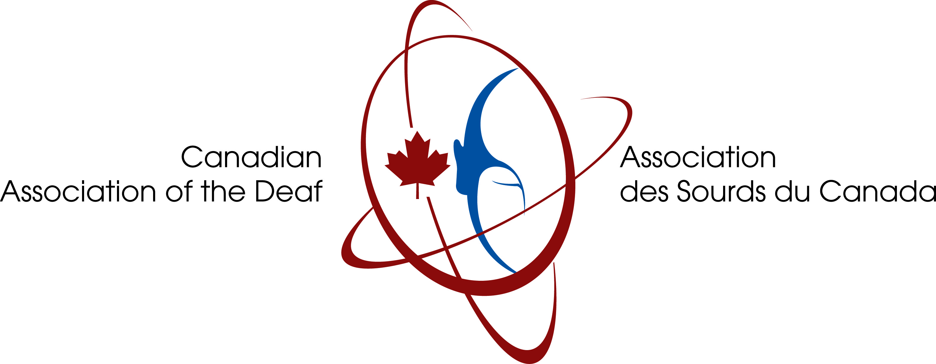

For Immediate Release
September 16, 2025

Canadian Association of the Deaf – Association des Sourds du Canada announces 2025 International Day of Sign Languages (IDSL) and International Week of the Deaf People (IWDP).

(Ottawa, Ontario) --- The Canadian Association of the Deaf – Association des Sourds du Canada (CAD-ASC) is proud the hoisting the Deaf Flag at the Parliament Hill for the second time in history on Tuesday September 23, 2025 at 12 p.m. EST in honour of the U.N. declaration of the International Day of Sign Languages (IDSL).

North of the eternal flame, in front of the Parliament buildings, the event will include dignitaries such as Christopher Sutton, Canada’s Accessibility Commissioner, the honourable Patty Hajdu, Minister of Jobs and Families, and the Honourable Leslie Church, Parliament Secretary to the Ministry. As well as the students from Centre Jules-Leger, who will sign O Canada in LSQ during the raising of the Deaf flag.

The CAD-ASC is proud to endorse World Federation of the Deaf (WFD)’s global campaign: “No Human Rights without Sign Language Rights” to promote International Day of Sign Languages and International Week of the Deaf People on September 22 to 28, 2024.

The Deaf Flag was approved by the WFD in July 2023, and it represents a powerful symbol for our sign language communities around the world.

The International Day of Sign Languages aims to raise awareness on sign languages, which take places during the International Week of Deaf People. The event is celebrated through various activities by respective sign language communities in Canada and around the world. These activities underline the importance of sign languages and human rights of our communities to various stakeholders including governmental bodies.

Along with Parliament Hill, the following cities will also raise the Flag on IDSL:

- Confederation Building, 100 Prince Philip Dr., St. John’s, Newfoundland and Labrador: September 22nd, 1 p.m. NDT.
- Quinte Sports & Wellness Centre, 265 Cannifton Rd., Belleville, Ontario: 9 a.m. EST
- Milton Town Hall, 150 Mary St., Milton, Ontario: 10 a.m. EST
- Confederation Park, 209-211 Ontario St., Kingston, Ontario: 11 a.m. EST
- Peterborough Square, 340 George St. N, Peterborough, Ontario: 11 a.m. EST
- Barrie City Hall, 70 Collier St., Barrie, Ontario: 1 p.m. EST
- Toronto City Hall, Rooftop, 100 Queen St. W, Toronto, Ontario: 11:30 a.m. EST
- RRC Polytech’s Notre Dame Campus (at main entrance), 2055 Notre Dame Ave., Winnipeg, Manitoba: 11 a.m. CST
- Manitoba Legislative Building, 450 Broadway, Winnipeg, Manitoba: 12 p.m. to 3 p.m. CST
- Saskatchewan Legislative Building, 2405 Legislative Dr., Regina, Saskatchewan: 1 p.m. CST
- City of Calgary Municipal Complex Plaza (Outdoor), 800 Macleod Trail SE, Calgary, Alberta: 11:30 a.m. to 1 p.m. MST.
- Prince George City Hall, 100 Patricia Blvd, Prince George, British Columbia: 4 p.m. PST

In addition, CAD-ASC is also pleased to publicize Blue Light Campaign that will be happening across Canada to mark the International Day of Sign Languages during the International Week of Deaf People. By illuminating public building in blue, the main colour of the Deaf flag. This initiative will promote Deaf equality and our sign language. As well as highlight human rights issues and accessibility. These following cities across Canada that will be illuminated in blue:

- CN Tower, 290 Bremner Blvd, Toronto, Ontario
- Moira River Bridge, Belleville, Ontario
- Kingston City Hall, 216 Ontario St., Kingston, Ontario
- The OTTAWA Sign, 6 York St., Ottawa, Ontario
- Brampton City Hall, 2 Wellington St. W, Brampton, Ontario
- Peterborough City Hall, 500 George St. N, Peterborough, Ontario
- Centennial Fountain (Little Lake Fountain), Peterborough, Ontario
- Provencher Bridge, Winnipeg, Manitoba
- The WINNIPEG Sign, Winnipeg, Manitoba
- Selkirk Water Tower, Selkirk, Manitoba
- Confederation Park, 1700 Elphinstone St., Regina, Saskatchewan
- Nutrien Tower, 315 19 St. E, Saskatoon, Saskatchewan
- Calgary Tower, 101 9 Avenue SW, Calgary, Alberta
- High Level Bridge, Edmonton, Alberta
- Vancouver Convention Centre, 1055 Canada Pl., Vancouver, British Columbia
- Science World, 1455 Quebec St, Vancouver, British Columbia
- BC Place, 777 Pacific Blvd, Vancouver, British Columbia
- Canada Place, 999 Canada PI., Vancouver, British Columbia
- B.C. Legislative Building, 501 Belleville St., Victoria, British Columbia
- Niagara Falls, Niagara Falls, Ontario

The Niagara Falls Illumination Board’s decision to honour IDSL by lighting the falls blue on September 23rd, 2025 at 10:15 p.m. You can see the falls illuminated through the live cam at: https://www.earthcam.com/canada/niagarafalls/?cam=niagarafalls_str

We invite you to join us across Canada as we celebrate the importance of sign languages as a fundamental human right and continue our efforts to increase public awareness on this year’s theme: “No Human Rights without Sign Language Rights”

For more information, please visit our website or contact:

www.cad-asc.ca/deaf-flag-raising/
https://cad-asc.ca/blue-light-campaign/
https://cad-asc.ca/event/international-week-of-the-deaf/

Shawna Joynt
President
Canadian Association of the Deaf – Association des Sourds du Canada
shawna.joynt@cad-asc.ca

Richard Belzile
Executive Director
Canadian Association of the Deaf – Association des Sourds du Canada
richard.Belzile@cad-asc.ca

