Breaking Barriers: Deaf Students in Legal Education – Survey Results and Analysis

April 2025

Richard Belzile, LL.B., Queen’s University,
Executive Director,
Canadian Association of the Deaf-Association des Sourds du Canada.

Table of Contents
Introduction 2
Responding Institutions 3
General Disability Support 3
Deaf-Specific Support 3
Additional Comments 4
Data Collection on Accommodation 4
Previous Deaf Graduates 4
Current Enrollment of Deaf Students 4
Accommodations & Training Provided 5
Sensitivity Training and Professional Development 5
Sign Language Instruction 6
Scholarships and Financial Aid 6
Initiatives to Increase Deaf Student Enrollment 6
Overall Summary and Ranking 7
Appendix – Survey Questions 8

Introduction
The Canadian Association of the Deaf – Association des Sourds du Canada (CAD-ASC) initiated a survey to gather detailed insights on how law schools in Canada accommodate Deaf students, particularly those who rely on sign language or alternative communication methods.
Four law school provided responses:

- Windson Law,
- Bora Laskin Faculty of Law,
- Western University Faculty of Law, and the
- University of Manitoba Faculty of Law

These submissions reflect policies, accommodations, and perspectives on Deaf and hard-of-hearing students pursuing legal education.

Responding Institutions
Each participating school identified specific individuals, ranging from assistant deans and associate deans to student service advisors and directors of equity. Their roles offer a spectrum of viewpoints regarding student services, academic programming, and institutional equity mandates. The diversity of positions allowed the survey to capture a more comprehensive look at each faculty’s approach.

General Disability Support
All four respondents confirmed having general policies or programs to support students with disabilities. These frameworks often involve collaboration with a broader university accessibility office, indicating that law schools typically rely on campus-wide resources. The existence of these policies suggests a level of institutional awareness about disability-related matters and a willingness to provide some degree of support, whether through classroom accommodations, specialized technology, or administrative processes.

Deaf-Specific Support
Only two schools reported that they maintain a policy or program specifically tailored for Deaf students who rely on sign language. One school indicated the absence of such a targeted approach, while another could not confirm or had no recorded data. This disparity underscores that some faculties have begun developing or integrating Deaf-focused measures, whereas others rely solely on general disability supports. Where policies are absent, there may be limited understanding of cultural and linguistic requirements among Deaf law students who rely predominantly on sign language.
Additional Comments
Two respondents described additional context for their existing policies. One school emphasized a discretionary admissions category called “Access,” under which Deaf students are encouraged to apply. This admissions approach is complemented by an overarching university-wide policy on disability accommodations. Another respondent serving as a director of equity noted collaboration with the university’s Student Accessibility Services, focusing on dismantling structural and attitudinal barriers for all learners. These comments highlight that formal frameworks often partner with broader university offices to deliver Deaf-focused services.
Data Collection on Accommodation
Three of the four responding institutions stated that they collect data related to the accommodation needs of Deaf students or employees, including sign language interpreting costs. One institution reported no formal data collection in this area. Gathering systematic information is beneficial because it allows administrators to identify trends, forecast budgets for interpreting services or technology, and measure the effectiveness of existing support structures. Without such data, it may be more challenging for institutions to create robust, evidence-based accessibility plans.
Previous Deaf Graduates
Two schools indicated that they had graduated Deaf lawyers in the past, one stated none, and one was uncertain. The presence of Deaf alumni in at least two institutions suggests that Deaf students have succeeded with existing supports and persevered through legal education requirements. It also signals to prospective Deaf applicants that success is achievable, though it remains unclear whether these graduates had robust or merely minimal support while enrolled.
Current Enrollment of Deaf Students
Only one of the participating law schools noted having Deaf students enrolled at the time of the survey. The remaining three reported no currently enrolled Deaf students who signed. This data point may reflect variations in recruitment or admission practices, the nature and extent of outreach to the Deaf community, or broader institutional reputations concerning disability accommodations. Schools with active Deaf enrollment can offer real-time feedback to administrators about potential gaps or strengths in their accessibility practices, while those without such enrollments may lack immediate incentive to refine their policies.
Accommodations & Training Provided
All four schools stated that note-taking services are available. Three reported offering real-time captioning services, although one school mentioned relying on alternative software rather than in person Communication Access Realtime Translation (CART). Two specifically provide sign language interpretation and visual alarms or alerts, whereas one school offers specialized tutoring and Deaf-Blind intervenor services. Three schools ensure accessible online learning platforms and alternative-format materials such as Braille or large print. No institutions reported using Protactile interpreting, but some respondents indicated readiness to provide additional supports as needed. In effect, each faculty implements a selection of accommodations, though the full range of Deaf-centric services varies widely among them.
Sensitivity Training and Professional Development
Two law schools responded that they do offer professional development or sensitivity training programs aimed at accommodating Deaf and disabled students. The other two do not currently have such programs or are unaware of them. For those that do provide training, faculty and administrative staff can gain insight on Deaf culture, inclusive teaching methods, and the dynamics of disability law. This type of education fosters a climate where Deaf students can engage on more equitable terms.
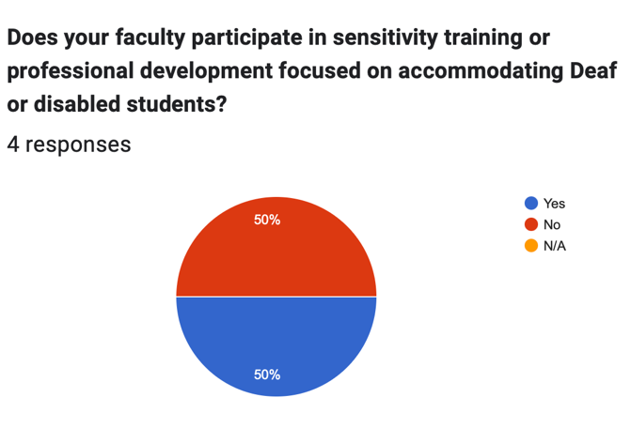

Sign Language Instruction
Half of the schools offer sign language classes for the general student population, and these classes count toward degree credit. The other half reported no such curriculum. Sign language courses can help normalize the presence of Deaf culture within the campus and create a more inclusive environment. Where these courses are absent, hearing students and faculty may have fewer opportunities to understand the linguistic and cultural nuances of Deaf communities.
Scholarships and Financial Aid
Two institutions mentioned having scholarships or financial aid options specifically designated for Deaf or disabled students. This financial backing can directly influence the feasibility of law school, especially given the added expenses of living accommodations or assistive devices. The other two respondents stated no known specialized funding for Deaf students, which may pose financial barriers to prospective applicants or current enrollees seeking to manage the additional costs associated with accessibility supports.
Initiatives to Increase Deaf Student Enrollment
Two law schools expressed openness or intent to develop initiatives aimed at growing the number of Deaf students enrolled. One school explicitly indicated no such plans, and one marked this question as not applicable. Proactive initiatives might include dedicated recruitment or outreach programs, close collaboration with Deaf-serving organizations, or streamlined application processes with robust accommodation details.
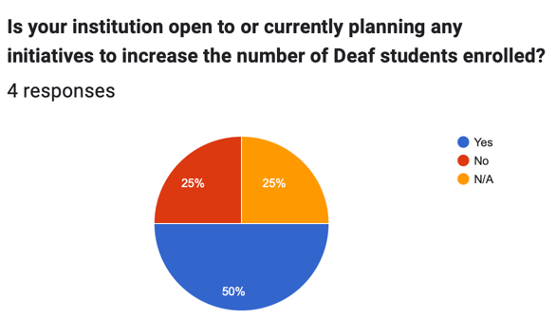

Overall Summary and Ranking
CAD-ASC is well aware of the small number of respondents to our survey. We are also acutely aware of the shortage of lawyers that can communicate with their client in American Sign Language (ASL) or langue des signes québécoises (LSQ). In light of the remaining academic, professional, fiscal and legal barriers to Deaf people who use sign as their primary language of communication, CAD-ASC is aware of the barriers to Deaf people seeking a career in law or as a lawyer. This survey alone will not remove those barriers.
The purpose of our survey was to uncover the pockets of schools to recommend to Deaf students that would support Deaf students into their ranks and hopefully amongst their graduates.
Although, we collected responses from only four schools, their answers illustrate the varied ways in which Canadian law schools address the needs of Deaf students. Although, four may be small, it does represent approximately 20% of Canadian Law Schools. It is our hope that future years will show a greater number of responses.
CAD-ASC hopes that our questions, and the research into them by the law school representatives that answered them, would highlight the existing barriers and the means to lower them for their current and future students. The data reflect both advancements and gaps in Deaf education within legal institutions. For example;
- Every school that answered maintained some level of disability support, but many relied on institution-wide policies rather than specialized Deaf-oriented programs.
- Several offer sign language interpretation, real-time captioning, and note-taking services, though the breadth and consistency of these accommodations differ from one law school to another.
- Half provided scholarships aimed at reducing financial barriers for Deaf or disabled students, but schools that plan to expand initiatives may wish to draw on the practices of those already enrolling Deaf students and track results to inform future policy adjustments or surveys.
Students contemplating a law school education have many factors to consider, but if we were to offer suggestions these students, I would suggest Windsor Law for combining Deaf-specific policies, systematic data tracking, and a wide suite of accommodations that shows an awareness of Deaf students needs and supports and Deaf enrolment.

Appendix – Survey Questions
Good day,
We hope this message finds you well. We are the Canadian Association of the Deaf - Association des Sourds du Canada (CAD-ASC), the oldest national consumer organization of, by and for Deaf individuals in Canada for having its interests represented at national level.
We are conducting this survey to better understand the current landscape and historical context of educational and employment opportunities for Deaf individuals within Canadian law schools. As you know, the federal government has unanimously passed the Accessible Canada Act, 2005. The aim of this legislation is to remove barriers to people with disabilities in areas of federal jurisdiction and to meet our international obligations under the United Nations Convention Convention of Rights for Persons with Disabilities. Currently, the number of trained lawyers who are Deaf in Canada remains strikingly low. Your responses will be invaluable in shaping future initiatives aimed at enhancing accessibility and inclusion in legal education. We appreciate your time and thoughtful input.
This survey is fully available in American Sign Language (ASL) and Langue des signes québécoise (LSQ). To receive the survey in ASL or LSQ, please contact our office through Video Relay Service at 613-518-2944 or email us at admin@cad-asc.ca. We are committed to ensuring full accessibility and equal participation for all respondents.
SURVEY QUESTIONS
Before you begin, we would like to provide a brief explanation of terminology related to deafness. The term "deaf" encompasses a range of experiences and identities connected to hearing loss, which can vary significantly among individuals. Here’s how the term applies differently based on your provided categories:
a) Deaf people who sign (Deaf with a capital "D") : These are individuals who have significant or total hearing loss and primarily use sign language as their mode of communication. Sign languages, such as American Sign Language (ASL), are fully developed languages with their own syntax and grammar, distinct from spoken languages. People in this group often identify culturally and socially with the Deaf community, valuing their shared language and experiences as central to their identity and identify themselves by capitalizing the word Deaf.
b) Deaf people who rely on speech reading, speech, and note-taking (Oral deaf): This group consists of deaf or hard-of-hearing individuals who may use a variety of methods to communicate and receive information in settings where sign language is not used. Speech reading (often called lip reading) involves interpreting the movement of lips, face, and tongue to understand spoken language. These individuals may also utilize hearing aids or cochlear implants to assist with hearing and speech, and might use note-taking services, such as real-time captioning, in educational or professional environments to aid comprehension.
c) Hearing people who sign, such as former interpreters or a Child of Deaf Adult (CODA): This category includes hearing individuals who are fluent in sign language. This group often includes people who have close family members or work regularly with the Deaf community, which necessitates or facilitates their use of sign language. Former interpreters have professional skills in sign language, often used in various settings to facilitate communication between Deaf and hearing individuals. CODAs are hearing individuals raised by Deaf parents; they are typically native signers and often serve as cultural bridges between Deaf and hearing communities.
- Please indicate the law school you are responding on behalf of:
- Please state your name and position:
- Does your institution have a policy or program in place to support students with disabilities?
  - Yes
  - No
  - N/A
- Are there policy or program that specifically supports for Deaf students who sign?
  - Yes
  - No
  - N/A
- Does your institution collect data on the accommodation needs of Deaf employees, students or expenditures on sign language interpreting?
  - Yes
  - No
  - N/A
- Has your institution ever graduated any Deaf lawyers?
  - Yes
  - No
  - N/A
- Are any Deaf students currently enrolled in your law program?
  - Yes
  - No
  - N/A

- Which of the following accommodations does your law school provide for Deaf and/or Deaf-Blind students? (Select all that apply).
Sign language interpretation (ASL/LSQ)
Real-time captioning services (CART)
Note-taking services
ProTactile interpreting
Specialized tutoring services
Deaf-Blind intervenor services
Visual alarms and alerts
Accessible online learning platforms
Alternative format materials (Braille, large print, digital)
Specialized academic advising
None of the above
Not applicable – no Deaf or Deaf-Blind students currently enrolled
Other (please specify): _________________
- Does your faculty participate in sensitivity training or professional development focused on accommodating Deaf or disabled students?
  - Yes
  - No
  - N/A
- Does your university offer sign language classes to the general student population that count towards degree credit?
  - Yes
  - No
  - N/A
- Are there scholarships or financial aid options specifically for Deaf or disabled students at your law school?
  - Yes
  - No
  - Please provide link to application process.
- Is your institution open to or currently planning any initiatives to increase the number of Deaf students enrolled?
  - Yes
  - No
  - N/A
Open-ended questions:
1. Please provide any additional comments or information regarding your institution's support for Deaf students in the law program.

2. Should we have further questions for you, who can we contact?

CLOSING PARAGRAPH
We thank you for your time in completing this survey. Your detailed responses are vital for our continued advocacy and efforts to enhance the educational experiences and opportunities for Deaf students in the legal field.

The CAD-ASC has not yet encountered the graduates or lawyers cited by respondents. Our usage of “Deaf” refers to culturally Deaf individuals who communicate primarily in sign language; respondents may have applied a broader audiological definition, which could explain the disparity.
Protactile is a form of communication for Deaf-Blind people using sign language through tactile channels.

